What to do today
IMPORTANT! Parent or Carer – Read this page with your child and check that you are happy with what they have to do and with any weblinks or use of the Internet required.

1. Story time
Read and enjoy the poem My Step-Dad is an Alien.
- Did you already think the step-dad was an alien before you read the last bit about the tail?
- Which part of the poem gave it away to you?

2. Noun phrases
Open the Hamilton PowerPoint, Nouns and Adjectives.
- Read slides 1-3 and complete the exercise on nouns on slide 3.
- Read slide 4.
- Now choose a colour and carefully underline all the nouns you find in My Step-Dad is an Alien.
- Use a different colour to underline all the adjectives.
- Check your underlined words on the Answers page.

3. Writing about aliens
Read and enjoy My Step-Mum is an Alien.
- Now look through the Instructions on My ____________ is an Alien.
- Write all about an alien relative in your family!

Now try this Fun-Time Extra
- Invent your own alien-detecting machine. Draw it and add labels explaining what the different parts do.
- Ask a grown up if you can make your machine out of junk modelling materials.
- Test it out amongst your family. Are there any aliens amongst them?!

My Step-Dad is an Alien

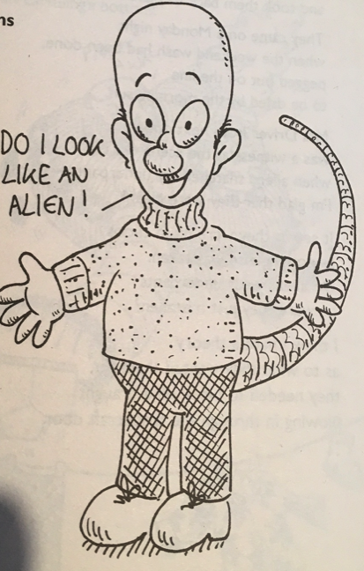

I’d suspected for some time.
I finally got up the courage
To talk to him about it.

I think you’re an alien, I told him.

Nonsense, he said. Why do you think that?

You’re bald. You don’t have any hair,
anywhere.

That’s not unusual, he said.

Well, you’ve got one green eye
and one blue one.

That doesn’t make me an alien, he replied.

You can make the toaster work
without turning it on.

That’s just a trick, he smiled.

Sometimes I hear you talking to Mum
in a weird alien-language.

I’m learning Greek
and Mum lets me practise on her.

What about your bright blue tail?

Ah, he said thoughtfully.
You’re right, of course.
So, the tail gave it away, did it?

by Roger Stephens
From Aliens Stole My Underpants
Edited by Brian Moses
My Step-Dad is an Alien

Nouns and Adjectives
Answers

I’d suspected for some time.
I finally got up the courage
To talk to him about it.

I think you’re an alien, I told him.

Nonsense, he said. Why do you think that?

You’re bald. You don’t have any hair,
anywhere.

That’s not unusual, he said.

Well, you’ve got one green eye
and one blue one.

That doesn’t make me an alien, he replied.

You can make the toaster work
without turning it on.

That’s just a trick, he smiled.

Sometimes I hear you talking to Mum
in a weird alien-language.

I’m learning Greek
and Mum lets me practise on her.

What about your bright blue tail?

Ah, he said thoughtfully.
You’re right, of course.
So, the tail gave it away did it?

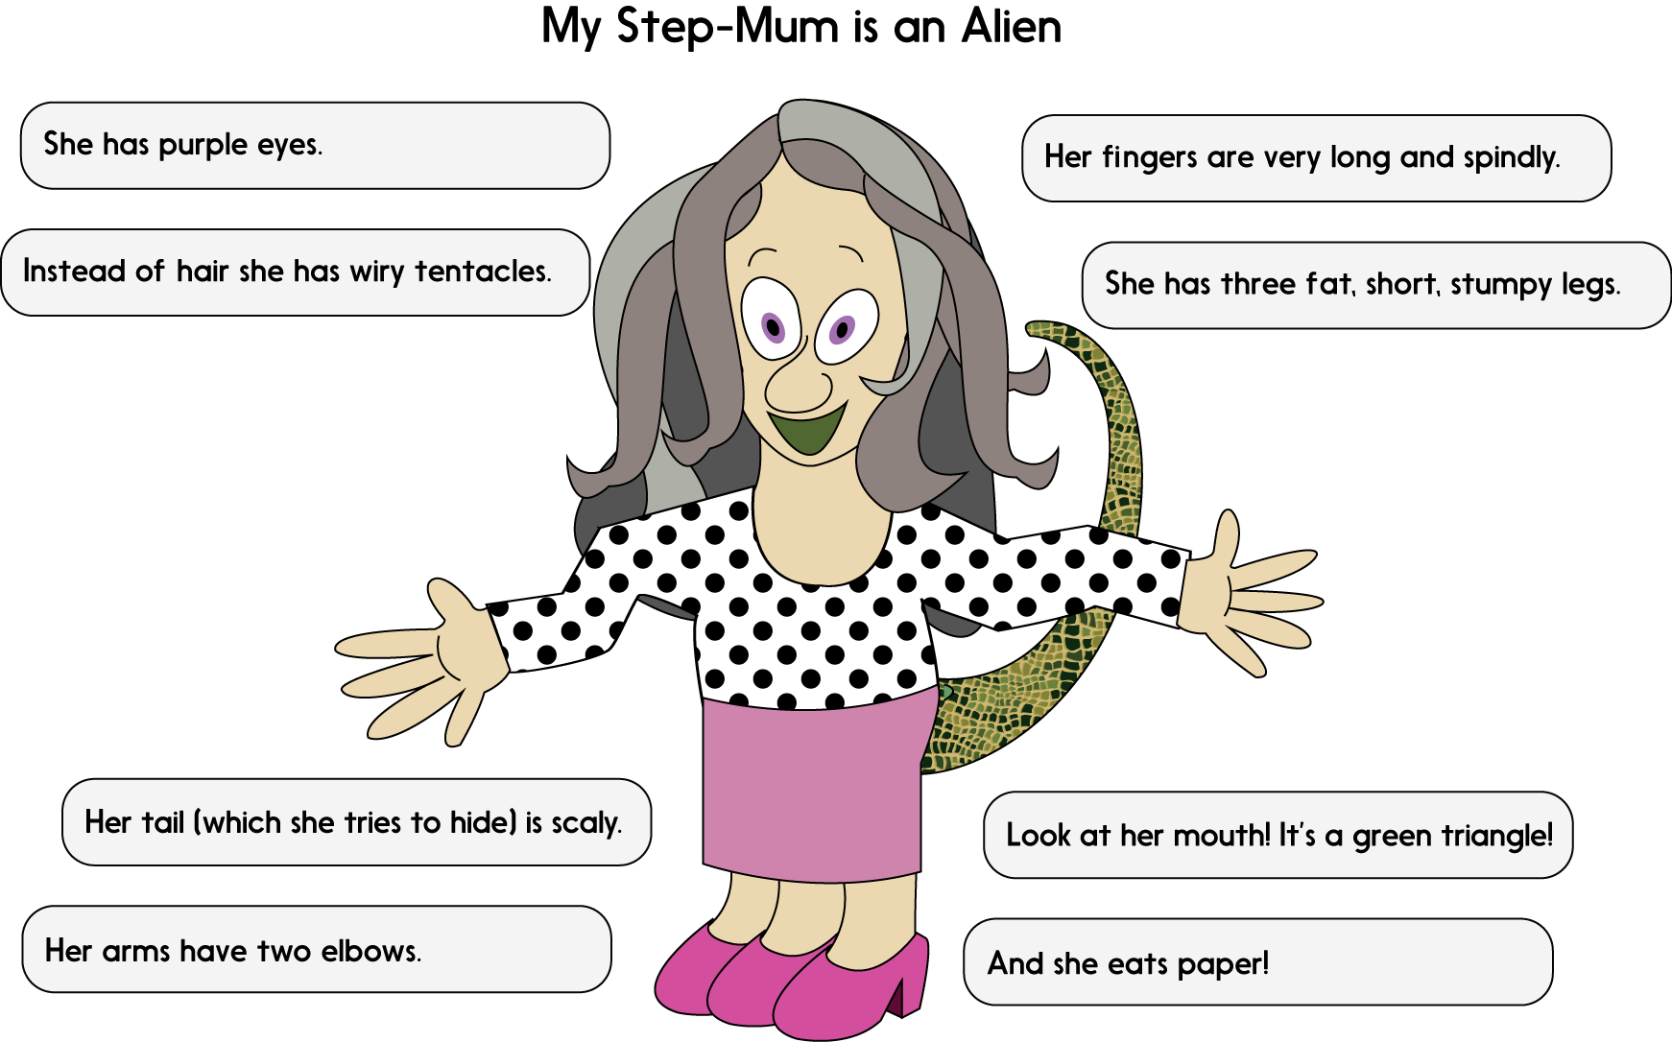

My Relative is an Alien

Instructions

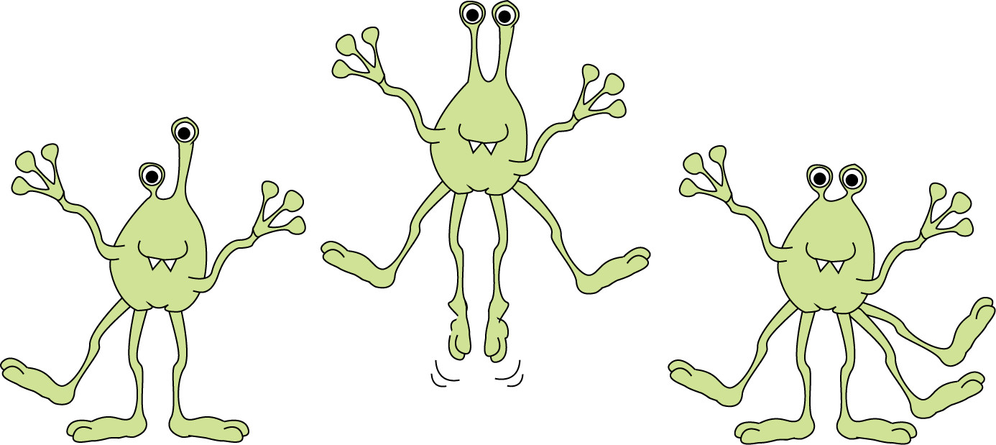

You are going to: draw and write sentences describing someone in your family who is actually an alien!

What to do:

- Choose or make up a relative to be your alien, e.g. a brother, an aunt, a granddad or nana.

- Write your title with their name in it. My Granddad is an Alien.

- Draw your relative in the middle of the box.

- Around your drawing, write eight ‘clue’ sentences like those on My Step-Mother is an Alien.

- Use really good, exciting adjectives to describe your nouns: He has crinkly green lizard’s skin. His eyes are a bright flaming yellow…

- Make sure you begin all your sentences with a capital letter. Don’t forget your full stops.

Challenge: can you write more than eight sentences about your relative?
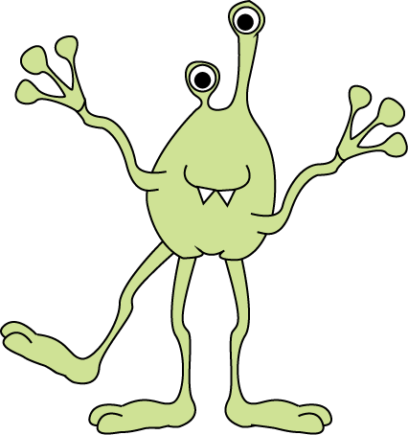

____________________________________________________

My Alien-Detecting Machine

