What to do today
IMPORTANT! Parent or Carer – Read this page with your child and check that you are happy with what they have to do and with any weblinks or use of the Internet required.

1. Story time
Read the poem Out of a Cloud by Richard Edwards.
- How many verses does the poem have?
- Which is your favourite? Can you say why?

2. Rhymes and rhyming
Re-read the first verse of Out of a Cloud.
- Find and highlight the four words in the verse that rhyme.
- Now do the same with the second and third verses.
- Check your work against the Answers page.
- Next to each verse, write other words that would also rhyme with that verse’s set. Do six more words maximum. (see answers)

3. Writing in response to a poem
Read each of the questions on Where has Desmond gone?
- On What I think has happened to Desmond, write sentences/short paragraphs in response to each question.
- Use Conjunctions to link ideas in your sentences.
- Use correct punctuation in all your sentences.
- Illustrate your page with pictures.

Now try this Fun-Time Extra
- Do you believe in UFOs? On UFOs! draw one and say what you think the creatures might be.
Out of a Cloud
I have never seen one,
Desmond saw one though,
He said it hummed like hives of bees,
He said it glowed a glow,
He said it swooped out of a cloud
and lit the fields below,
He said it took his heart away,
Desmond’s UFO.

Of course no one believed him,
But wandering here and there,
Desmond scanned the sky each night,
With his hopeful stare,
Examining the Milky Way,
Venus, the Plough, the Bear,
Searching, wishing, longing,
Desmond head-in-air.

And then one day he vanished.
How? We’ll never know.
We found no clue or trace of him,
Hunting high and low,
Except, spiked on a barbed-wire fence,
A note saying: ‘Told you so,’
And all around the grass pressed down...
Where did Desmond go?
By Richard Edwards
From Aliens Stole My Underpants edited by Brian Moses

Out of a Cloud

Rhyme Answers

I have never seen one,
grow
no
go
blow
toe

Desmond saw one though,
He said it hummed like hives of bees,
He said it glowed a glow,
He said it swooped out of a cloud
and lit the fields below,
He said it took his heart away,
Desmond’s UFO.
_____________________________________________________________

Of course no one believed him,
where
fair
stare
chair
beware

But wandering here and there,
Desmond scanned the sky each night,
With his hopeful stare,
Examining the Milky Way,
Venus, the Plough, the Bear,
Searching, wishing, longing,
Desmond head-in-air.
______________________________________________________________

And then one day he vanished.
flow
Joe
follow
know
show

How? We’ll never know.
We found no clue or trace of him,
Hunting high and low,
Except, spiked on a barbed-wire fence,
A note saying: ‘Told you so,’
And all around the grass pressed down...
Where did Desmond go?

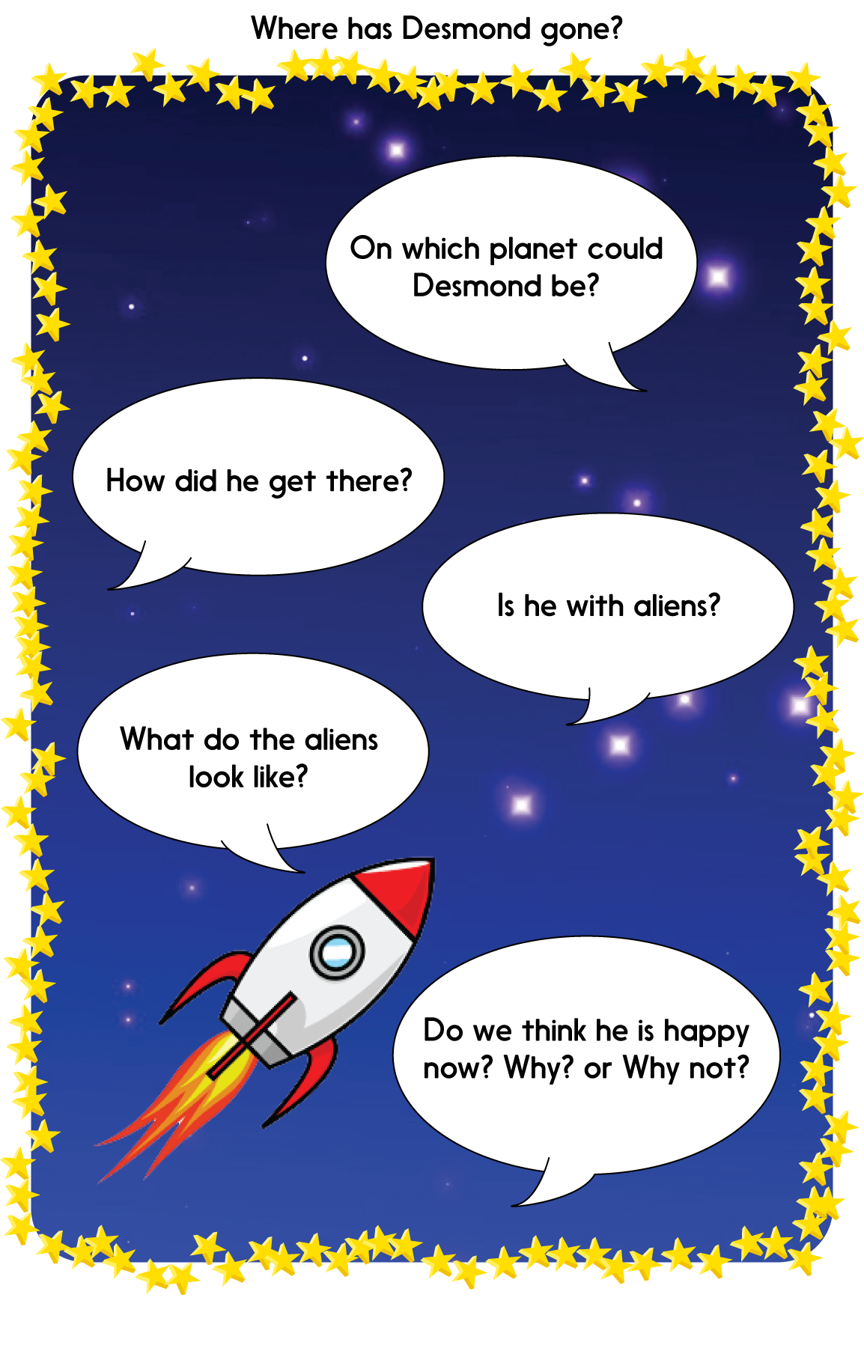

What I think has happened to Desmond

Conjunctions

and

for nor but or yet so

when if that although

Use a conjunction to link two ideas together in one sentence.

I think Desmond could be on the Planet Mars but he might just be on the Moon.

I think Desmond got there in the UFO although he may have been beamed straight to Mars with a laser.
UFOs!

____________________________________________________________________________________________________________________________________________________________________________________________________________________________________________________________________________________________________________________________________________________________________________

