What to do today
IMPORTANT! Parent or Carer – Read this page with your child and check that you are happy with what they have to do and with any weblinks or use of the Internet required.

1. Reading time
Re-read Animal Recipes.
- Look at all the words used instead of said when the animals speak: growled, muttered, barked, etc.
- Which is your favourite?
- Can you suggest other said words to go with those from the story?

2. Recipes layouts
Re-read Bear’s Recipe for Jam Tarts.
- Identify and highlight the features of recipes using the Features of Recipes below.
- Do the same with Giraffe’s Recipe for Cole Slaw.
- Why do you think the recipes list the ingredients before they say what to do? Would it work as well the other way round? Why not?

3. Writing a recipe
With a grown up, decide on a simple easy recipe that you could help make in the kitchen.
- Make your food.
- Follow the Recipe Writing Instructions for what to do next.

Now try this Fun-Time Extra
- Decorate and send your recipe to a relative like Granny or Grandad.
- Provide them with a Recipe Feedback form to fill in for you to read. You could use the one provided here or make up your own.

Features of Recipes

What do recipes look like?
What things can we see in recipes?

- A clear title showing the name of the food;

- Clear headings separating the different parts;

- A list of ingredients in bullet points;

- A numbered list of instructions telling us what to do;

- Bossy verbs used to start sentence;

- Pictures of ingredients or of the final result!
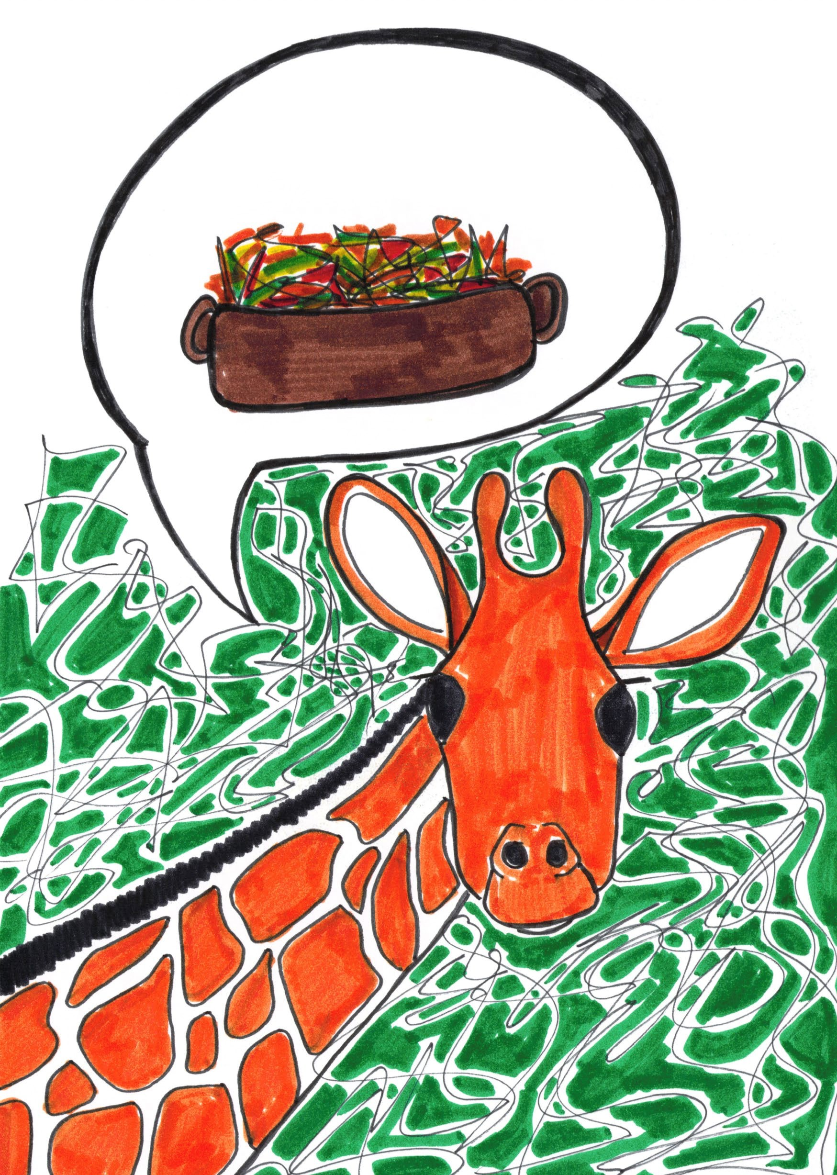

Can you find these things in the recipes below?

Bear’s Recipe for Jam Tarts
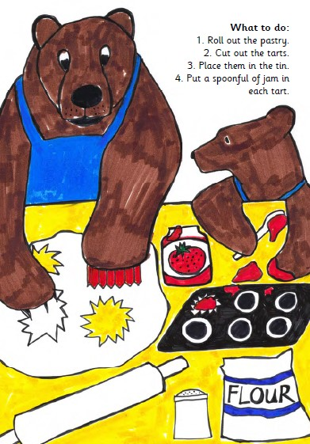
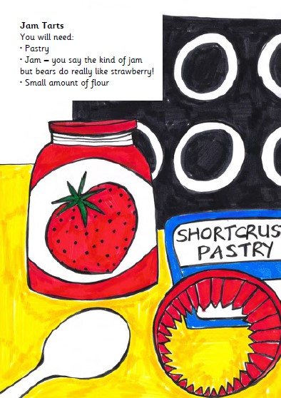

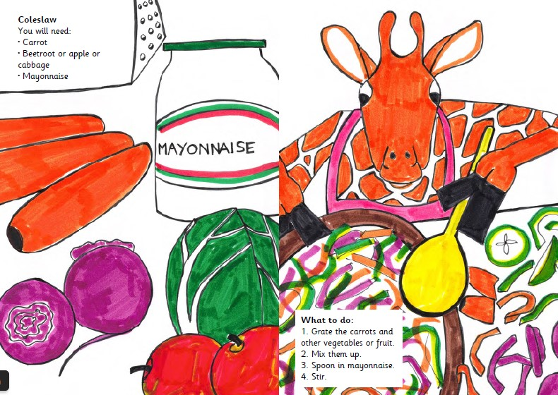
Giraffe’s Recipe for Cole Slaw

Recipe Writing Instructions

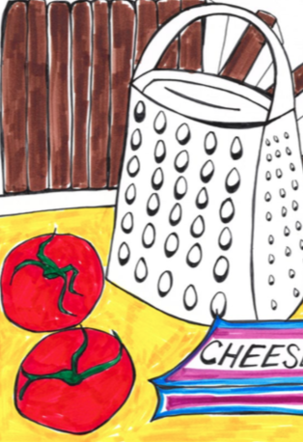

- Now that you have made and enjoyed your lovely food you are going to write out your recipe so that other people can use it too.
- Either on the Recipe page or on a plain piece of paper, write down the name of the dish you have made as a heading.
- Use bullet points to show the ingredients you need for the recipe.
- Write a set of numbered instructions telling someone how to make your recipe. You may need to carry on the back of your page.
- Be careful to get your instructions in the right order.
- Be sure to use bossy verbs at the start of your instruction sentences.
- Keep looking at the recipes on Features of Recipes to make sure you have got all the right language and layout features in your writing.

You will need:
What to do:

Recipe Feedback Form

Please tell me what you thought of my recipe!!

Name of recipe
Tasting notes
Appearance notes
General comments
Star rating out of 5

