What to do today
IMPORTANT! Parent or Carer – Read this page with your child and check that you are happy with what they have to do and with any weblinks or use of the Internet required.

1. Reading time
Read and enjoy the story, Animal Recipes.
- Which of the recipes would you most like to eat? Why is that your favourite?

2. Looking at verbs
Look again at the Recipe Collection from the text.
- Read each recipe.
- Highlight all the bossy, ordering verbs. (See answers at the end.)
- Say where bossy verbs are in instruction sentences – at the beginning, in the middle or at the end?

3. Writing about animals and their food choices
You are now going to select, draw and write about another animal that is not in Animal Recipes.
- Read through the Animals and their Recipes Instructions sheet.
- Use your best handwriting and word spacing for your sentences.
- Remember to check through your writing carefully when you think you have finished.

Now try this Fun-Time Extra
- On My Food on..., keep a list of everything you eat on one whole day.
- At the end of the day, describe what the very nicest thing you had was, and why you liked it the best.

- Read each recipe.
- Highlight the ‘bossy words’.
How to make jam tarts | How to make cheesy toast
- Roll out the pastry.  - Cut out the tart.  - Place them in the tin.  - Put a spoonful of jam in each tart.  - Put the tarts into the oven for 10 to 12 minutes. | - Take a thick slice of bread and butter it.  - Grate the cheese.  - Put a thick layer of grated cheese on the bread.  - Put three slices of tomato on top.  - Grill for 3 or 4 minutes.
How to make rice crispies | How to make eggy bread
- Melt the butter over a love heat.  - Add the chocolate and golden syrup.  - Stir well – so there are no lumps.  - Add 12 big spoons of crispies or more and stir till they are all chocolaty.  - Put dollops into each paper case. | - Take three eggs.  - Whisk them well.  - Soak the bread in the egg.  - Ask a grown-up to fry the bread on both sides.  - Spread with Marmite.

Recipes
Animals and their Recipes

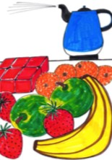

You are going to:
Write sentences about what food and drink you think an animal of your own choice would like.

What to do:
- Choose a new animal that is not in Animal Recipes. Maybe choose one from Animal Suggestions.

- Think about some meals, dishes or foods you think that animal might really enjoy. (You don’t have to be realistic with the food!)
In the wild a lion might eat a deer or a gazelle but you could say he’d like to eat a roast dinner, ice cream and strawberries.

- Explain why you think your creature would like those foods.
Use the word because to introduce your reasons.
I think a lion would love to eat a huge roast dinner with lots or roast potatoes and parsnips because they need a lot of energy for all their hunting and running around.

- Write your sentences on My Animal.

- Add some drawings to your page showing your animal and its food.

Challenge:
Do the same thing for a different animal and different foods.

Animal Suggestions

Use one of these animals if you can’t think of one yourself. | 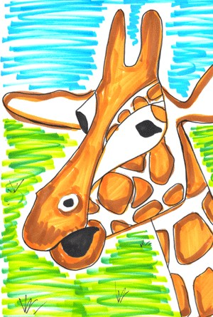  giraffe
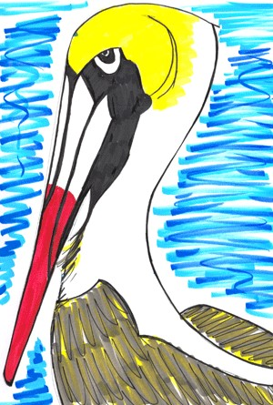  pelican | 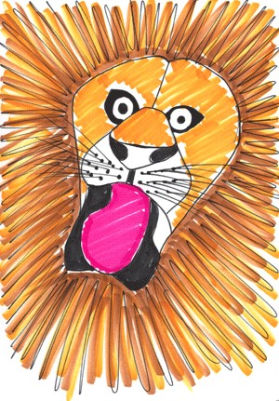  lion
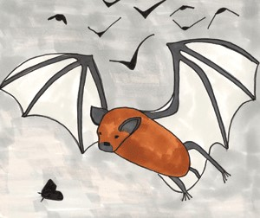  bat | 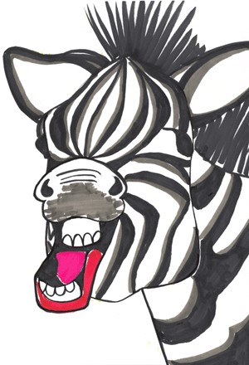  zebra
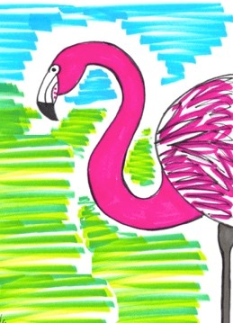  flamingo | 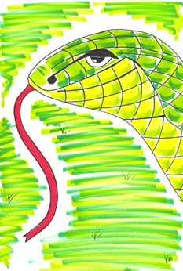  snake

My Animal

My Food on ______________________

The nicest thing I ate today was ______________________________________________________
_________________________________________________________________________________________________________________________________________________________________________________________________________________________________________________________

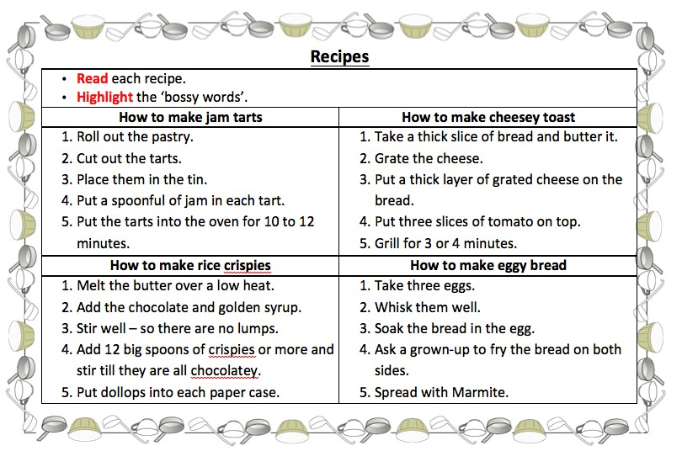
Answers to bossy verbs

