What to do today
IMPORTANT! Parent or Carer – Read this page with your child and check that you are happy with what they have to do and with any weblinks or use of the Internet required.

1. Story time
Go back to https://www.youtube.com/watch?v=7qMMhJ4iiu8 and re-listen to Diary of a Wombat.

2. Verbs and tenses
What are verbs? What does being ‘in the past tense’ mean?
- Carefully read The Past Tense Simple and Progressive Forms and then go back to the start of Diary of a Wombat. Be ready to pause the video so you can see the Monday and Tuesday pages.
- On Monday’s and Tuesday’s Verbs record all the verbs used on those days in the diary.
- What tense are the verbs in? Confirm that they are in the past tense.
- Are the verbs in the simple or progressive form of the past tense? Confirm that they are in the simple form of the past tense.

3. Writing time
Look at Wombat’s Simple Past Sentences.
- Rewrite each sentence using the progressive form of the past tense.
- Now read the sentences on Wombat’s Progressive Past Sentences.
- Rewrite each sentence in the simple past tense.
- Check with the Answers for both to see how you got on.

Now try this Fun-Time Extra
- On Verbs, write down in the past tense any verbs that say what you have done today (watched TV, played in the garden, had lunch).
- Rewrite each one in the progressive past (was watching, was playing).

The Past Tense – Simple and Progressive Forms

When we write about things that happened in the past, we can show this by using the simple past verb form.

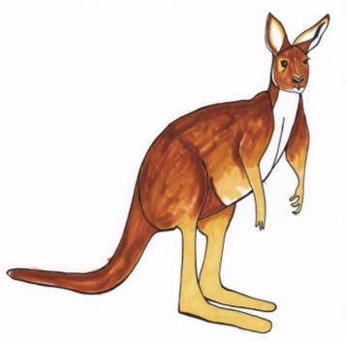
The kangaroo jumped over the fence.

Often we add -ed to the end of the verb.
Other verbs take different forms to show past tense.

The kangaroo ate some grass.

To show that the past action was in progress for a period of time, or at the same time as something else, we can use the past progressive form.

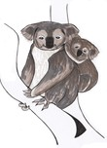
The baby koala was holding on tightly while its mother climbed the tree.

The koalas were eating leaves from the tree.

The baby held onto her mother for a while – it takes time to climb a tree. The koalas may not have finished eating leaves.

To write in the past progressive form we use helping verbs (was or were) and add -ing to the base verb.

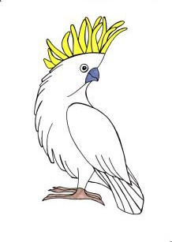
The cockatoo was flapping its wings in the sunshine. The cockatoo was cracking seeds open with its beak. The birds were squabbling in the trees.

Monday’s and Tuesday’s Verbs
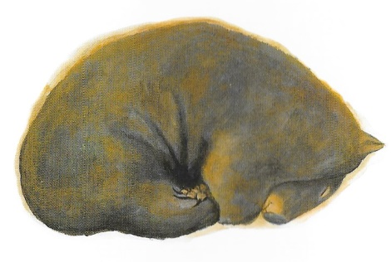

Monday | Tuesday

Wombat’s Simple Past Sentences

- Read each sentence carefully and highlight the verbs.  Watch out – some sentences contain more than one verb.  - Rewrite each sentence in the space below but using the progressive form of the past tense. | 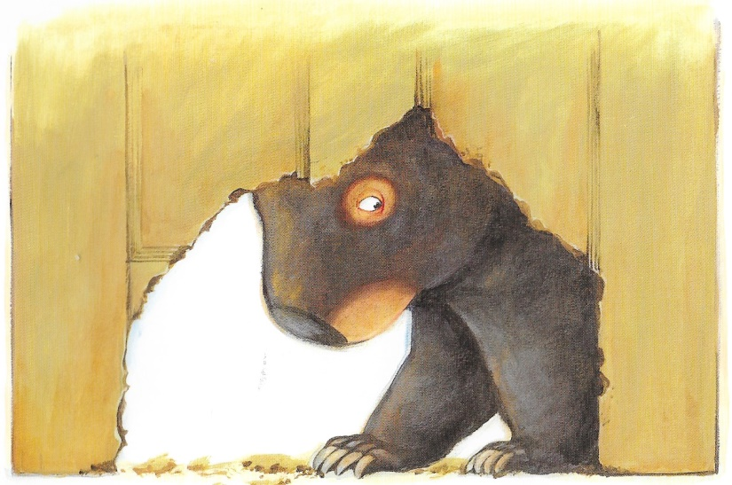

Wombat slept peacefully through the morning.
She gnawed on a carrot.
She fought with a flat, hairy creature.
Wombat dug a deep, dark hole in the garden and hid from the sun.
Mum and Dad nailed up the door and took in their washing.
Wombat’s Progressive Past Sentences
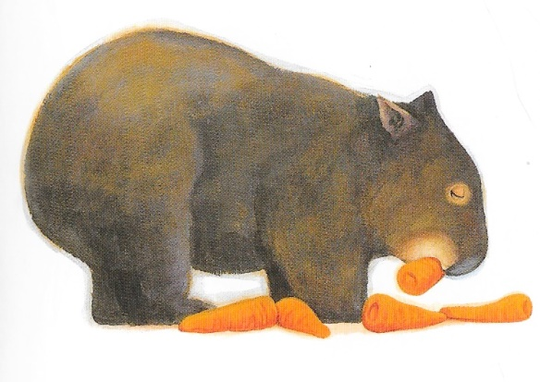
- Read each sentence carefully and highlight the verbs.
Watch out – some sentences contain more than one verb.
- Rewrite each sentence in the space below but using the simple form of the past tense.

Wombat was finding her grass dull and tasteless.
The wombat was scratching on the garden chairs and rubbing against the table legs.
Mum and Dad were looking for carrots and oats for the pesky wombat.
The rain was falling and the wombat’s new hole was quickly filling with water.
The children were hearing strange noises from under the house as the wombat was digging a hole there.

Answers
Wombat’s Simple Past Sentences

Wombat slept peacefully through the morning.
Wombat was sleeping peacefully through the morning
She gnawed on a carrot.
She was gnawing on a carrot.
She fought with a flat, hairy creature.
She was fighting with a flat, hairy creature.
Wombat dug a deep, dark hole in the garden and hid from the sun.
Wombat was digging a deep, dark hole in the garden and hiding from the sun.
Mum and Dad nailed up the door and took in their washing.
Mum and Dad were nailing up the door and taking in their washing

Answers
Wombat’s Progressive Past Sentences

Wombat was finding her grass dull and tasteless.
Wombat found her grass dull and tasteless.
The wombat was scratching on the garden chairs and rubbing against the table legs.
The wombat scratched on the garden chairs and rubbed against the table legs.
Mum and Dad were looking for carrots and oats for the pesky wombat.
Mum and Dad looked for carrots and oats for the pesky wombat.
The rain was falling and the wombat’s new hole was quickly filling with water.
The rain fell and the wombat’s new hole quickly filled with water.
The children were hearing strange noises from under the house as the wombat was digging its hole there.
The children heard strange noises from under the house as the wombat dug its hole there.

Verbs

Today I...

Simple Past Tense | Progressive Past tense

Here is a picture of me performing one of these actions

