What to do today
IMPORTANT! Parent or Carer – Read this page with your child and check that you are happy with what they have to do and with any weblinks or use of the Internet required.

1. It’s story time
- Listen to/watch the reading of Diary of a Wombat by Jackie French and Bruce Whatley https://www.youtube.com/watch?v=7qMMhJ4iiu8
- Look again at Text Types. What sort of writing is Diary of a Wombat?
- Agree that Diary of a Wombat is fiction, a story and a diary.

2. Spelling focus
Look at the set of jumbled Days of the Week and read each one aloud.
- Cut up the cards and sequence the days correctly, Monday to Sunday.
- On My Days of the Week, practise spelling each word. Use a ‘look, cover, write, check’ method to help you get the spellings right.
- Remember that days of the week always start with a capital letter.

3. Writing time
Agree that Diary of a Wombat is told from the point of view of the wombat.
- Look at The Dust Bath. Write a sentence expressing what the wombat thinks about having a dust bath: I had a lovely refreshing dust bath, which really cheered me up.
- Would the family feel the same? No! Write a sentence expressing what the family feel. That annoying wombat ruined our barbecue!
- Write sentences for wombat and the family on The Mat and The Door.

Now try this Fun-Time Extra
- Write about a real or made up day in the style of The Diary of a Wombat – Morning… sat around in pjs. Afternoon... played in the garden. Got muddy. Went indoors. Add some pictures to your diary.
Text Types

Factual  Factual texts give information and details about real people, things and places. A factual text is not a story. | Story  A tale about made-up characters and places. | Information  A text that gives you facts and details about a particular subject. | Poetry  Poems have verses and often have rhymes in them. They sound a bit like songs. | Diary  A text written by someone recounting what they did on a particular day.
Fiction  Made-up stories. Fiction is the opposite of non-fiction. | Letter  Letters and emails are messages written by one person to another. They often start Dear..., and have an address and a date at the top of the page. | Instructions  Instructions tell you what to do. They use bossy language and list the things you need to do to achieve something. | Non-fiction  Non-fiction texts are the opposite of fiction texts. They give factual information about real things. | Biography  A biography is an account of a real person’s life.

Days of the Week

Tuesday
Sunday
Friday
Monday
Saturday
Thursday
Wednesday

My Days of the Week

1.

2.

3.

4.

5.

6.

7.

The Dust Bath
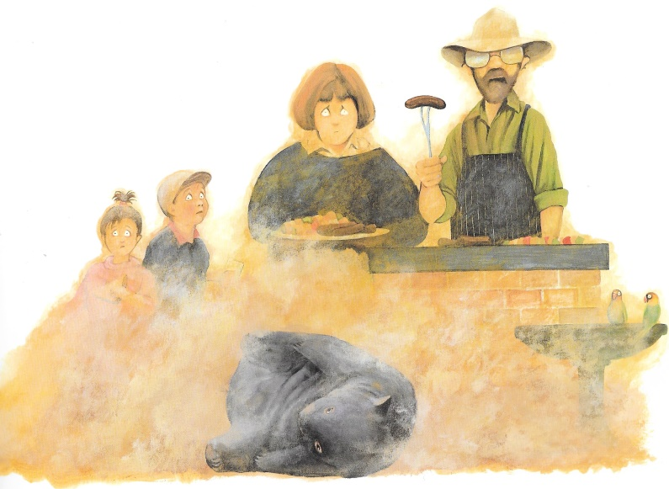
Wombat’s point of view
Family’s point of view

The Mat
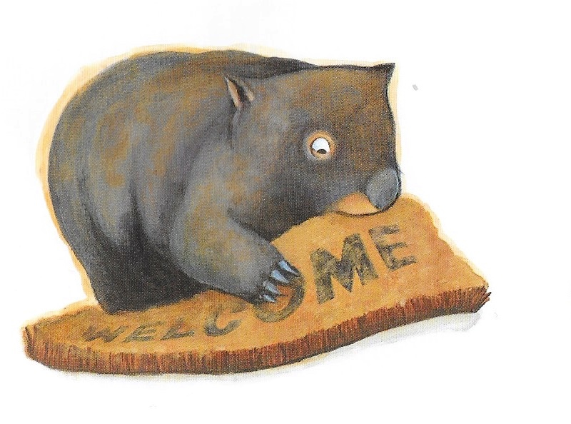
Wombat’s point of view
Family’s point of view

The Door
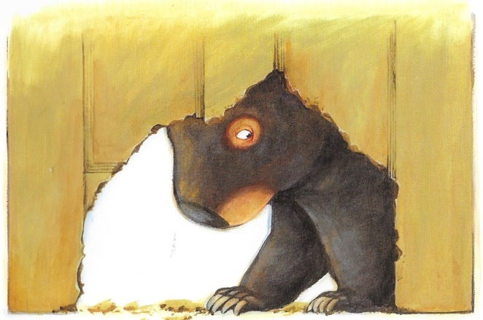
Family’s point of view

Wombat’s point of view

