What to do today
IMPORTANT! Parent or Carer – Read this page with your child and check that you are happy with what they have to do and with any weblinks or use of the Internet required.

1. Reading time
Look at the pictures on Wombats and carefully read the text about these intriguing Australasian animals.
- What was the most interesting thing you learned about wombats?

2. Different sorts of writing
Look at the list of different types of writing on Text Types.
- Read each heading and its definition.
- Highlight all the headings that describe the kind of text that Wombats is.
Pssstt! There is more than one. Check with the Answers page which is at the end of the document.

3. Answering questions
Look at the set of Wombat Questions.
- Read each question carefully.
- Answer each question.
- Go back and check with the text of Wombats if you need to.
- Re-read your answers to be sure you have said what you wanted to.

Now try this Fun-Time Extra
- Draw or paint your own picture of a wombat.
- Write sentences explaining what you find interesting about wombats.

Wombats

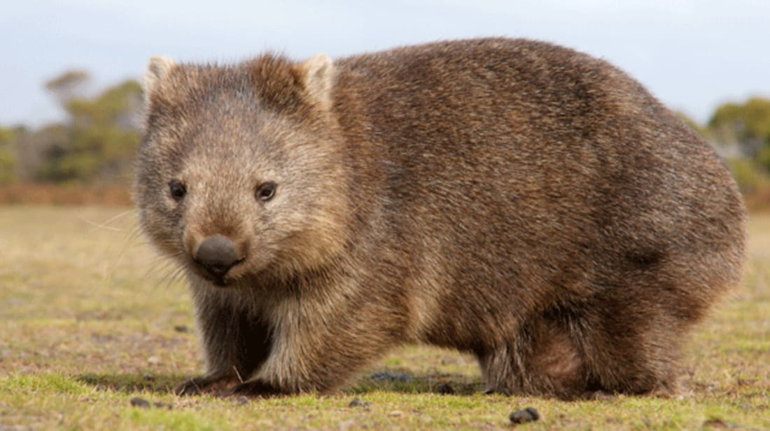

What is a wombat?
Wombats are short-legged, muscular marsupials. A marsupial is an animal that gives birth to live young, which they then carry and feed in a pouch. Wombats can grow to about 1 metre long and can weigh as much as 30kg (which is the same as 200 bananas!).

Where do wombats live?
Wombats live in Australia and some of the small islands surrounding Australia.

What do wombats eat?
Wombats are mainly nocturnal and emerge at night to feed on grasses, herbs, bark and roots. The incisor teeth of a wombat are continually growing, so to keep them in check wombats gnaw on bark and tough vegetation.

Why do wombats burrow?
Wombats have wide, barrel shaped bodies and strong feet with long claws which mean they are made for digging. Wombats excavate extensive systems of tunnels and chambers. Wombats sleep, rest and raise their family in the burrow.

What’s special about a wombat?

- A wombat’s pouch is unusual among marsupials because it faces backwards towards the rump (the area around its bottom). This is so the wombat won’t spray mud into the pouch when it is digging.

- Wombat poo is shaped like a cube. This is because wombats mark their territory using the scent from their poo and having cube shaped pooh stops it from rolling away.

- Wombats have a tough rump. When they feel threatened, a wombat will dive into a tunnel, blocking the entrance with its rump. The sturdy rump prevents predators from being able to remove and attack the wombat.

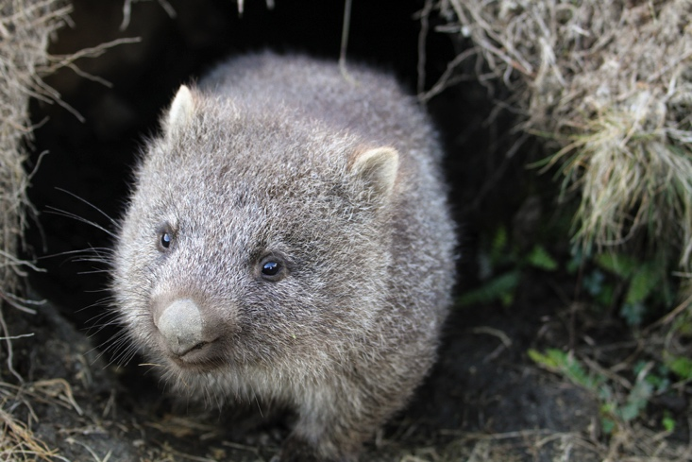

Text Types

Factual  Factual texts give information and details about real people, things and places. A factual text is not a story. | Story  A tale about made-up characters and places. | Information  A text that gives you facts and details about a particular subject. | Poetry  Poems have verses and often have rhymes in them. They sound a bit like songs. | Diary  A text written by someone recounting what they did on a particular day.
Fiction  Made-up stories. Fiction is the opposite of non-fiction. | Letter  Letters and emails are messages written by one person to another. They often start Dear..., and have an address and a date at the top of the page. | Instructions  Instructions tell you what to do. They use bossy language and list the things you need to do to achieve something. | Non-fiction  Non-fiction texts are the opposite of fiction texts. They give factual information about real things. | Biography  A biography is an account of a real person’s life.

Wombat Questions

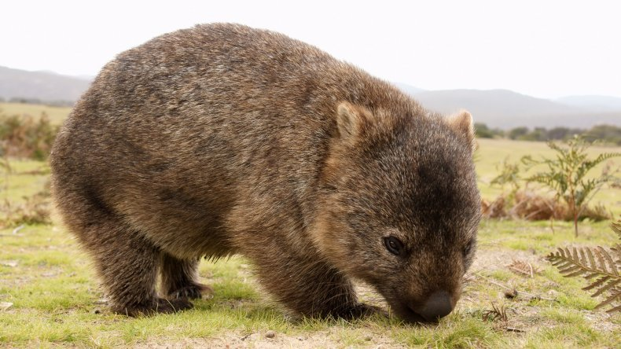

1. Wombats can grow to be 1 metre in length. How many kilograms (kg) can they weigh?

_____________________________________________________________

2. What do wombats do to stop their incisor teeth growing too long?

_____________________________________________________________

3. The text says that ‘Wombats excavate extensive systems of tunnels and chambers’ in the ground. Copy out the word in the sentence which means the same thing as dig.

_____________________________________________________________

4. True or false? ‘Marsupials have pouches that their young grow and feed in.’ Circle either true or false.

5. True or false? ‘Wombats eat frogs, mice and big insects.’ Circle either true or false.

6. In your own words, say why the opening of a wombat’s pouch faces away from its front paws.

____________________________________________________________________________________________________________________________

7. Why is a wombat’s poo cube shaped?
____________________________________________________________________________________________________________________________

8. For what reason do wombats sometimes dive into their burrows and block the entrance with their sturdy rumps?

____________________________________________________________________________________________________________________________

9. Write a caption to go with this picture:

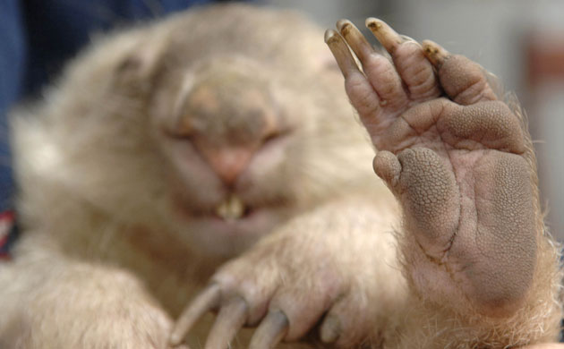

____________________________________________________________________________________________________________________________

Text Types – What is Wombats? ANSWERS

Factual  Factual texts give information and details about real people, things and places. A factual text is not a story. | Story  A tale about made-up characters and places. | Information  A text that gives you facts and details about a particular subject. | Poetry  Poems have verses and often have rhymes in them. They sound a bit like songs. | Diary  A text written by someone recounting what they did on a particular day.
Fiction  Made-up stories. Fiction is the opposite of non-fiction. | Letter  Letters and emails are messages written by one person to another. They often start Dear..., and have an address and a date at the top of the page. | Instructions  Instructions tell you what to do. They use bossy language and list the things you need to do to achieve something. | Non-fiction  Non-fiction texts are the opposite of fiction texts. They give factual information about real things. | Biography  A biography is an account of a real person’s life.

Answers to wombat questions
1. Wombats can grow to be 1 metre in length. How many kilograms (kg) can they weigh? They can weigh up to 30 kilograms.

2. What do wombats do to stop their incisor teeth growing too long? They gnaw on bark and tough vegetation.

3. The text says that ‘Wombats excavate extensive systems of tunnels and chambers’ in the ground. Copy out the word in the sentence which means the same thing as dig. Excavate

4. True or false? ‘Marsupials have pouches that their young grow and feed in.’ It’s true.

5. True or false? ‘Wombats eat frogs, mice and big insects.’ It’s false.

6. In your own words, say why the opening of a wombat’s pouch faces away from its front paws. The wombat’s pouch faces away from its front paws so that, when it is digging, the mud does not get sprayed into the pouch.

7. Why is a wombat’s poo cube shaped? The wombat uses its poo to mark its territory and the cube shape stops the poo rolling away.
8. For what reason do wombats sometimes dive into their burrows and block the entrance with their sturdy rumps?
Wombats dive into their burrows when they feel threatened. The wombat’s bottom is strong so that it stops predators from being able to get into the burrow and attack the wombat or its babies.

