What to do today
IMPORTANT! Parent or Carer – Read this page with your child and check that you are happy with what they have to do and with any weblinks or use of the Internet required.

1. Story time
Go back to https://www.youtube.com/watch?v=hNdKEz6p9Qg&t=2s and watch Super Daisy for the last time.
- Pause the story at 2:58, Super daisy is smarter than a space alien from Planet Brainbox.
- Who says, ‘How many ps in Planet Pea?’ Daisy does.
- What is the alien’s answer? We know who says what because of the speech bubbles.

2. Comic story writing
You are going to draw and write your comic today on a comic page.
- First create your very own comic page using Making a Simple Comic Page.
- Then follow the instructions in Writing your own comic story to create a fantastic adventure of your own.

3. Reading aloud
Show off your finished comic to your family. Read it aloud to them. Say the speech bubbles with a different voice for each speaker.
- How would each one speak – bravely, crossly, cheerfully?

Now try this Fun-Time Extra
- Copy and send your comic strip to relatives by post or email. You can write a message to go with your comic, explaining what you did.

Writing your own comic story

You are going to draw and write your comic today on a Comic Page.

Look at the instructions on Making a Simple Comic Page below and follow them to create your very own Comic Page.

Now you can get writing…

- In the first empty panel, draw your superhero and your planet from Part 1 of your planner.

- Add a speech bubble and write what the superhero is saying.

- Use your best handwriting and word spacing. Remember to start your sentence with a capital letter and end it with a full stop.

- Now do the same thing for the next two panels – one for each part of the remaining sections on your planner.

- Use the empty panel to make up your own ending. Maybe you can have Mum saying, ‘Suppertime, everyone! It’s [whatever your vegetable is]!’ and the children groaning, ‘Oh, no!’
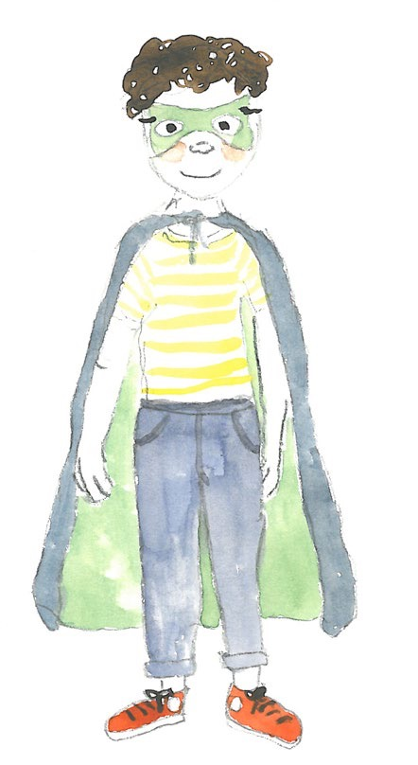

Making a Simple Comic Page

- Find a nice large piece of square or rectangular paper. A big piece of paper is important, as smaller pieces don’t allow enough space for drawings or writing in speech bubbles.

- Fold the paper in half and then in half again.

- Unfold the paper so that the creases make four panels or sections.

- You can use a marker pen to go round the edges of each panel so that they stand out clearly.

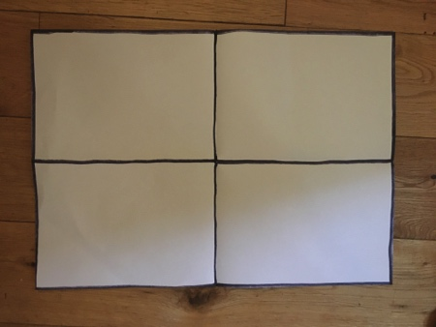

- If you want you can add text boxes in the top left hand corner of each panel for children to write in scene-setting story explanations. It was morning in Super Daisy’s house...

