What to do today
IMPORTANT! Parent or Carer – Read this page with your child and check that you are happy with what they have to do and with any weblinks or use of the Internet required.

1. Story time
Re-open https://www.youtube.com/watch?v=hNdKEz6p9Qg&t=2s and listen again to Super Daisy and the Peril of Planet Pea.

2. Spelling
Draw and write the names of six vegetables you know on My Vegetables.
- Put a star next to one vegetable that you really don’t like!
- Write a sentence at the bottom of the page explaining which is your favourite vegetable.

3. Story planning
Tomorrow you are going to draw and write your own short Super Daisy comic. Today you will plan your comic.
- Use the Planning to write a comic sheet below and follow the instructions.
- Now use the special Planner and complete it.

Now try this Fun-Time Extra
- On Ugghh – Gross!, write down some nasty menu combinations for your story vegetable: hot chocolate with cabbage; cabbage in ice cream; cabbage flapjacks, etc.
- Draw one of these not very nice foods!
My Vegetables

___________________________________________________________________________________________
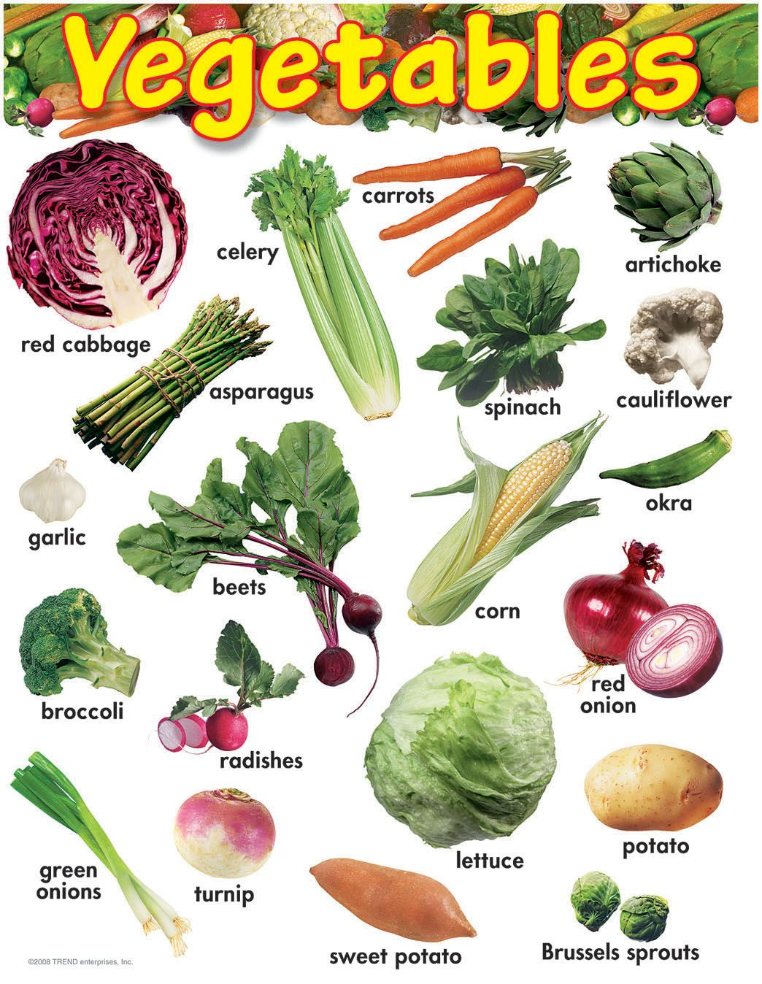

Planning to write a comic!

Tomorrow you are going to draw and write your own short Super Daisy comic.

Today you will plan your comic.

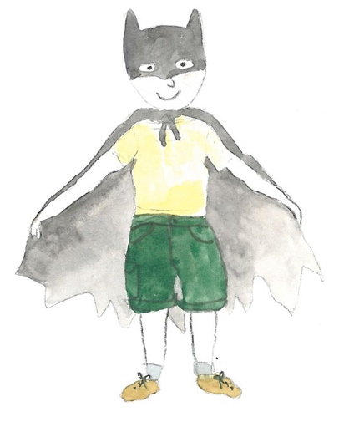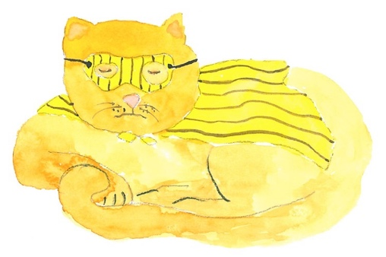

- On the Planner, write down your super character’s name and the name of the vegetable planet that is threatening the Earth, e.g. Planet Cabbage.

- What does your superhero say? Oh no! Planet Cabbage is zooming towards Earth!

- Decide what two things your superhero uses to fight the vegetables. What does your super character say? I’m going to use my super strength and my super bin to defeat Planet Cabbage.

- Decide what your super character says to the veggie planet and what the veggie planet says back. Got you, Planet Cabbage! / Oh no, my plans are ruined!

My Comic Planner

1. My superhero’s name is:  _____________________________  My Vegetable Planet’s name is:  _____________________________  This is what the superhero says to their friends when they see the Planet:  ____________________________  ____________________________  ____________________________  ____________________________  ____________________________  ____________________________  ____________________________ | 2. The weapons or skills my superhero uses to fight the Vegetable Planet are:  1. __________________________  2. __________________________  The superhero says to the planet:  ____________________________  ____________________________  ____________________________  ____________________________  The planet replies:  ____________________________  ____________________________  ____________________________  ____________________________  ____________________________ | 3. This is how my superhero defeats the planet:  ____________________________  ____________________________  ____________________________  ____________________________  ____________________________  My superhero says:  ____________________________  ____________________________  ____________________________  ____________________________  The planet says:  ____________________________  ____________________________  ____________________________  ____________________________

Ugghh - Gross!

