What to do today
IMPORTANT! Parent or Carer – Read this page with your child and check that you are happy with what they have to do and with any weblinks or use of the Internet required.

1. Story time
Read and enjoy the Hamilton Group Reader, Superheroes – All Sorts by Ruth Merttens and Anne Holm Petersen.

2. Looking at opposites
Look for pairs of words in Superheroes – All Sorts that are opposites.
- Look at the words in the two columns at the top of Opposites.
- Read each word. Draw a line from a word in the left-hand column to its opposite in the right-hand column.
- Now read the words in the second table on Opposites.
- Write in an opposite word of your own for each of these words.
- Write a sentence contrasting your favourite opposites: A feather is light but an elephant is heavy.

3. Expressing your opinion
Look at the Pictures of the Town and Country Superheroes from the book.
- Which would you like to live in, the town or the country?
- Think of at least two reasons for your choice and write these on Town or Country?. Link your ideas with a conjunction.

Now try this Fun-Time Extra
- On Map, draw a “bird’s eye view” picture of your town, village, road or area, like those in the story.
- Add in a picture of yourself as a superhero.
- Label different things on your picture: The swimming pool; The shops I go to; My friend Ben’s house; Our closest park, etc.

Opposites

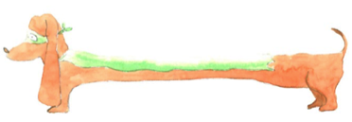 and 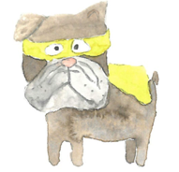

rough | tiny
light | full
huge | heavy
sad | laugh
empty | smooth
cry | happy

asleep
kind
strong
thin
loud

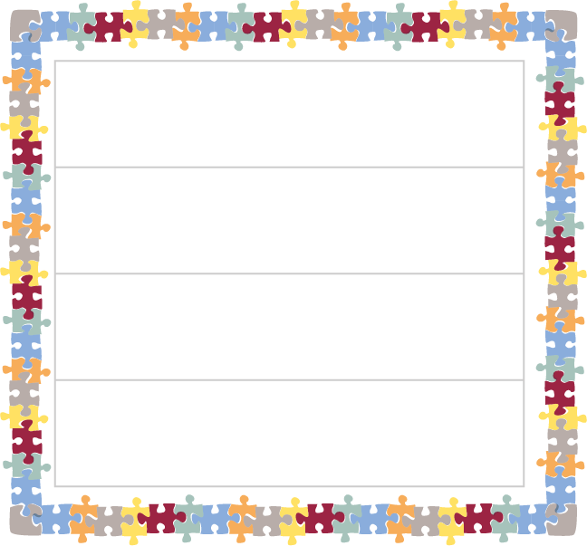

Town and Country Superheroes

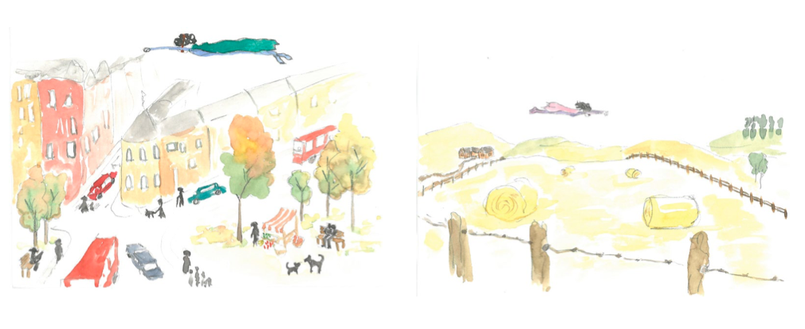

Town or Country?

- Would you prefer to live in the town or the country? Think of two reasons.
- Write a sentence to explain, linking your two ideas with a conjunction.
I would like to live in the country because it is muddier and there are lots of animals there.
- Write some more sentences explaining your opinion.

My Map of Where I Live

