What to do today
IMPORTANT! Parent or Carer – Read this page with your child and check that you are happy with what they have to do and with any weblinks or use of the Internet required.

1. Story time
Read the poem My Mother is a Superhero by Pie Corbett.
- Talk about any words you don’t understand.
- Can you suggest other words for these that mean the same thing?

2. Answer questions about what you’ve read
Look at the set of My Mother is a Superhero Questions.
- Carefully read each question in turn and give your answers.
- Take the first of today’s Superhero Challenges and write your answers out in your best handwriting in the spaces provided.

3. Write a poem similar to one you have read
Decide who in your family is a bit of a superhero!
- Follow the instructions to write your very own Superhero poem.
- Use the poem paper provided.
- Take the Superhero Challenge: can you write the same number of lines as in Pie Corbett’s poem? Well done if you can!

Now try this Fun-Time Extra
- On My superhero’s costume would be..., design a costume for your family superhero.
- Write some sentences about it: It has a mask so that they can...

My Mother is a Superhero!

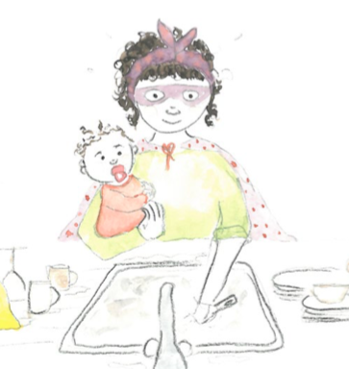

My mother is a superhero because she can –
clean a house at the snap of her fingers,
fly to the moon and back in the blink of an eye,
extinguish a fire with her icy breath,
see into the mind of a robber,
foretell any disaster,
avoid a collision with the power of thought,
turn back the snow and warm up icy paths,
rescue a drowning man without a second thought,
create joy where gloom has taken grip
and even halt a war before it has begun,
all without moving from the sofa.

Pie Corbett

My Mother is a Superhero Questions

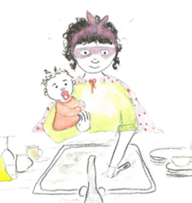

When the poem says that the mum can clean the house at the snap of her fingers, does that mean she can do it very quickly or very slowly?

_______________________________________________________________________

What can the mum do with her icy breath?

_______________________________________________________________________

What sort of disaster in the house do you think the mum could foretell?
(Foretell means knowing it was going to happen before it actually did.)

_______________________________________________________________________

If you could see into the mind of a robber what sort of thing might they be thinking of?

_______________________________________________________________________

Suggest another word that means the same thing as:

rescue __________________________
halt ____________________________

Which of all the mum’s superpowers sounds the best? Why do you think that?

______________________________________________________________

______________________________________________________________

_____________________________________________________________

My _____________________________ is a Superhero!

Follow these instructions to write your very own Superhero poem

- On the poem paper below, fill in the title with their name, e.g. brother: My Brother Is a Superhero.

- Write the first line of your poem, spelling because correctly: My brother is a superhero because he...

- Write your poem, listing the reasons why your brother is a hero: ...makes pizza/ reads to me at night/ is amazing at football/ can blow big bubble gum bubbles/ helps Mum in the garden.

- In at least one of your lines, use the word and to join two ideas together: makes amazing pizzas and reads to me at night.

- Take the Superhero Challenge: can you write the same number of lines as in Pie Corbett’s poem? Well done if you can!
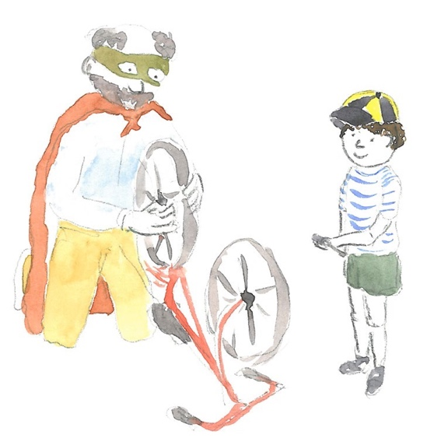

My _____________________________ is a Superhero!

My superhero’s costume would be...

