What to do today
IMPORTANT! Parent or Carer – Read this page with your child and check that you are happy with what they have to do and with any weblinks or use of the Internet required.

1. Story time
Go to https://www.youtube.com/watch?v=WDSeC-mOYaE and re-watch Superhero ABC for the last time.
- What letter does the Zinger start with? In America, where this book comes from, they call a zed a zee!

2. Reading dialogue
Go back to the page in Superhero ABC that features ‘Upside Down Man’.
- In a comic, how can you tell when someone is speaking and what they are saying? They use speech bubbles.
- What does the little boy say about Upside Down Man? What does the dog say?!

3. Writing dialogue
Today, you are going to write a conversation between your invented superhero and your invented super-villain.
- Use Superhero and Villain Dialogue and plan your dialogue.
- Carefully write your sentences. Write the villain’s words in the first speech bubble and the superhero’s words in the second.

Now try these Fun-Time Extras
- Cut out your speech bubbles and glue them above your superhero and super-villain pictures.
- Write a story in a Mini-Book about a contest between your superhero and super-villain. Add drawings to your story.

Superhero and Villain Dialogue

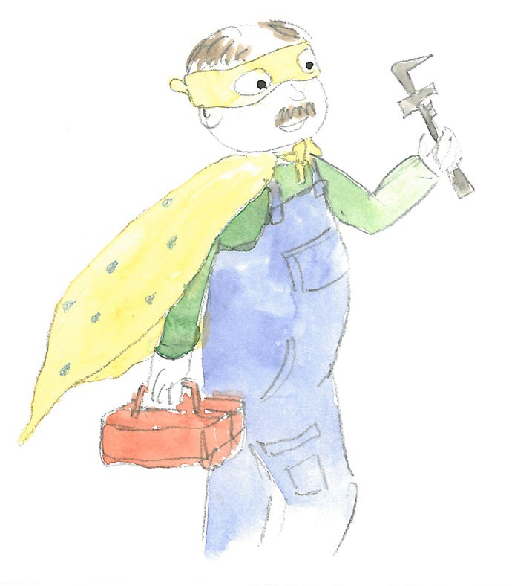

Today, you are going to write a conversation between your invented superhero and your invented super-villain.

- What could your superhero say? I’ve got you! You’ll never succeed while I am around!

- Carefully write your sentence in a speech bubble.

- Now do the same thing for your super-villain. Bah! Foiled again by a pesky superhero and their clever tricks.

- Remember to use good word spaces and capital letters. You might want to use an exclamation mark instead of a full stop!

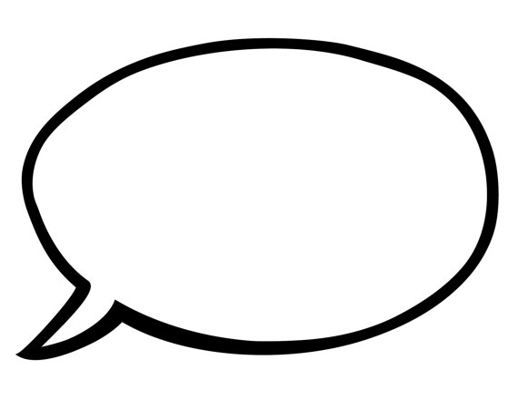

How to Make a Mini Book

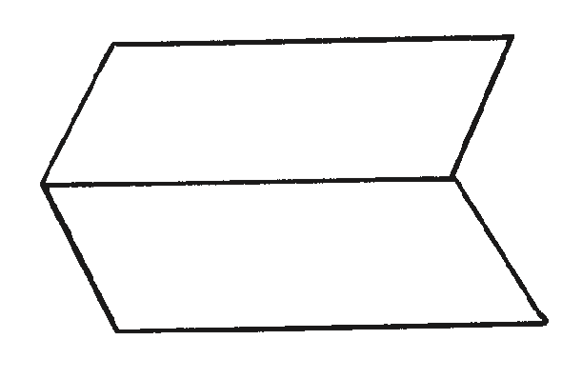
- Fold a sheet of paper in half lengthways and then unfold it.

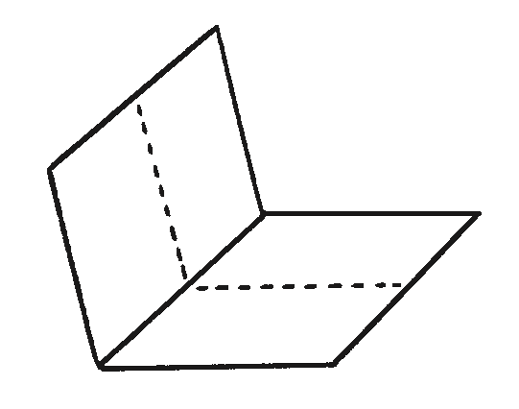
- Fold the same sheet of paper in half widthways and leave it folded.

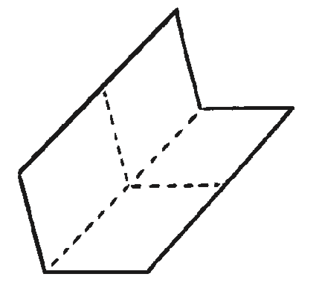
- Fold it in half again in the same direction and then unfold the last fold.

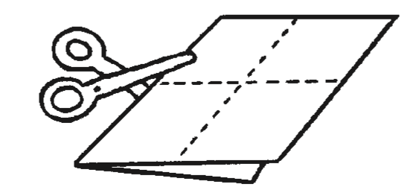
- Cut along the centre crease until you reach the middle of the piece of paper.

- Unfold the paper completely. There should be a slit through the middle of the paper. Fold the paper in half lengthways again and then push the two ends inwards towards each other to create a star shape with four arms.
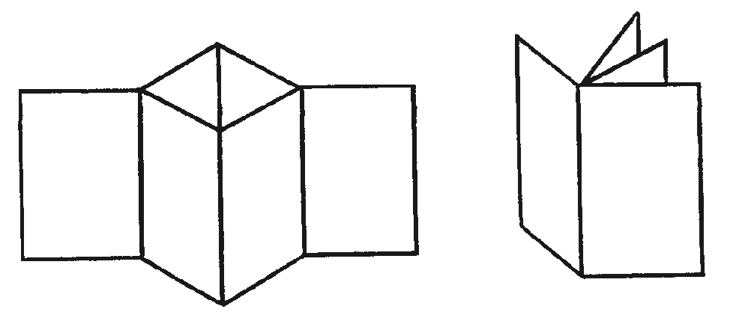

The four arms are the pages of the book. Fold all of the arms around to face the same direction and the book is complete.

