What to do today
IMPORTANT! Parent or Carer – Read this page with your child and check that you are happy with what they have to do and with any weblinks or use of the Internet required.

1. It’s story time
Go to https://www.youtube.com/watch?v=WDSeC-mOYaE.
- Listen to the Superhero ABC, written by Bob Macleod.
- Which is your favourite of the superheroes? Why did you like them?

2. Spelling ‘doing’ words
Go back to the pages of the Superhero ABC showing Bubble Man and Captain Cloud.
- What does Bubble Man do? He blows bubbles at bullies. We can say his special skill is blowing bubbles.
- What does Captain Cloud do? He calmly catches crooks. We can say he is good at catching crooks.
- Read the information on How to Spell ‘-ing’ Verbs. Then complete the exercise Turning each of these action words into -ing words.

3. Inventing a superhero
Today, you are going to create your own superhero!
- Read Superhero Suggestions and look at Creating my own Superhero.
- Then carefully fill in all the boxes on your Superhero ID Form to capture all your fantastic ideas.

Now try this Fun-Time Extra
- Draw or paint your superhero. Write their name out carefully underneath.

How to Spell ‘-ing’ Verbs

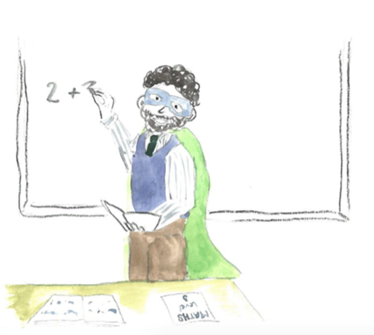
For most verbs, if you want to write them in their ‘doing’ form, you just add ing.

catch catching
jump jumping
climb climbing

With verbs that end with a vowel then a consonant you usually double the consonant before you add the ing.

run running
drop dropping
hit hitting

Often with verbs that end in e you drop the e before you add the ing

make making
like liking

Turn each of these action words into -ing words

The first one is done for you.

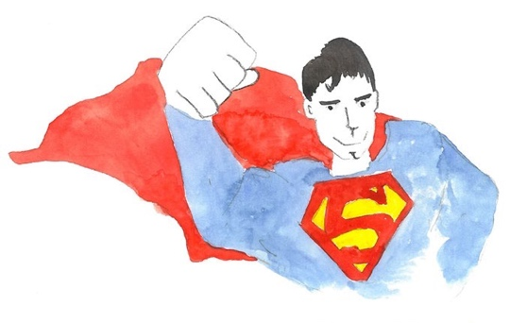 | This superhero flies | His superpower is  flying
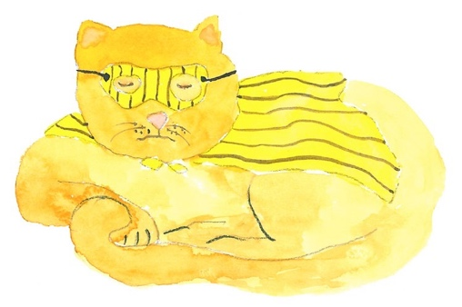 | This superhero purrs | Her superpower is
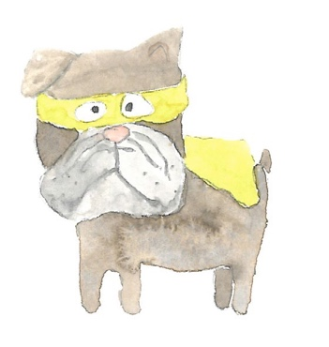 | This superhero hides | His superpower is
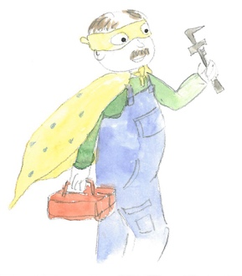 | This superhero fixes things | His superpower is
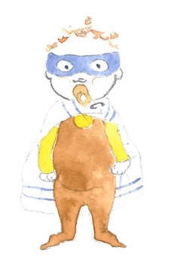 | This superhero cries loudly | Her superpower is

Superhero Suggestions

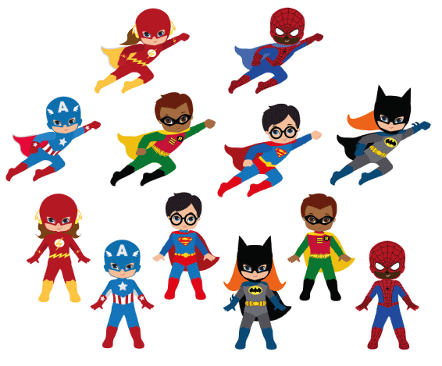

Bottom half, left to right: The Flash, Captain America, Superman, Cat Girl, Robin, Spider Man

Creating my own Superhero – here’s how!

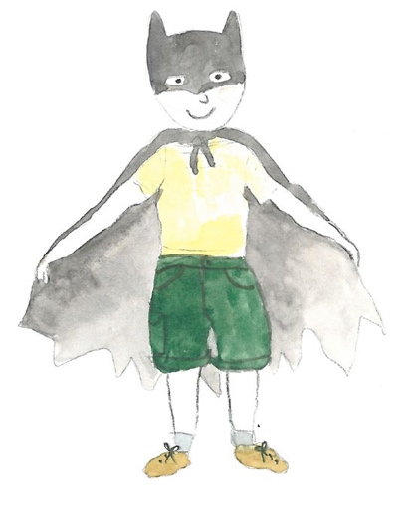

Today, you are going to create your own superhero!

- Your superhero could be like one of those you have seen in the Superhero ABC.

- They could be like the famous superheroes from Superhero Suggestions or any other superhero you have read about or seen in films, TV programmes or comics.

- Carefully fill in all the boxes on your Superhero ID Form to capture all your fantastic ideas.

- Use ‘doing’ verbs to say what your hero’s special powers, skills or abilities are.

Superhero ID Form

Name:
Costume and tools:
Origin. How they became a superhero:
Home or Base:

Special powers, skills or abilities:

