What to do today
IMPORTANT! Parent or Carer – Read this page with your child and check that you are happy with what they have to do and with any weblinks or use of the Internet required.

1. Story time
- Re-read Superheroes – All Sorts.

2. Answering questions about a story
Look at the page of Seven Super Questions.
- Read the first question carefully and say what you think the answer is.
- Now go on and answer the rest of the questions.
- Use the Superhero Reading Strategies to help you read any words that are new or tricky.
- If you are a superhero, write all or some of your answers using your very best handwriting.

3. Extending sentences with because
Of all the superheroes in Superheroes – All Sorts, which do you think is the best?
- On My All Sorts Top Star, draw the ‘best’ superhero from the story and write a sentence saying why you have chosen them.
- Use the word because to explain your choice. I think the plumber superhero is the best because he can stop floods and help people.
- Use Batman’s Guide to Spelling Because to help your spelling.
- Set yourself a super challenge: how many sentences about your best superhero from the story can you write?

Now try this Fun-Time Extra
- Go to https://www.youtube.com/watch?v=ntuqTuc6HxM Listen to the song, Search for the Hero. Learn the chorus to the song off by heart.

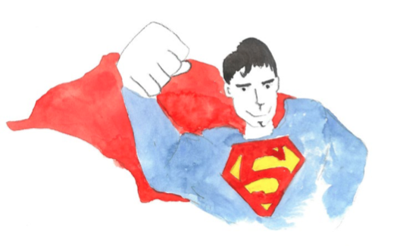
Seven Super Questions

1. Which superhero in the story wears a red skirt and has yellow legs?
____________________________________________________________

2. Which superhero is the opposite of the fat superhero?
____________________________________________________________

3. Write two other pairs of opposites used in the story.
____________________________ and ____________________________
____________________________ and ____________________________

4. Name two places where we are told that there are superheroes.

____________________________ and ____________________________

5. What is a plumber?

_____________________________________________________________

6. What does it mean when it says that superheroes ‘come in all shapes and sizes’?

____________________________________________________________

7. Look at the superhero who is described in the story as ‘short’. What
sort of ‘superheroic’ things might the short superhero get up to?

_____________________________________________________________
_____________________________________________________________
___________________________________________________
Superhero Reading Strategies

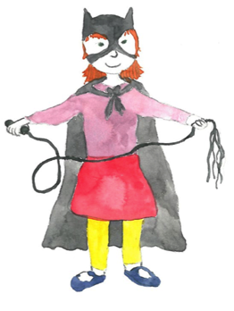

- Look at the pictures to help.

- Try to sound out the word using the sounds you know.

- Look at the beginning letters.

- Look at the ending of the word.

- Look for a smaller word within the word.

- Skip the word and read through to the end of the sentence.

- Try to have a guess at the word. Does your word make sense in the sentence?

- Use the other words around to get the context of the word.

- Go back and re-read the word and the sentence.

- Look the word up in a dictionary.

- Ask a friend or an adult for help.

My All Sorts Top Star

_____________________________________________

_______________________________________________________________________________________________________________________________________________________________________________________________________________________________________________________
Batman’s Guide to Spelling Because

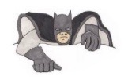
because

big elephants can always understand small elephants

Search for the Hero
by M People

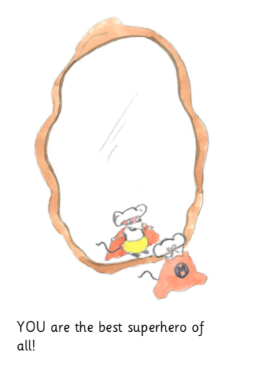

Chorus Lyrics

You’ve got to search for the hero inside yourself
Search for the secrets you hide
Search for the hero inside yourself
Until you find the key to your life!

This is a picture of Superhero Me!

