What to do today
IMPORTANT! Parent or Carer – Read this page with your child and check that you are happy with what they have to do and with any weblinks or use of the Internet required.

1. Story time
Read the Hamilton Group Reader Superheroes – All Sorts.
- The story says that ordinary people can be superheroes every bit as much as people like Batman or Superman.
- Do you know any everyday superheroes? What makes them a hero?
(You might like to think of some of the people who have been carrying on their jobs while most of us stay safe at home – NHS workers, Postal workers, Shop workers and so on.)

2. Picking a favourite superhero
Think about the famous superheroes you and people in your family know.
- Choose your favourite out of these. You can look at the pictures on Superhero Suggestions for more ideas.
- On My Favourite Superhero Is..., draw your chosen superhero.
- Carefully write out your superhero’s name, making sure you begin it with a capital letter.

3. Writing captions
Think of two things you really like about the superhero you have chosen.
- Underneath your picture write a sentence expressing your thoughts.
- Use the word and to join your two ideas. Batman is really brave and I like his cool utility belt. You could try using ‘but’….
- Use clear word spaces in your sentence.
- Don’t forget your capital letter and full stop.

Now try this Fun-Time Extra
- Have you ever been brave and courageous like a superhero? What did you do? Do a drawing of you being amazing and brave on When I was a Superhero. Add a sentence or two describing what you did.

My Favourite Superhero Is...

_____________________________________________

________________________________________________________________________________________________________________________________________________________________________________________________________________________________________________________

Superhero Suggestions

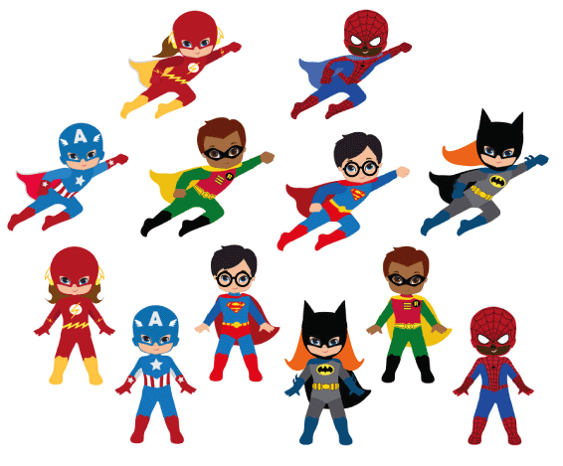

Bottom half, left to right: The Flash, Captain America, Superman, Cat Girl, Robin, Spider Man

When I was a Superhero

________________________________________________________________________________________________________________________________________________________________________________________________________________________________________________________

