**What to do**

**Reading**

*IMPORTANT Parent or Carer –*

*Please check that you are happy with any weblinks or use of the internet.*

Our focus today is reading.

**1. Read a rhyming book.**

Share and read together **Dogs eat frogs**. As they spot the rhyming pattern, give your child time to predict what the animals might eat, using the rhyme. *This is tricky but fun.*

**2. Respond to the story.**

* Discuss the book. Explore the question and answer pattern. Who is asking the questions? - *The cat.* Look back at the questions. Notice that the questions end with a question mark. Trace it with your fingers on the screen. Make a question mark in the air with your finger. *How can we show questions with our voices?*
* Ask your child to read some of the questions. You read the corresponding answer in the role of the different animals. What will happen when they question the wolf?!
* Discuss some of the answers. *Is this a fact book? Are the answers true?* *Do bears really eat chairs?* Agree that this is a funny book which uses rhyme to make up funny sentences (a bit like *Oi Dog* in the Speaking and Listening activity).
  + Say that the cat was very curious. *What other questions could he have asked?*
  + Talk about other animals that he could have asked a question about what they eat. Say the question sentences together using ‘question voices’.
  + Record some of the questions on *Questions for Animals* below. You can write for your child or you could write together. The focus is on thinking of questions rather than writing them. (You could ask all sorts of animal questions – follow your child’s interests.)

**Try these Fun-Time Extras**

* Find out what some animals really eat. Use books and websites, such as <https://www.bbc.co.uk/bitesize/topics/z6882hv/articles/z96vb9q>
* Play a rhyming matching game using the *Funny Pairs* cards below.

Questions for Animals

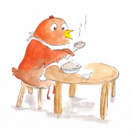

Funny Pairs

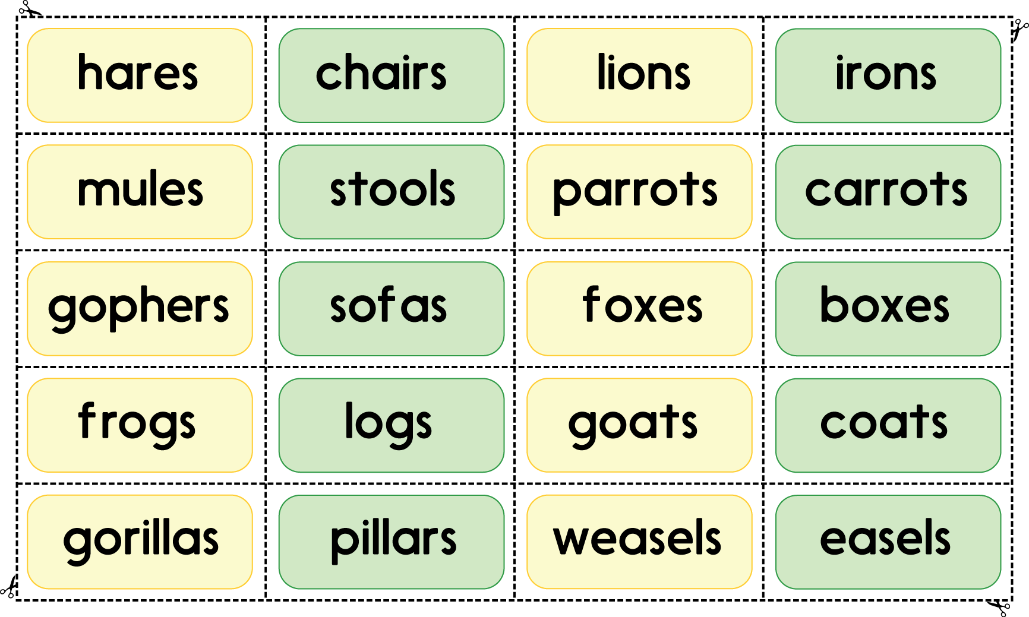

* Cut out each word.
* Read each word together. (Most can be sounded out but some you may need to read to your child.)
* Match pairs of rhyming words.