What to do
Listening & Speaking
IMPORTANT Parent or Carer –
Please check that you are happy with any weblinks or use of the internet.

Our focus today is speaking and listening – expressing ourselves in spoken language.

1. Listen to a story
Watch and listen and enjoy the story of Oi Frog, by Kes Gray and Jim Field being told in this storytelling video from Cbeebies Bedtime Stories: https://www.youtube.com/watch?v=oPDyXsSbxOY&t=88s (or you could read the story to your child if you have a copy at home).

2. Respond to the story

- Talk about the book. What is it about? What did the frog want to do? – Sit down. What was the cat doing? - Being very bossy, telling everyone the rules of where animals should sit. Did they notice a pattern? - All the rules rhyme!
- Say some of the rhyming lines (see below), leaving a pause to see if your child can join in, using rhyme to say the last word. They might use what they remember from the story which is great. If their word is different from the book, praise their imagination, and if it rhymes praise their excellent rhyming!
- Discuss ideas for funny things that someone should not sit on, e.g. a bowl of jelly, a pinecone, a cake. Discuss why these are silly places to sit and what would happen if you did. Together draw pictures of Silly Seats (see below). You could label them if you wish.

Try these Fun-Time Extras

- Take a soft toy around the home, giving ‘bossy cat’ instructions, e.g. Oi Bear, sit on the chair! Oi dinosaur, sit on the floor! - easy to rhyme toys are best, e.g. bear, cat, dog etc. You could also do this without rhyming, focusing on silly seats.
- Play rhyming games, based around ‘I Spy’, e.g. I spy with my little eye, something that rhymes with gopher. – Sofa.
- Listen to Kes Gray read some of his other ‘Oi…’ books https://www.youtube.com/channel/UCoOhtVZl1EUE-o3rFpBghNg .

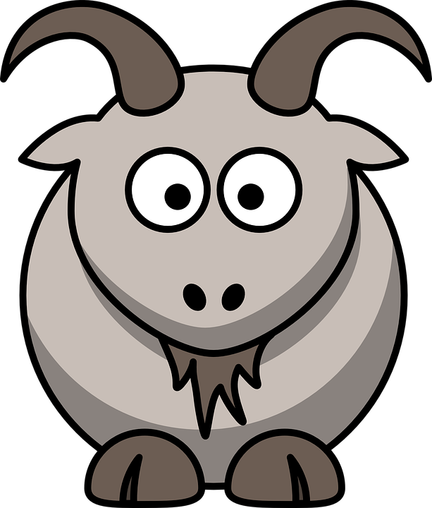
Rhyming Lines

Cats sit on…mats.
Hares sit on…chairs.
Mules sit on…stools.
Lions sit on…irons.
Parrots sit on…carrots.
Foxes sit on…boxes.
Goats sit on…coats.
Puffins sit on…muffins.
Snakes sit on...cakes.
Owls sit on…towels.
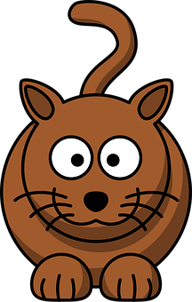

Silly Seats

