What to do
Listening & Speaking
IMPORTANT Parent or Carer –
Please check that you are happy with any weblinks or use of the internet.

Our focus today is speaking and listening – expressing ourselves in spoken language.

1. Listen to a story
Watch and listen to the story of Three Billy Goats Gruff being told in this storytelling video: https://www.youtube.com/watch?v=f4kdZTnizG4 (or you could read the story to your child if you have a copy at home).

2. Respond to the story

- Talk about the story. What happened in the story? How many goats were there? Why did the goats want to cross the bridge? What did the troll say each time the goat went on the bridge? Can we say it like the troll in grumpy troll voices? What order did the goats cross the bridge? What happened in the end?
- Together make Lolly Stick Puppets (see below) by printing, cutting out and sticking the characters below onto lolly sticks or straws with tape. If you do not have a printer, you could draw simple characters together. As you make the characters, discuss them. Which goat is this? Which is the biggest? What do you notice about his chin/horns? What sort of face does the troll have? What do you think he is feeling? Etc.
- Use the puppets to retell the story using character voices and saying the repeating phrases, ‘Who’s that trip-trapping over my bridge?’ ‘I’m going to eat you…’

Try these Fun-Time Extras

- Use household items to make sound effects for the story. Can you recreate the trip-trapping noise? Can you make a splash? Can you roar like a troll? Can you make crunching sounds as the goats eat the fresh green grass?
- Make paper plate masks to re-enact the story – see below for simple ideas. Listen to the story again, joining in with the repeating phrases in character.

Lolly Stick Puppets – Cut around the thick lines and then tape on a lolly stick.

Make a Goat or Troll Mask

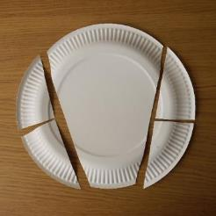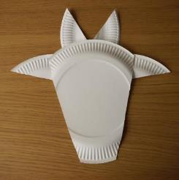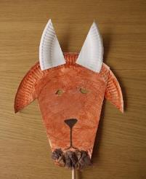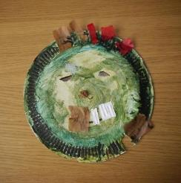
Resources:
Paper plate
Paint/coloured pens/pencils
Glue
Things to stick on, e.g. tissue paper, fabric, yarn, etc.

