What to do today
IMPORTANT Parent or Carer – Read this page with your child and check that you are happy with what they have to do and any weblinks or use of internet.

1. Read a poem
- Read Goldilocks and the Three Bears. Read the poem twice - once in your head and once out loud.
- Follow the words of the poem as you watch this animation:
https://www.youtube.com/watch?v=IxHn2v3dz5E
- Which part of the animation do you think is most effective? Why?

2. Practise expanding noun phrases to change perceptions
- Use the Revision Card to remind yourself about noun phrases.
- Complete Changing Perceptions. Complete pairs of sentences for 1-6. Challenge yourself to complete 7-14 as well.

Well done! Share your sentences with a grown-up. Show them how you have expanded noun-phrases and created different meanings.

3. Now for some writing
- Pick a fairy-tale you know well and think about how you could make up a changed version.
- Use words and pictures to show your changed version on Fairy Tale Planner.
- Write a version of your changed fairy-tale.

Try the Fun-Time Extra
- Watch this reading of another of Roald Dahl’s Revolting Rhymes:
https://www.youtube.com/watch?v=fbFMwH_CuJk
- Prepare, record and share your own reading of Goldilocks and the Three Bears.

Goldilocks and the Three Bears By Roald Dahl

This famous wicked little tale
Should never have been put on sale.
It is a mystery to me
Why loving parents cannot see
That this is actually a book
About a brazen little crook.
Had I the chance I wouldn’t fail
To clap young Goldilocks in jail.
Now just imagine how you’d feel
If you had cooked a lovely meal,
Delicious porridge, steaming hot,
Fresh coffee in the coffee-pot,
With maybe toast and marmalade,
The table beautifully laid,
One place for you and one for dad,
Another for your little lad.
Then dad cries, “Golly-gosh! Gee-whizz!
Oh cripes! How hot this porridge is!
Let’s take a walk along the street
Until it’s cool enough to eat.”
He adds, “An early morning stroll
Is good for people on the whole
It makes your appetite improve
It also helps your bowels to move.”
No proper wife would dare to question
Such a sensible suggestion,
Above all not at breakfast-time
When men are seldom at their prime.
No sooner are you down the road
Than Goldilocks, that little toad
That nosey thieving little louse,
Comes sneaking in your empty house.
She looks around. She quickly notes
Three bowls brimful of porridge oats.
And while still standing on her feet,
She grabs a spoon and starts to eat.
I say again, how would you feel
If you had made this lovely meal
And some delinquent little tot
Broke in and gobbled up the lot?
But wait! That’s not the worst of it!
Now comes the most distressing bit.
You are of course a houseproud wife,
And all your happy married life
You have collected lovely things
Like gilded cherubs wearing wings,
And furniture by Chippendale
Bought at some famous auction sale.
But your most special valued treasure,
The piece that gives you endless pleasure,
Is one small children’s dining-chair,
Elizabethan, very rare.
It is in fact your joy and pride,
Passed down to you on grandma’s side.
But Goldilocks, like many freaks,
Does not appreciate antiques.
She doesn’t care, she doesn’t mind,
And now she plonks her fat behind
Upon this dainty precious chair,
And crunch! It bursts beyond repair.
A nice girl would at once exclaim,
“Oh dear! Oh heavens! What a shame!”

Not Goldie. She begins to swear.
She bellows, “What a lousy chair!”
And uses one disgusting word
That luckily you’ve never heard.
(I dare not write it, even hint it.
Nobody would ever print it.)
You’d think by now this little skunk
Would have the sense to do a bunk.
But no. I very much regret
She hasn’t nearly finished yet.
Deciding she would like a rest,
She says, “Let’s see which bed is best.”
Upstairs she goes and tries all three.
(Here comes the next catastrophe.)
Most educated people choose
To rid themselves of socks and shoes
Before they clamber into bed.
But Goldie didn’t give a shred.
Her filthy shoes were thick with grime,
And mud and mush and slush and slime.

Worse still, upon the heel of one
Was something that a dog had done.
I say once more, what would you think
If all this horrid dirt and stink
Was smeared upon your eiderdown
By this revolting little clown?
(The famous story has no clues
to show the girl removed her shoes.)
Oh what a tale of crime on crime!
Let’s check it for a second time.
Crime One, the prosecution’s case:
She breaks and enters someone’s place.

Crime Two, the prosecutor notes:
She steals a bowl of porridge oats.
Crime Three, she breaks a precious chair
Belonging to the baby Bear.
Crime Four, she smears each spotless sheet
With filthy messes from her feet.

A judge would say without a blink,
“Ten years hard labour in the clink!”
but in the book, as you will see,
the little beast gets off scot-free,
while tiny children near and far
shout, “Goody-good! Hooray! Hurrah!”
“Poor darling Goldilocks!” they say,
“Thank goodness that she got away!”
Myself I think I’d rather send
Young Goldie to a sticky end.
“Oh daddy!” cried the Baby Bear,
“My porridge gone! It isn’t fair!”
“Then go upstairs,” the Big Bear said,
“Your porridge is upon the bed.
But as it’s inside mademoiselle,
You’ll have to eat her up as well.
Revision Card – Noun Phrases
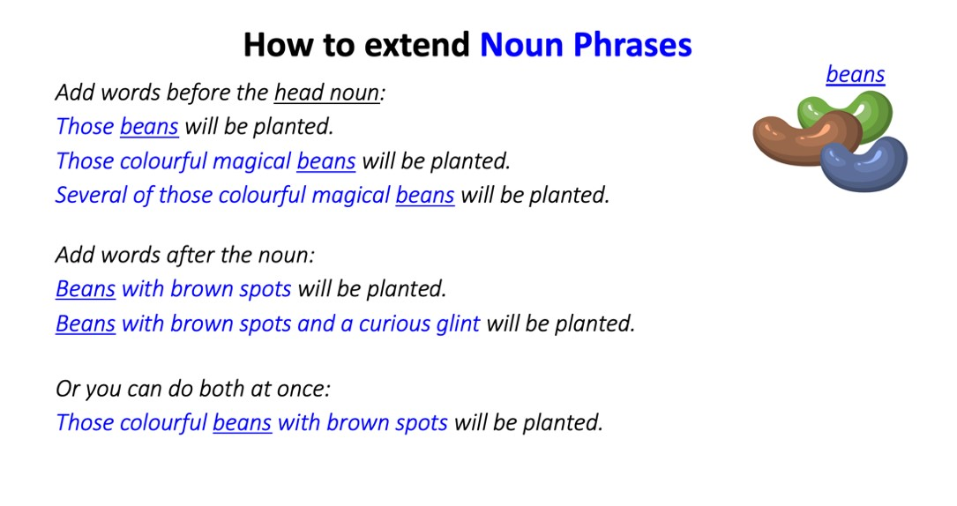
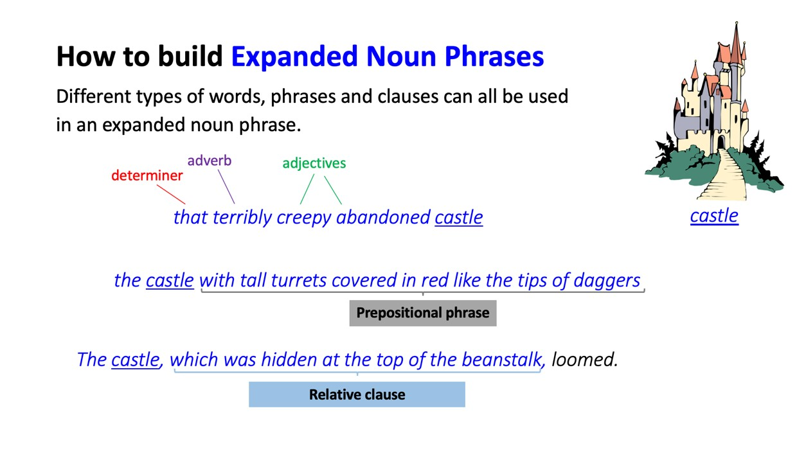

Changing Perceptions

Write two new versions for each of these sentences with expanded noun phrases.
Make opposite images with your pair of noun phrases.
The first has been done for you.

- The children ran to the cottage.

The cruel children with axes and hammers, who had already smashed up three homes in the wood, ran to the cottage.
The terrified children with no-one left to help them, ran to the cottage.

- Cinderella mopped the floor.
- The prince rode his steed.
- The boy laughed.
- Rapunzel called down from the tower.
- The witch hid in the bushes.
- The wolf lay under the covers.
- The giant shouted.
- The princess sang.
- The Queen gave Snow White an apple.
- The woodcutter raised his axe.
- The King sat in the throne.
- The pigs skipped down the lane.
- The baby slept peacefully.
Fairy Tale Planner

1. Introduce the setting and characters – how are these changed from the original? | 2. Think about how the story starts | 3. How does the plot develop
4. What is the climax of the story? | 5. How does the problem resolve itself? | 6. What happens in the end?

Changed Fairy Tale

Write your changed fairy-tale here.

