What to do today
IMPORTANT Parent or Carer – Read this page with your child and check that you are happy with what they have to do and any weblinks or use of internet.

1. Read the end of the story
- Read Ending and then read Ending Questions. Think about your answers and then write them as clear sentences.

2. Write a letter
- Use Letter Planner to plan a letter to send to Eric (imagine you are the narrator of the story).
- Write your letter carefully.

Well done! Share your writing with a grown-up. Explain why you thought of these particular questions.

3. Practise reading the story
- Practise reading the story out loud. Decide the pace that you will read and the expression that you will use. Find the text for the story here:
https://www.theguardian.com/books/gallery/2009/may/13/shaun-tan-eric-story-pictures
- When you are ready, read the story to somebody else or make a recording of yourself and send it someone.

Try the Fun-Time Extras
- Watch this animation of Eric’s story.
https://www.youtube.com/watch?v=S3x3Zn-qKSQ
- Could you try to make your own version of the story? You could use photographs or you could create an animation.

Ending

Nevertheless, none of us could help but be bewildered by the way Eric left our home: a sudden departure early one morning, with little more than a wave and a polite goodbye.

It actually took us a while to realise he wasn’t coming back.

There was much speculation over dinner later that evening. Did Eric seem upset? Did he enjoy his stay? Would we ever hear from him again? An uncomfortable feeling hung in the air, like something unfinished, unresolved. It bothered us for hours, at least until one of us discovered what was in the pantry.

Go and see for yourself: it’s still there after all these years, thriving in the darkness. It’s the first thing we show any new visitors to our house. ‘Look what our foreign exchange student left for us,’ we tell them.

‘It must be a cultural thing,’ says Mum.

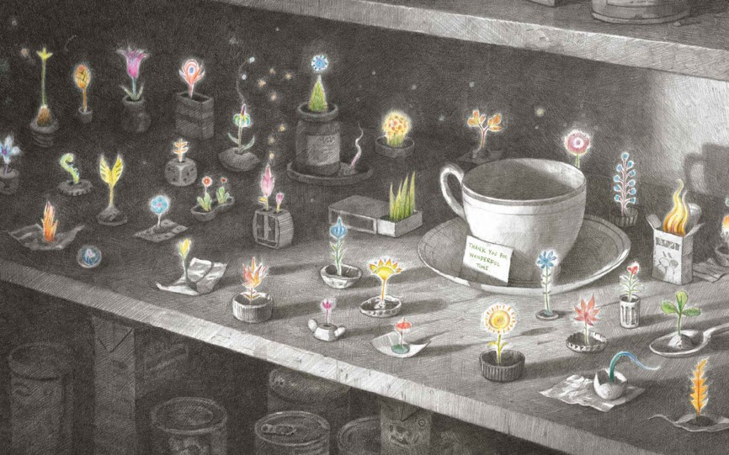
From Eric by Shaun Tan
Ending Questions

- Why do you think the family bewildered?
- Why do you think that Eric chose to leave that way?
- Have you ever had the feeling of something ‘unfinished’. When?
- How do you think the family felt when they saw the pantry?
- Where do you think Eric has gone?

Letter Planner

Think of 3-5 points for each section

What might you want to tell Eric?

What might you want to ask Eric?

What hopes might you have for Eric?
Letter to Eric

