What to do today
IMPORTANT Parent or Carer – Read this page with your child and check that you are happy with what they have to do and any weblinks or use of internet.

1. Read an explanation
- Read Maillard Reaction Explanation
- What do you think is the most important information here to help someone understand the Maillard Reaction?
- Read Explanation Features. Highlight and annotate Maillard Reaction Explanation to show any of these features.

2. Read more explanations and answer questions.
- Choose a Question Set to work with. Question Set 1 is easiest, Question Set 2 is in the middle and Question Set 3 is hardest.
- Complete the Question Set that you have chosen by reading the explanations that it tells you to read and answering the questions in clear sentences.

3. Watch and compare two videos
- Watch these two video explanations of the Maillard Reaction.
https://www.youtube.com/watch?v=c7WI41huAok
https://www.youtube.com/watch?v=kwW8YBC5SKc
- Which of these is the best explanation in your opinion?
- Use Video Comparison to make notes about the good and less good features of each of these videos.

Try the Fun-Time Extra
- Can you try explaining the Maillard Reaction to somebody else? Are they able to understand? Do they ask any questions that you are not sure about? How could you test whether they have understood?

Maillard Reaction Explanation

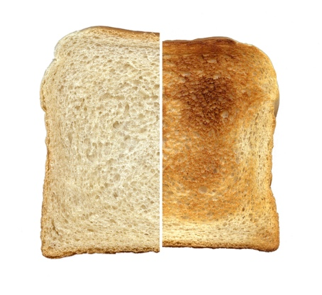

The Maillard Reaction is a chemical reaction that happens to some food when it is heated.

It happens when the food reaches a temperature between 140°C and 165°C. (Normal room temperature is about 18°C)

When the food reaches this temperature, two types of chemical that are in the food react with one another. The two types are carbohydrate molecules (a sugar wrapped up in a starch) and amino acids.

These two chemicals form an unstable structure which undergoes further changes. This produces hundreds of different by-products. These result in hundreds of different aromas and flavours.

The reaction is named after the French scientist, Louis-Camille Maillard who first discovered it in 1912.

The Maillard Reaction is the reason that toast, biscuits and cooked meat have a different flavour and appearance when they have been cooked.
Explanation Features

Purpose – tells why or how something happens

Range – Non-fiction book or article, encyclopaedia entry, write-up of a science experiment, technical manual.

- Title telling what needs to be explained
- Introduction (often making a link to the reader)
- Clear layout (e.g. sections or paragraphs)
- Bullet points or sub-headings
- Diagrams and illustrations
- Technical vocabulary (often with definitions)
- Present-tense verbs
- Causal language (e.g. because; ‘if…then…’; the reason that; when; so; this results in; this causes; therefore)
- Passive verbs
- Formal connectives (e.g. however, therefore, consequently)
- Usually formal register
- Closing sentence to round off the explanation

Questions Set 1

Read ‘The Science of Browning, Flavouring and Aroma 1’

- Which four foods does the writer give as examples for browning?

- Which adjectives does she put with browning and with fragrances in the first sentence?

- What effect do you think she is trying to make with these adjectives?

- What does she promise the reader in the last sentence of the first paragraph?

- Why do you think she says this?

- What sub-heading does the writer use?

- Why do you think she has put the first sentence after the sub-heading in italics?

- Which words are put in bold in this explanation?

- Why do you think they are in bold?

Questions Set 2

Read ‘The Science of Browning, Flavouring and Aroma 1 and 2’

- What descriptive language does the writer use in the first paragraph?

- What is the effect of this language?

- What does the writer promise the reader in the last sentence of the first paragraph?

- How successful do you think she has been with this promise?

- What sub-headings does the writer use?

- Why do you think she has put the first sentence after each subheading in italics?

- Which words are put in bold in this explanation?

- Why do you think they are in bold?

- What examples of causal language can you find in this explanation?

- What would you say about the formality of this piece of writing? Can you find examples of formal and informal vocabulary?

- Which part of this explanation do you think needs most improvement? What would you do to improve it?

Questions Set 3

Read The Science of Browning, Flavouring and Aroma 1 and 2 AND Compound Chemistry Text and Graphic

- Compare the two introductions.
What can you find that is similar between them? What is different? Which do you think is the most effective? Why?

- Compound Chemistry does not have subheadings, whereas The Science of Browning does.
What difference does this make?
What sub-headings could be used in Compound Chemistry?

- Find examples of technical vocabulary in each of the articles
Make a two-column table to compare this vocabulary. What do you notice? Why do you think there is a difference?

- Find examples of causal language from each of the articles.
Are any examples used by both articles?

- What extra information is given by the Graphic?
List some of this information.
How does the graphic help you understand this information?

- Summarise the difference between these two explanations.
Would you say that one is more effective than the other? Why?

The Science of Browning, Flavouring and Aroma 1
The reason behind mouth-watering crispy brown food
If you have tried pan-frying chicken or fish for dinner, you must have noticed the beautiful browning on the exterior and the mouth-watering fragrances. This browning process can be seen in many different types of food, ranging from seared meat, pan-fried fish, roasted coffee and toasted marshmallows. Each of these foods have a distinct browning and a flavour which is the result of a special chemical reaction named Maillard Reaction. Let’s check out the science of browning, flavouring and aroma, without going deep in to the complex processes and jargon.
What is the Maillard Reaction?

Maillard reaction is the chemical reaction which occurs between amino acids and reducing sugars in the presence of heat that results in the browning of food while forming new aromas and flavours.
Amino acids are the building blocks of proteins which can be found in our food. Reducing sugars are sugars which can act as reducing agents in biochemical processes.
Amino acids and reducing sugars found in food are rearranged in rings and groups of rings so that they reflect light in such a way that it gives the food the signature brown colour as well as tons of rich flavours.
The Maillard reaction is named after French chemist Louis-Camille Maillard, who first described it in the year 1912.
The Science of Browning, Flavouring and Aroma 2

The Flavour Reaction
The most interesting fact about the Maillard reaction is not the browning, but the aromas and flavours formed during the chemical process.
Although it is sometimes called the browning reaction, it is also called the flavour reaction as well. The molecules formed during this reaction are responsible for the characteristic aromas which can be smelt during frying, roasting, searing and baking. This process becomes complex when you leave the pan on the heat for long. Proteins and sugars continue to react and form various, more complex molecules.
The Maillard reaction occurs in almost every food we cook. However, the aromas and flavours formed vary from food to food. Different sugars and proteins produce different aromas and flavours, depending on how you cook. This is why a poached egg will not taste the same as a fried egg. This is why you will not get the smell of frying meat in a pan, when boiling meat in a pot.

Temperature, Moisture and Time
Temperature, moisture and time are the key factors to get the Millard reaction started.
High temperature speeds up the Maillard reaction as it increases the rate of the chemical reaction and speeds up evaporation of water in the food. As food dries, the sugars and proteins become more concentrated, speeding up the reaction. However, make sure your cooking temperature does not go beyond 180 °C / 355 °F. Going above this temperature will result in a different reaction named pyrolysis, which is commonly known as burning! People do like their food a bit charred, but too much charring and burning will result in bitterness, which is not that appealing to your taste buds.
If your food is wet, it will not reach a temperature above the boiling point of water. At atmospheric pressure, only high-heat cooking techniques can dry out the food enough to raise the temperature sufficiently.
However, you can make the process happen at a lower temperature, with a lot more water. If you cook chicken or beef in vegetable stock for eight or 12 hours, the result will be a brown, aromatic liquid.

Proteins and Sugars
If there were no proteins or sugars, there would not be any Maillard Reaction.
Proteins and sugars are crucial for the Maillard reaction to occur. Some proteins are Maillard-susceptible. They love to react with sugars, but not all types of sugar. Complex sugars like starches and normal table sugar have large molecules and will not react with Maillard-susceptible proteins. Instead, simple sugars called reducing sugars can attract amino acids and react with them at certain temperature and moisture levels to start the Maillard reaction.
by Vijini Mallawaarachchi
https://medium.com/@vijinimallawaarachchi/maillard-reaction-the-science-of-browning-flavoring-and-aroma-1605133960ae

Compound Chemistry – Text

There’s one chemical reaction that, whether you have an interest in chemistry or not, we all carry out on a regular, maybe even daily, basis. That reaction? The Maillard Reaction. This is a process that takes place whenever you cook a range of foods – it’s responsible for the flavours in cooked meat, fried onions, roasted coffee, and toasted bread. The reaction’s name is a little deceptive, because it’s really an umbrella term for a number of reactions that can produce a complex range of products. The main stages, and some of the different classes of products, are summarised in the graphic below.
The Maillard reaction takes its name from French chemist Louis-Camille Maillard, who originally described the reaction between amino acids and sugars in 1912. His study did not offer much in the way of analysis on the reaction’s impact on flavour and aroma in cooking, however; it was not until the 1950s that its mechanisms and culinary contributions would become more clearly understood.
In 1973, American chemist John E Hodge published a mechanism for the different steps of the reaction, categorising its stages and identifying a range of the different products produced as a result of these. He identified the first stage as being the reaction between the sugar and the amino acid; this produced a glycosylamine compound, which in the second step is rearranged to produce a ketosamine. The final stage consists of this compound reacting in a number of ways to produce several different compounds, which can themselves react to produce further products.
Melanoidins are one of the potential end products. These are long, polymeric compounds, which act as brown pigments, giving the cooked food its brown colouration. The Maillard reaction is referred to as a non-enzymatic browning reaction, as these melanoidins are produced without the aid of enzymes; this differs from enzymatic browning, which is what turns fruits such as avocados brown.
Hundreds of other organic compounds are formed. A subset of these can contribute to the food’s flavour and aroma, and some of the different families of these compounds are detailed in the graphic. As a consequence of the complexity of the Maillard reaction, different amounts of different compounds can be formed in different foodstuffs, giving the wide variety of potential flavours. Cooking conditions can also influence the flavours produced; temperature and pH, amongst other factors, can have an influence.
Due to its complexity, there’s still plenty we don’t know about the Maillard reaction. Whilst we know that factors such as pH and temperature can affect the course of the reaction, we still know little about how to adjust these to specifically influence the final products. As we learn more about it, we learn more about the reactions that make cooked foods taste so good – not a bad application of chemistry!
from: https://www.compoundchem.com/2015/01/27/maillardreaction/

Compound Chemistry – Graphic
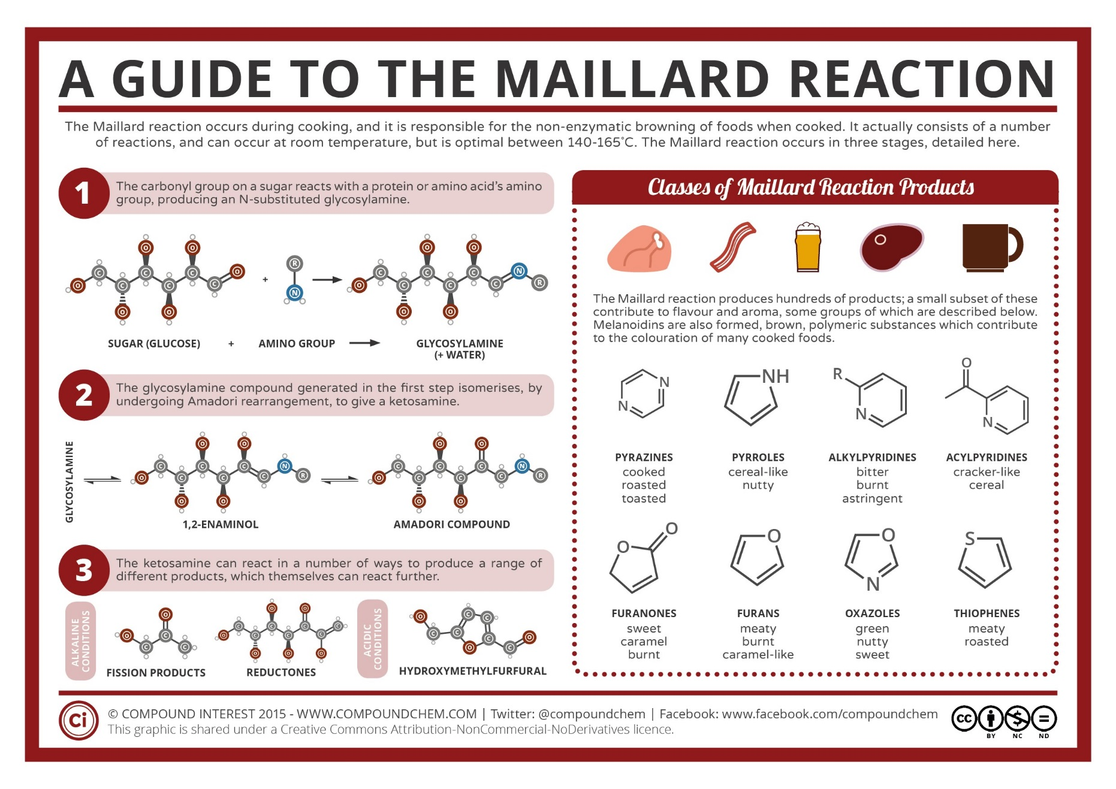

Video Comparison

Video Title | Positives | Negatives

Suggested answers Questions Set 1

Read ‘The Science of Browning, Flavouring and Aroma 1’

- Which four foods does the writer give as examples for browning?
seared meat, pan-fried fish, roasted coffee, toasted marshmallows
- Which adjectives does she put with browning and with fragrances in the first sentence?
beautiful, mouth-watering

- What effect do you think she is trying to make with these adjectives?
To let the reader know that the browning and fragrance of the food makes it attractive and appealing.

- What does she promise the reader in the last sentence of the first paragraph?
To explain the Maillard Reaction simply without using difficult-to-understand scientific language.

- Why do you think she says this?
To keep the reader engaged and to link to the next section of the text.

- What sub-heading does the writer use?
What is the Maillard Reaction?

- Why do you think she has put the first sentence after the sub-heading in italics?
This sentence summarises exactly what the reaction is and how it happens.

- Which words are put in bold in this explanation?
The technical language is in bold.

- Why do you think they are in bold?
These are words and phrases which you might not come across very often and the writer provides a definition for these words.

Suggested answers Questions Set 2

Read ‘The Science of Browning, Flavouring and Aroma 1 and 2’

- What descriptive language does the writer use in the first paragraph?
adjectives - beautiful browning, mouth-watering fragrances
- What is the effect of this language?
To let the reader know that the browning and fragrance of the food makes it attractive and appealing.
- What does the writer promise the reader in the last sentence of the first paragraph?
To explain the Maillard Reaction simply without using difficult-to-understand scientific language.
- How successful do you think she has been with this promise?
Answers could vary here but should give reasons for their opinion, e.g. I think she has been successful because she starts each section with a summary sentence and then goes into more detail explaining it and giving clear definitions of the technical vocabulary.
- What sub-headings does the writer use?
What is the Maillard Reaction?; The Flavour Reaction; Temperature, Moisture and Time; Proteins and Sugars
- Why do you think she has put the first sentence after each subheading in italics?
The sentences in italics summarise exactly what the sub-section below is about.
- Which words are put in bold in this explanation?
The technical language is in bold.
- Why do you think they are in bold?
These are words and phrases which you might not come across very often and the writer provides a definition for these words.
- What examples of causal language can you find in this explanation? Children could highlight these in the text, examples include: which is the result of, that results, which can, so that, in such a way, are responsible for, when, depending on, will result in…
- What would you say about the formality of this piece of writing? Can you find examples of formal and informal vocabulary? Examples will vary but should show an understanding of the formal and informal ‘voice’:
formal - At atmospheric pressure, only high-heat cooking techniques can dry out the food enough to raise the temperature sufficiently.
informal - Let’s check out the science of browning, flavouring and aroma…
- Which part of this explanation do you think needs most improvement? What would you do to improve it? Answers will vary but children should be able to provide an explanation for their answer, e.g. I think the section about moisture could be improved because there wasn’t a definition of ‘atmospheric pressure’ which is a technical phrase that not many people will understand.

Suggested answers Questions Set 3

Read The Science of Browning, Flavouring and Aroma 1 and 2 AND Compound Chemistry Text and Graphic

- Compare the two introductions.
What can you find that is similar between them? What is different? Which do you think is the most effective? Why?
Both introductions link to the reader ‘If you have tried…’ ‘…we all carry out on a regular basis...’
The first introduction includes more descriptive language, the second uses more scientific language.
Answers about which is most effective will differ but children should be able to explain their answer, e.g. I think the first introduction is more effective because it made me feel like I would be able to understand what the Maillard Reaction is even though I’m not a scientist.
- Compound Chemistry does not have subheadings, whereas The Science of Browning does.
What difference does this make?
Sub-headings make it easier to understand what the different paragraphs are about.
What sub-headings could be used in Compound Chemistry?
Answers will differ but could include:
Where does the name come from? What are the stages of the reaction? Why does the food turn brown? What is the result of the reaction?
- Find examples of technical vocabulary in each of the articles
Make a two-column table to compare this vocabulary. What do you notice? Why do you think there is a difference?
Answers could include:
The Science of Browning, Flavouring and Aroma 1 and 2 | Compound Chemistry Text and Graphic
amino acids  reducing sugars  molecules  browning / flavour reaction  evaporation  pyrolysis  atmospheric pressure  proteins  starches | amino acids  glycosylamine compound  ketosamine  compound  Melanoidins  polymeric compounds  pigments  non-enzymatic  enzymes  subset
There is more complex vocabulary in the second article to explain the chemistry that occurs in the Maillard Reaction. The first article tries to explain the reaction using language that most non-scientists would be more familiar with.

- Find examples of causal language from each of the articles.
Are any examples used by both articles?
Children could highlight these in the texts, examples in article 1 include: which is the result of, that results, which can, so that, in such a way, are responsible for, when, depending on, will result in…
Examples in article 2 include: it’s responsible for, because, however, as a result, this produced, can contribute, can be formed, due to, can affect,
- What extra information is given by the Graphic?
List some of this information.
The graphic explains the chemical compounds which are formed at each stage of the reaction. It details the products which are made in the reaction and describes these.
How does the graphic help you understand this information?
The pictures show that the compounds have different chemical structures. It also shows how the different flavours of the products might be described.

- Summarise the difference between these two explanations.
The first article explains the Maillard Reaction in simple, everyday language so that everyone can understand what it is and what the results are. The second article is a more scientific explanation and includes more detail for scientists and for people who want to have a more in-depth understanding of the reaction and the products that are made.
Would you say that one is more effective than the other? Why?
Answers will differ but children should be able to explain why they think their preferred article is more effective.

