What to do today
IMPORTANT Parent or Carer – Read this page with your child and check that you are happy with what they have to do and any weblinks or use of internet.

1. Read a blog post
- Read Naughty Dog Blog
- Read through Informal Writing Features. Which of these features can you find in the blog-post? Highlight and annotate the text to show them.

2. Revise Active and Passive Voice
- Use the PowerPoint about active and passive voice and listen to the teaching. If this is not possible, remind yourself using the Revision Card.
- Complete Active and Passive Voice Practice.

3. Now for some writing
- Write a short blog-post about one of these titles:
- The day of the big match
- Fire!
- My kid brother/sister
- My favourite animal
- Food
- Include some sentences in the active voice and some in the passive voice.

Well done. Share your writing with a grown-up. Show them which sentences you’ve written in the active voice and which are written in the passive voice.

Try the Fun-Time Extras
- Read some more blog-posts. Try to find examples of sentences in the active and passive voice.

Naughty Dog Blog

Has anyone else got this dog trouble? I love my dog BUT…

Honestly… I just cannot believe it! Turn your back for just 5 mins and that’s it! Another catastrophe has occurred.

Here’s my week so far!  Monday – removed my oldest, most  P R E C I O U S, soft toy (yes! I have had it since I was a baby!) from my bed and took it downstairs.  She’s not even supposed to GO upstairs …  How she got the crown I honestly DO NOT KNOW! I can only assume that she crawled under the desk in my room and it fell on her. Princess or what?  Not a good start to the week – mine not hers I mean! | 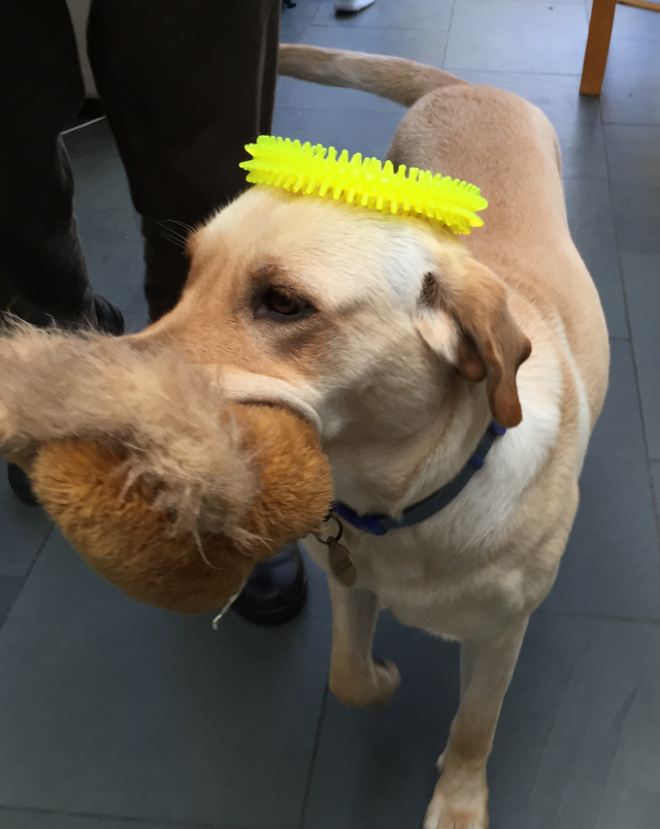

Tuesday – got into the rubbish bin in the kitchen and created H A V O K, and I mean havoc! She practically destroyed the bin AND

stinky horrible yukky slimy bits of old food half-eaten sandwiches rotten fruit disgusting remains potato peelings ancient cheese mum had thrown out and yes, even some porridge that my baby sister hadn’t eaten

were all over the floor!

To add insult to injury, the dog had been sick – ON the sofa!

I ask you. What can an owner do?

Informal Writing Features

Feature | Example | *
Colloquial, non-Standard English vocabulary | mates rather than acquaintances  grabbed the spuds rather than collected the potatoes
Looks and sounds very much like spoken English | Making a paper plane? The best way to use a piece of A4 – ever!
Rhetorical questions and asides | So, what’s new in the world of sport?  The weather forecast was good (yeah, right!).
Contains contractions and abbreviations | should’ve rather than should have  telly rather than television  wanna rather than want to
May use onomatopoeic words | Whoosh, zingy, kaboom!
Makes use of clichés, idiomatic expressions and other figures of speech | You could have knocked the boffins down with a feather rather than Scientists were extremely surprised by the results
Short sentences, sometimes incomplete and using parenthesis, dashes or dots | Mind you, you never know…  So – let’s check out what’s new.  Football (boring!)
Frequently written in the first person form and making use of second person pronouns | I’m going to tell you why you and your friends will love it rather than It is anticipated that many people will be delighted.
Often uses the active voice | You then join the pieces of wood together instead of The pieces of wood are then joined together.

Active and Passive Voice – Revision Card

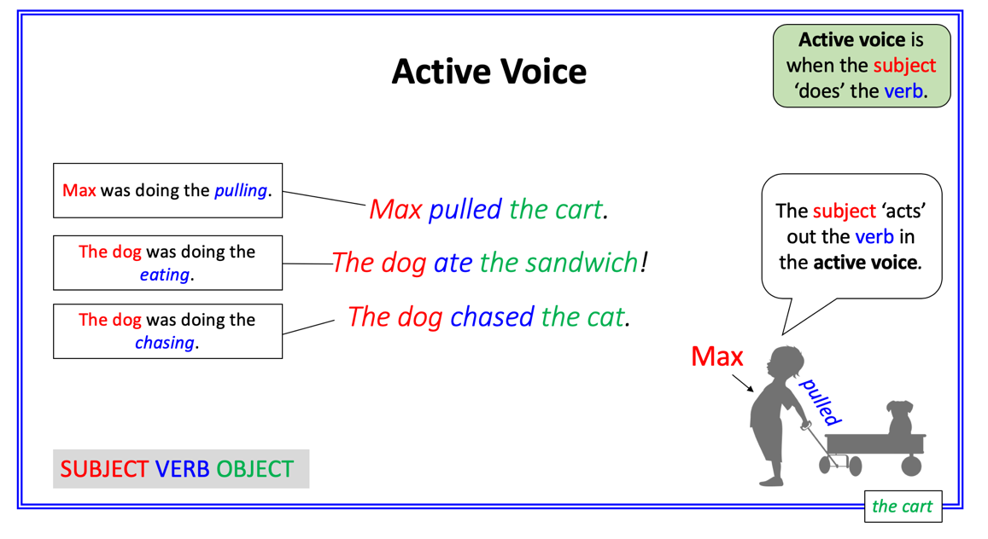 | 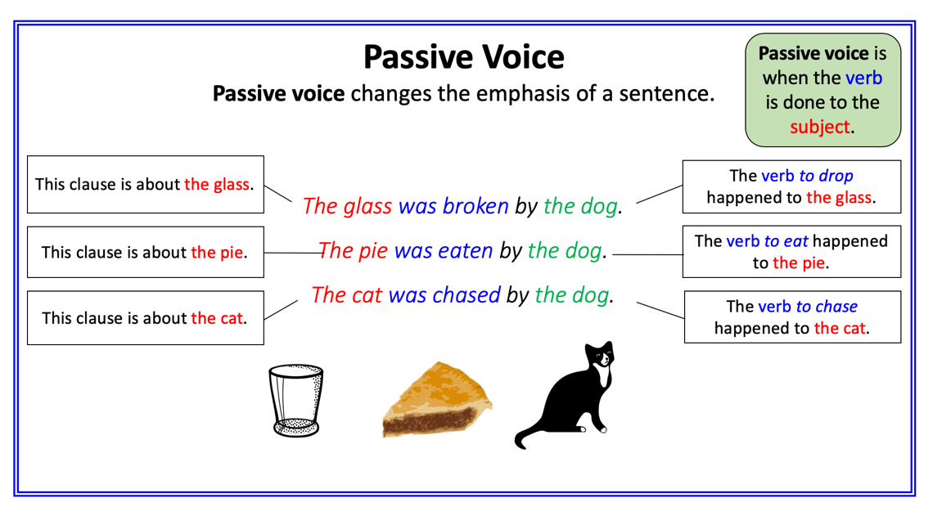
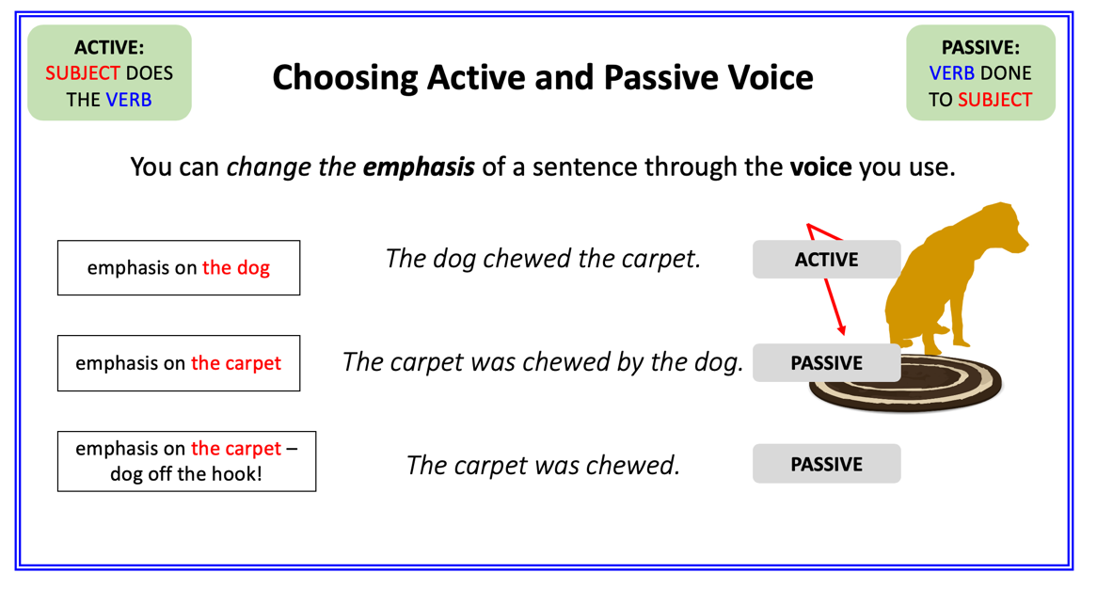 | 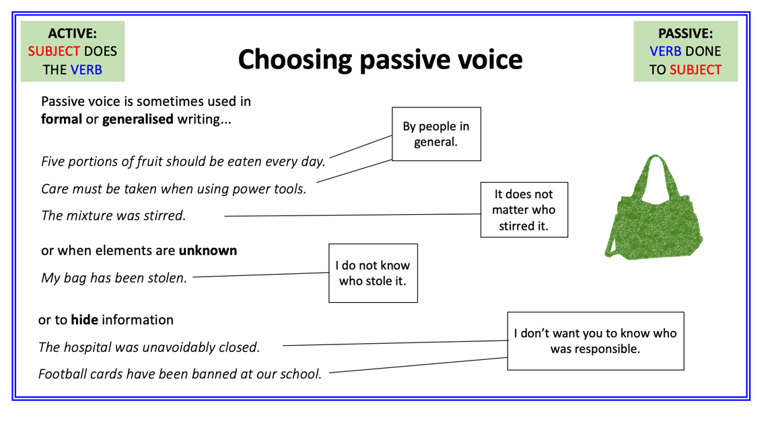

Active and Passive Voice Practice

1. Copy each of these sentences and indicate whether it is active or passive. The first one has been done for you.

John posted his comments on the blog. Active
The stick was carried home by the dog.
Abi picked up her towel.
Rain lashed the windows all night.
Lunch was cooked by Mrs Darwin in the school kitchen.
The roof was covered by moss.
The party was given by Ben, Chris’s big brother.

2. Rewrite these active sentences as passive sentences. The first one has been done for you.

The cat scratched the girl. The girl was scratched by the cat.
The teacher rang the bell.
The rain soaked my coat and boots.
The vast mountain overshadowed the tiny cottage.
The manager threw open the doors at 9am.
The sea wall held back the waves all night.

3. Rewrite these passive sentences as active. The first one has been done for you.

The chocolate cake was baked by Ben. Ben baked the chocolate cake.
The trees were knocked down by the storm winds.
The bone was thoroughly chewed by the dog.
The Harry Potter books were written by J K Rowling.
The hot chocolate was spilt by your younger brother.
The windows were broken by the bear.

Blog-Post
Write about one of these: The day of the big match; Fire!; My kid brother or sister; My favourite animal; Food. Include some sentences in active and some in passive voice.

Active and Passive Voice Practice - ANSWERS

1. Copy each of these sentences and indicate whether it is active or passive. The first one has been done for you.

John posted his comments on the blog. Active
The stick was carried home by the dog. Passive
Abi picked up her towel. Active
Rain lashed the windows all night. Active
Lunch was cooked by Mrs Darwin in the school kitchen. Passive
The roof was covered by moss. Passive
The party was given by Ben, Chris’s big brother. Passive

2. Rewrite these active sentences as passive sentences. The first one has been done for you.

The cat scratched the girl. The girl was scratched by the cat.
The teacher rang the bell. The bell was rung by the teacher.
The rain soaked my coat and boots. My coats and boots were soaked by the rain.
The vast mountain overshadowed the tiny cottage. The tiny cottage was overshadowed by the vast mountain.
The manager threw open the doors at 9am. At 9am, the doors were thrown open by the manager.
The sea wall held back the waves all night. The waves were held back by the sea wall all night.

3. Rewrite these passive sentences as active. The first one has been done for you.

The chocolate cake was baked by Ben. Ben baked the chocolate cake.
The trees were knocked down by the storm winds. The storm winds knocked down the trees.
The bone was thoroughly chewed by the dog. The dog thoroughly chewed the bone.
The Harry Potter books were written by J K Rowling. J K Rowling wrote the Harry Potter books.
The hot chocolate was spilt by your younger brother. Your younger brother spilt the hot chocolate.
The windows were broken by the bear. The bear broke the windows.

