What to do today
IMPORTANT Parent or Carer – Read this page with your child and check that you are happy with what they have to do and any weblinks or use of internet.

1. Read a profile
- Read Maya Angelou – Author Profile
- Which three facts about Maya Angelou do you think are most important? Write these in one sentence each. Why do you think this?

2. Watch three video performances of the poem
- Watch these three video performances of the poem:
https://www.youtube.com/watch?v=-pAxGbTwFm4
https://www.youtube.com/watch?v=Adg9rS4rVjI
https://www.youtube.com/watch?v=rZzOxWAxde0
- Make some Notes about these performances. What did you notice and like? Was there anything that you disliked?

3. Practise performing the poem
- Practise reading the poem out loud.
- Work on the first verse. Decide which words to emphasise and what expression you will use. Practise until you can speak really confidently.
- Challenge yourself to read the other verses just as well.

Well done! Read the poem to someone. What do they like about your performance?

Try the Fun-Time Extras
- Make a recording of your performance and share it with someone else.
- Use this website to find out more about Maya Angelou and make a poster about her like. https://kids.kiddle.co/Maya_Angelou

Maya Angelou – Author Profile

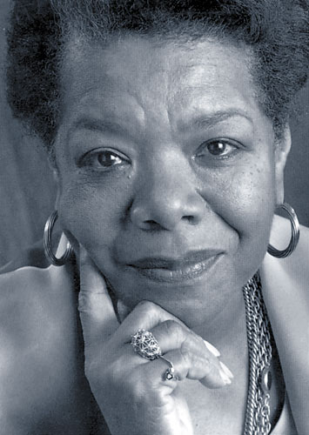

Maya Angelou was born in Missouri in the southern USA in 1928. She was the descendant of generations of people who had been imprisoned as slaves.
She experienced many difficulties in her family when she was growing up and was very often treated unfairly.
She worked at all sorts of jobs once she had left school, including as a cook, as a dancer and singer, as a journalist and as a campaigner for civil rights. She also directed films and acted in the theatre!
From very early on she had loved reading, memorising poetry and writing, and published her first book in the 1960s. She was famous for her memoirs and autobiographical pieces, the first of which was called I Know Why The Caged Bird Sings.

Caged Bird

A free bird leaps
on the back of the wind
and floats downstream
till the current ends
and dips his wing
in the orange sun rays
and dares to claim the sky.

But a bird that stalks
down his narrow cage
can seldom see through
his bars of rage
his wings are clipped and
his feet are tied
so he opens his throat to sing.

The caged bird sings
with a fearful trill
of things unknown
but longed for still
and his tune is heard
on the distant hill
for the caged bird
sings of freedom.

The free bird thinks of another breeze
and the trade winds soft through the sighing trees
and the fat worms waiting on a dawn bright lawn
and he names the sky his own

But a caged bird stands on the grave of dreams
his shadow shouts on a nightmare scream
his wings are clipped and his feet are tied
so he opens his throat to sing.

The caged bird sings
with a fearful trill
of things unknown
but longed for still
and his tune is heard
on the distant hill
for the caged bird
sings of freedom.

Maya Angelou,
The Complete Collected Poems of Maya Angelou
Virago, 1995

Notes

 |  | + | -
1. | https://www.youtube.com/watch?v=-pAxGbTwFm4
2. | https://www.youtube.com/watch?v=Adg9rS4rVjI
3. | https://www.youtube.com/watch?v=rZzOxWAxde0

