What to do today
IMPORTANT Parent or Carer – Read this page with your child and check that you are happy with what they have to do and any weblinks or use of internet.

1. Read a poem
- Look at the Caged Bird picture. Why do you think someone might keep a bird in a cage like that? What does it make you think?
- Read Caged Bird – First Verses. Read them twice: once in your head, once out loud. Each verse is just one sentence, so read so that it flows to the end.

2. Decide some Secret Strings
- Look at Example Secret Strings. Secret Strings are a way of showing how a word or phrase in a poem links with another word or phrase. You just spot a link and then use colours and highlights to show it.
- Read Caged Birds – Other Verses. Try adding secret strings. Any link that you can spot between words or phrases is OK.

Well done! Show your Secret Strings to a grown-up and explain the links that you have spotted. They can read Secret Strings Adult Reference to understand them or watch Michael Rosen explain them (he invented the idea).

https://www.youtube.com/watch?v=M39LCHSHNDw (from 1:38)

3. Answer some questions
- Read Reflection Questions. Think about your answers and then write them as sentences.

Try the Fun-Time Extras
- Make an illustration of the free bird, showing all it can do.
- Try learning some of the poem off-by-heart.
Caged Bird
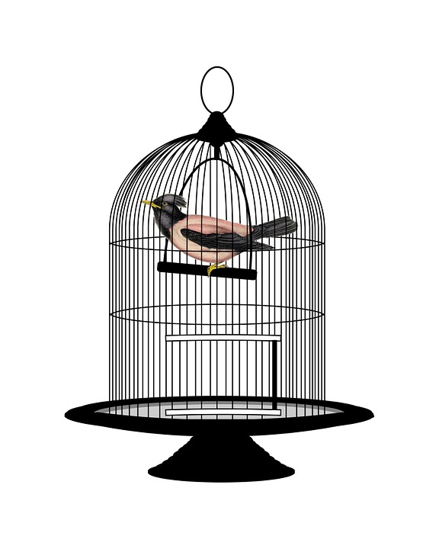

Caged Bird – First Verses

A free bird leaps
on the back of the wind
and floats downstream
till the current ends
and dips his wing
in the orange sun rays
and dares to claim the sky.

But a bird that stalks
down his narrow cage
can seldom see through
his bars of rage
his wings are clipped and
his feet are tied
so he opens his throat to sing.

Maya Angelou,
The Complete Collected Poems of Maya Angelou
Virago, 1995

SECRET STRINGS EXAMPLE
Caged Bird – First Stanza

A free bird leaps
on the back of the wind
and floats downstream
till the current ends
and dips his wing
in the orange sun rays
and dares to claim the sky.

• Wind and wing – echoing words (they sound similar)

• Free bird leaps – contrasting assonance

• sun rays dares sky – alliteration (letter ‘s’ at start and end)

• leaps/dares – strong verbs

• wind, stream, sun, sky – nouns to do with the natural world

• Floats downstream – contrasting assonance

Secret Strings: Adult Reference

Secret Strings is a way of thinking about poems explained by Michael Rosen in his book: What is Poetry? (2016 Walker Books).

He explains them as the way that poems bring words together.

They can include:

- Words sounding like one another (for example rhyme, alliteration or assonance)
- One line’s rhythm echoing that of another
- Words or groups of words repeating
- Word pictures made by the similar or the same words being used (The picture or imagery of the poem)
- Opposites

Importantly, Michael Rosen says this:

“Remember, these strings belong to you. They may be strings that the poet had in mind – but maybe not.”

In Caged Bird example, these Secret Strings have been marked:

- Free bird leaps – contrasting assonance

- Wind and wing – echoing words (they sound similar)

- Floats downstream – contrasting assonance

- sun rays dares sky – alliteration

- leaps/dares – strong verbs

- wind, stream, sun, sky – nouns to do with the natural world
Caged Bird – Further Verses

The caged bird sings
with a fearful trill
of things unknown
but longed for still
and his tune is heard
on the distant hill
for the caged bird
sings of freedom.

The free bird thinks of another breeze
and the trade winds soft through the sighing trees
and the fat worms waiting on a dawn bright lawn
and he names the sky his own

But a caged bird stands on the grave of dreams
his shadow shouts on a nightmare scream
his wings are clipped and his feet are tied
so he opens his throat to sing.

The caged bird sings
with a fearful trill
of things unknown
but longed for still
and his tune is heard
on the distant hill
for the caged bird
sings of freedom.
Maya Angelou,
The Complete Collected Poems of Maya Angelou
Virago, 1995

Reflection Questions

Does this poem remind you of anything?

What can a free bird do that a caged bird can’t?

What does a caged bird do that a free bird doesn’t?

Which would you rather be?

Which do you most feel like?

What emotions do you think the poet felt as she wrote about the caged bird?

What emotions might she have felt as she wrote about the free bird?

Do you know someone who would love this poem? Why would they?

Do you know someone who would hate this poem? Why would they?

How can something be unknown yet longed for? Is there anything like that in your life?

What is your favourite phrase in this poem?

