What to do today
IMPORTANT Parent or Carer – Read this page with your child and check that you are happy with what they have to do and any weblinks or use of internet.

1.Think about illustrations
- Look carefully at the Illustrations. These are from Eric by Shaun Tan.
- Read and think about the Reflection Questions.

2. Remind yourself about modal verbs
- Use the Revision Card to remind yourself about modal verbs.
- Now write some of the answers to the Reflection Questions as sentences that use modal verbs. Write at least 3 sentences. Challenge yourself to write 5 or more.

3. Make an illustration
- Read Illustration Brief. Make an illustration showing where Eric might go next, who he may meet and what he could do.
- When you have finished your illustration write some sentences to go with it. Include modal verbs in your sentences.

Well done! Share your illustration and sentences with a grown-up. Show them the modal verbs that you have used.

Try the Fun-Time Extras
- Watch this animation of Eric’s story.
https://www.youtube.com/watch?v=S3x3Zn-qKSQ
- Could you try to make your own version of the story? You could use photographs or you could use an animation.

Illustrations

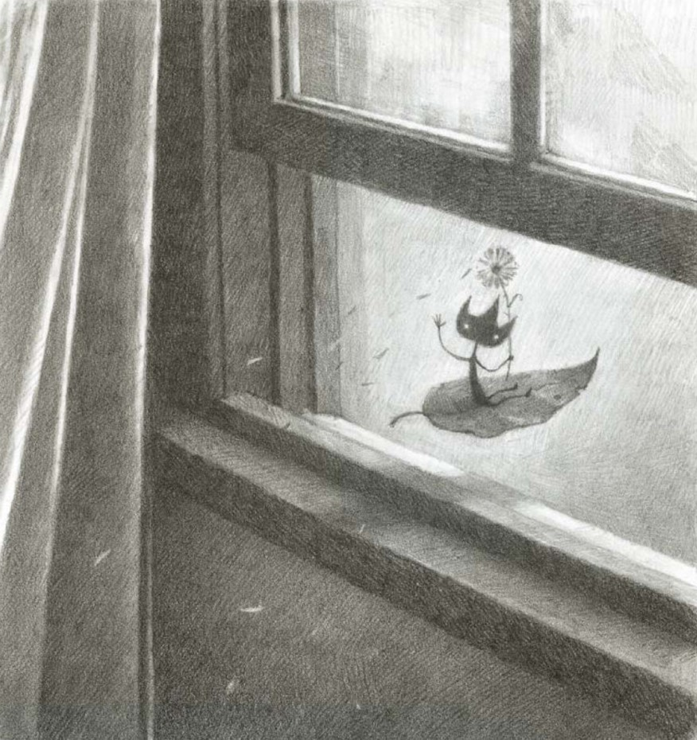 | 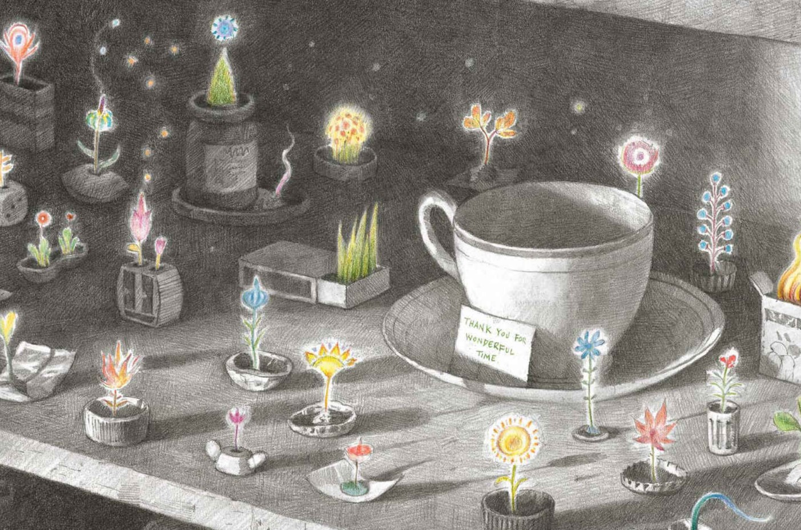

Reflection Questions

What is powering Eric’s leaf?

Was Eric upset?

Would they hear from him again?

How are the pantry plants powered?

Will they stay there for ever?
Modal Verb – Revision Card

Modal verbs show how possible or certain something might be.
They can express certainty, ability or obligation.
Certainty | Obligation | Ability
might  would  will  shall  may | ought  should  must | can  could

Modal verbs are placed before the verb they are modifying.
I thought I might ask him where he had come from.
I knew he would feel scared.
He will come back one day, I hope.
I shall remember him forever.
I may write a book about him.
Illustration Brief

Make an illustration to show where Eric goes next, who he meets and what he does.

Include detail in your illustration so that it matches the style of Shaun Tan.

Write some sentences to accompany your illustration. They must include modal verbs.

