What to do today
IMPORTANT Parent or Carer – Read this page with your child and check that you are happy with what they have to do and any weblinks or use of internet.

1. Watch a version of Eric
- Watch this video version of Eric. You can follow the words as you do.
https://www.vimeo.com/111187541
- What do you think about this version. Does it work to have an actor playing the character of Eric? Is the narration well read?

2. Practise using modal verbs
- Use the Revision Card to remind yourself about modal verbs.
- Read Eric Thoughts 1 and 2. What are some of the differences between the two sets of answers? Highlight the modal verbs that have been used.
- Sort the modal verbs that you have found into Certainty/Ability/Obligation.

Well done! Show your answers to a grown-up. You can check them at the end of this pack. Talk with them about your own answers to the three questions about Eric.

3. Now for some writing
- Think about your own answers to the three questions about Eric.
- Write your answers in clear sentences. Use modal verbs as you do this.

Try the Fun-Time Extras
- Look at the Endpapers. These are Shaun Tan’s drawings that he puts at the start and finish of his books. What is your favourite drawing? Could you make up a story about it?
- Could you make your own collection of sketches in this style?
Eric
Some years ago we had a foreign exchange student come to live with us. We found it very difficult to pronounce his name correctly, but he didn’t mind. He told us to just call him ‘Eric’.

We had repainted the spare room, bought new rugs and furniture and generally made sure everything would be comfortable for him. So I can’t say why it was that Eric chose to sleep and study most of the time in our kitchen pantry.

‘It must be a cultural thing,’ said Mum. ‘As long as he’s happy.’ We started storing food and kitchen things in other cupboards so we wouldn’t disturb him.

But sometimes I wondered if Eric was happy; he was so polite that I’m not sure he would have told us if something bothered him. A few times I saw him through the pantry door gap, studying with silent intensity, and imagined what it must be like for him here in our country.

Secretly I had been looking forward to having a foreign visitor – I had so many things to show him. For once I could be a local expert, a fountain of interesting facts and opinions. Fortunately, Eric was very curious and had plenty of questions.

However, they weren’t the kind of questions I had been expecting. Most of the time I could only say, ‘I’m not really sure,’ or ‘That’s just how it is.’ I didn’t feel very helpful at all.

I had planned for us to go on a number of weekly excursions together, as I was determined to show our visitor the best places in the city and its surrounds. I think Eric enjoyed these trips, but once again, it was hard to really know.

Most of the time Eric seemed more interested in small things he discovered on the ground. I might have found this a little exasperating, but I kept thinking about what Mum had said, about the cultural thing. Then I didn’t mind so much.

Nevertheless, none of us could help but be bewildered by the way Eric left our home: a sudden departure early one morning, with little more than a wave and a polite goodbye.
It actually took us a while to realise he wasn’t coming back.

There was much speculation over dinner later that evening. Did Eric seem upset? Did he enjoy his stay? Would we ever hear from him again? An uncomfortable feeling hung in the air, like something unfinished, unresolved. It bothered us for hours, at least until one of us discovered what was in the pantry.

Go and see for yourself: it’s still there after all these years, thriving in the darkness. It’s the first thing we show any new visitors to our house. ‘Look what our foreign exchange student left for us,’ we tell them. ‘It must be a cultural thing,’ says Mum.
Modal Verbs – Revision Card
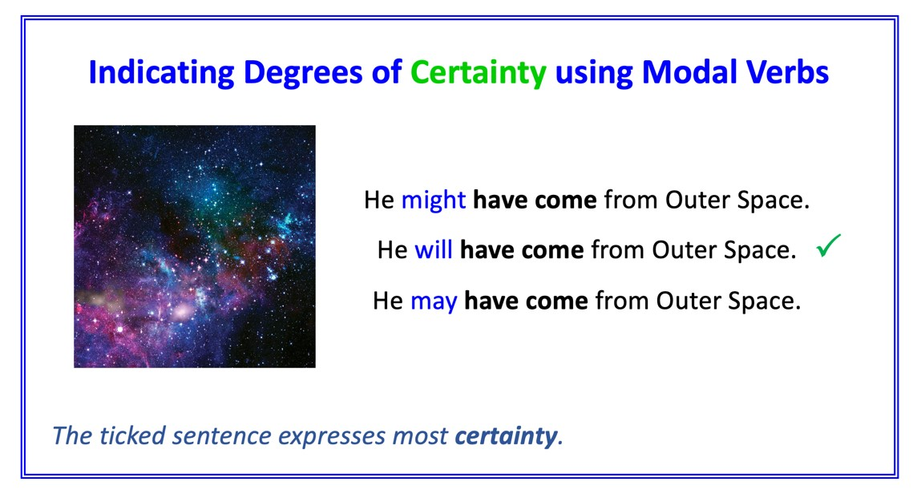
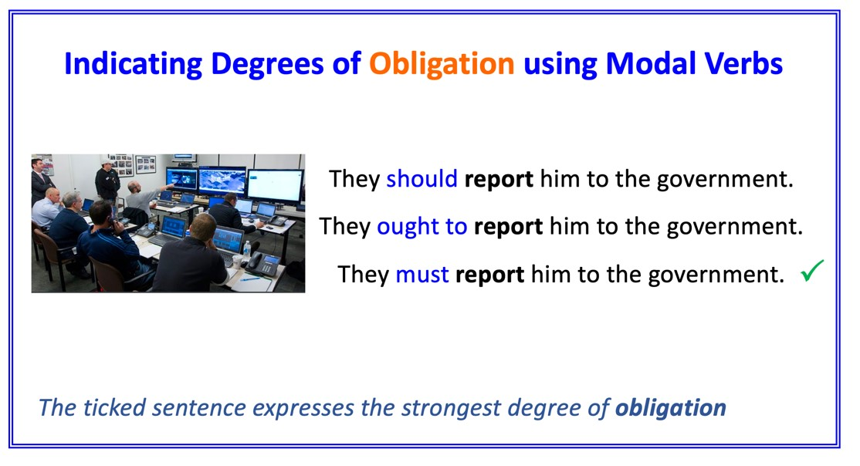
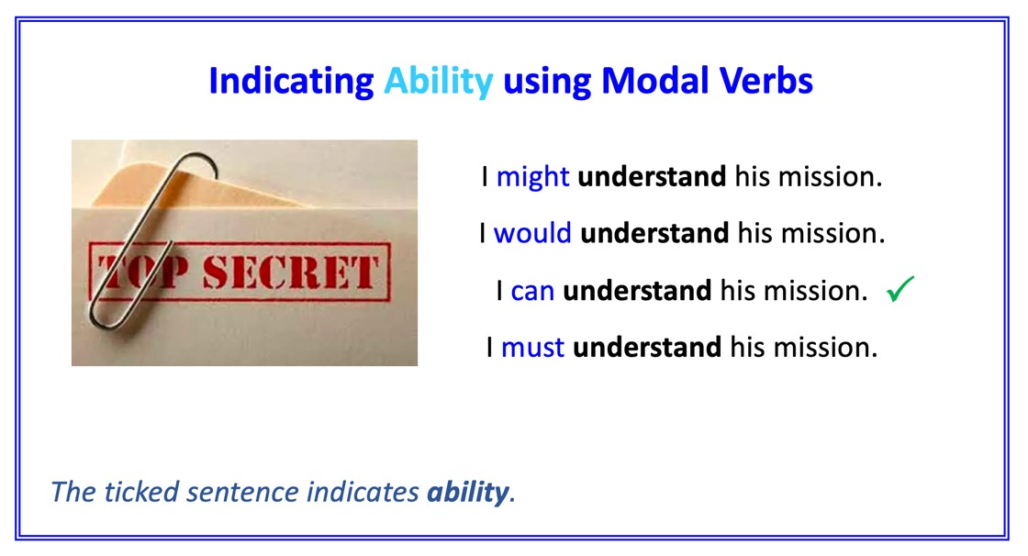

Eric Thoughts 1

Why do you think the family decided to have a foreign exchange student?

I think that they might have wanted to be kind and hospitable. They repainted the spare room and bought new rugs and furniture which may show how much care they were taking. When Eric went in the pantry, they decide they ought not to disturb him. This seems generous. They could have told him to stay in his room. They seem flexible.

Where do you think Eric has come from?

I think he may have come newly arrived from another planet. He might not actually be the exchange student. He may have turned up at the same time coincidentally. I think he feels he should learn about his new planet, so it could be that he is an explorer. Perhaps he will return home with news of what he has discovered.

How do you think the narrator feels about Eric?

I think he might feel quite fond of Eric because of the way that he tells the story. He speaks of him quite gently. He should be looking after him. He must be quite confused though. Eric can behave very strangely! His appearance could really frighten someone.

Eric Thoughts 2

Why do you think the family decided to have a foreign exchange student?

I think that they may just want the money. They might have wanted to do up the house anyway and they would get paid for doing that. The narrator may be quite caring with Eric, but his Mum doesn’t really say or do much. She should be more involved. She must have noticed that a strange creature is in her house. She could have told someone about it. Now no-one will ever know what sort of creature this was.

Where do you think Eric has come from?

I think he might have been visiting other people. He knows some of what he ought to do, for example he knows he should wave at people. He does that when he arrives. He must have learnt that from other visits. He could just go from house to house like this, one after another. Perhaps he will visit me one day!

How do you think the narrator feels about Eric?

I think he might feel quite confused about Eric. He has planned lots of things that they could do, but Eric doesn’t seem to join in with them as he ought to do. He should have asked Eric where he comes from. Maybe he is a bit scared about what Eric will say. He could feel quite proud to have been visited by Eric. It will be a story that he will enjoy telling for the rest of his life.
Certainty/Ability/Obligation

Sort the modal verbs that you have found into this table.

Certainty | Ability | Obligation

Eric – Your Thoughts
Use modal verbs in your answers

- Why do you think the family decided to have a foreign exchange student?
- Where do you think Eric has come from?
- How do you think the narrator feels about Eric?

Eric Thoughts 1 - ANSWERS

Why do you think the family decided to have a foreign exchange student?

I think that they might have wanted to be kind and hospitable. They repainted the spare room and bought new rugs and furniture which may show how much care they were taking. When Eric went in the pantry, they decide they ought not to disturb him. This seems generous. They could have told him to stay in his room. They seem flexible.

Where do you think Eric has come from?

I think he may have come newly arrived from another planet. He might not actually be the exchange student. He may have turned up at the same time coincidentally. I think he feels he should learn about his new planet, so it could be that he is an explorer. Perhaps he will return home with news of what he has discovered.

How do you think the narrator feels about Eric?

I think he might feel quite fond of Eric because of the way that he tells the story. He speaks of him quite gently. He should be looking after him. He must be quite confused though. Eric can behave very strangely! His appearance could really frighten someone.

Eric Thoughts 2 - ANSWERS

Why do you think the family decided to have a foreign exchange student?

I think that they may just want the money. They might have wanted to do up the house anyway and they would get paid for doing that. The narrator may be quite caring with Eric, but his Mum doesn’t really say or do much. She should be more involved. She must have noticed that a strange creature is in her house. She could have told someone about it. Now no-one will ever know what sort of creature this was.

Where do you think Eric has come from?

I think he might have been visiting other people. He knows some of what he ought to do, for example he knows he should wave at people. He does that when he arrives. He must have learnt that from other visits. He could just go from house to house like this, one after another. Perhaps he will visit me one day!

How do you think the narrator feels about Eric?

I think he might feel quite confused about Eric. He has planned lots of things that they could do, but Eric doesn’t seem to join in with them as he ought to do. He should have asked Eric where he comes from. Maybe he is a bit scared about what Eric will say. He could feel quite proud to have been visited by Eric. It will be a story that he will enjoy telling for the rest of his life.

Certainty/Ability/Obligation - ANSWERS

Certainty | Obligation | Ability
might  would  will  may | ought  should  must | can  could

Endpapers

