What to do today
IMPORTANT Parent or Carer – Read this page with your child and check that you are happy with what they have to do and any weblinks or use of internet.

1. Listen to a story
- Listen to or watch Eric by Shaun Tan using the video of Ruth Merttens reading the book https://www.youtube.com/watch?v=H71F0-_QrpE or the PowerPoint provided.
- What do you like about the story? Is there anything that you dislike about it? Does it remind you of anything that has happened to you? Does it remind you of any books that you have read?

2. Remind yourself about modal verbs
- Use PowerPoint on modal verbs. If this is not possible, use the Revision Card to remind yourself about these.
- Complete Modal Verb Activity. You could challenge yourself to write 5 or even 10 of your own sentences about Eric.

Well done! Share your sentences with a grown-up. Show them the modal verbs that you have used.

3. Practise reading the story yourself
- Read through Eric. Highlight the modal verbs that you can find in this writing. You can check your answers at the end of the pack.
- Practise reading the story, until you are really fluent.
- Share the story with somebody else and explain to them what is shown in the illustrations.

Try the Fun-Time Extras
- Can you find out some more about Shaun Tan? You could start at this website: http://www.shauntan.net/books.html
- Can you interview other people to find out about the strangest visitor they’ve ever had to their house?

Modal Verbs – Revision Card
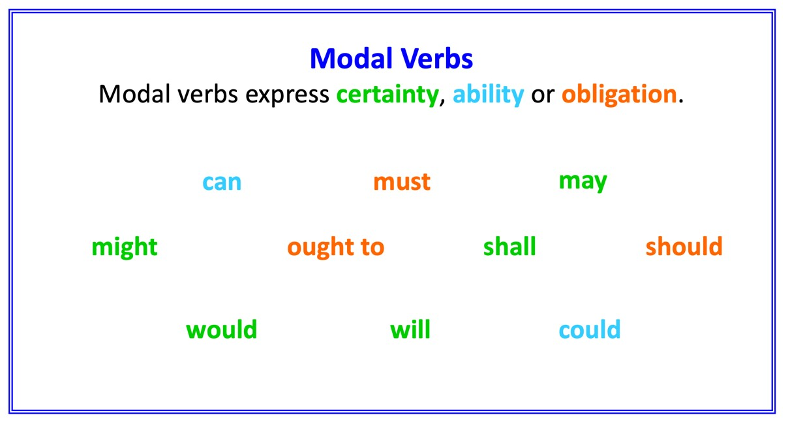
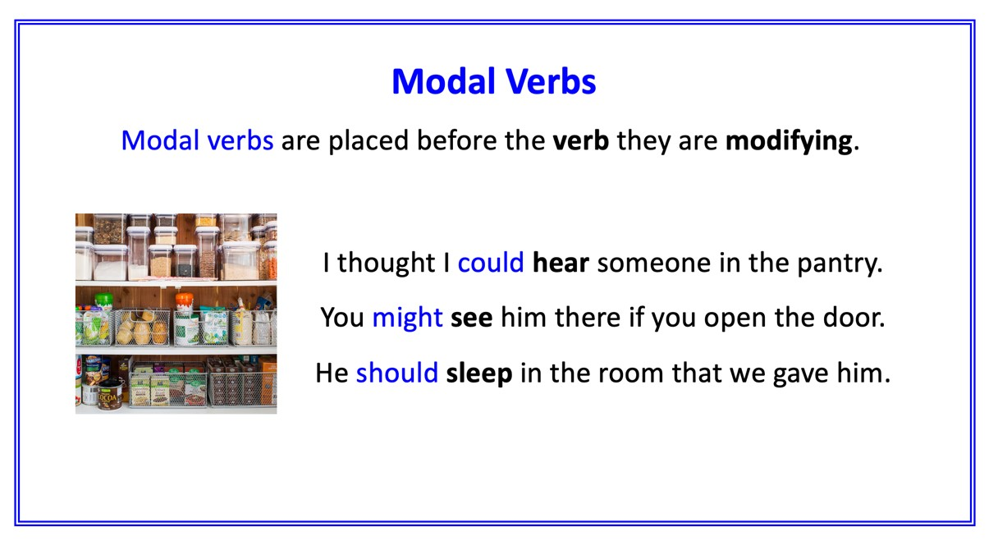
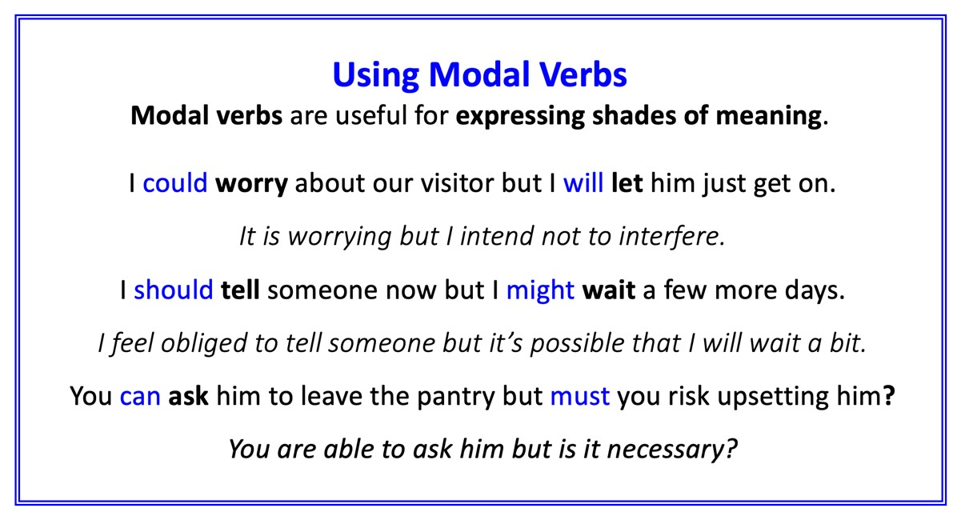

Modal Verbs Activity

Modal verbs can express certainty, ability or obligation.
Add a modal verb to each sentence so that it makes sense.
You might need to change or add some words.

1. We decided that we ________ host a foreign exchange student.
2. We thought that we _________ make the house welcoming for him.
3. We thought they _________ appreciate what we had done for him
4. When he went in the pantry, we agreed that we _________ not disturb him.
5. We worried that he _________not tell us if anything was wrong.
6. He __________ be described as very curious.
7. I thought that he __________ to see the city and its surrounds.
8. I thought that perhaps he ___________ be interested in something other than the ground.
9. I do not know whether we ___________ see him again.
Write at least 3 sentences of your own about Eric.
Each sentence must contain a modal verb.

Eric
Some years ago we had a foreign exchange student come to live with us. We found it very difficult to pronounce his name correctly, but he didn’t mind. He told us to just call him ‘Eric’.

We had repainted the spare room, bought new rugs and furniture and generally made sure everything would be comfortable for him. So I can’t say why it was that Eric chose to sleep and study most of the time in our kitchen pantry.

‘It must be a cultural thing,’ said Mum. ‘As long as he’s happy.’ We started storing food and kitchen things in other cupboards so we wouldn’t disturb him.

But sometimes I wondered if Eric was happy; he was so polite that I’m not sure he would have told us if something bothered him. A few times I saw him through the pantry door gap, studying with silent intensity, and imagined what it must be like for him here in our country.

Secretly I had been looking forward to having a foreign visitor – I had so many things to show him. For once I could be a local expert, a fountain of interesting facts and opinions. Fortunately, Eric was very curious and had plenty of questions.

However, they weren’t the kind of questions I had been expecting. Most of the time I could only say, ‘I’m not really sure,’ or ‘That’s just how it is.’ I didn’t feel very helpful at all.

I had planned for us to go on a number of weekly excursions together, as I was determined to show our visitor the best places in the city and its surrounds. I think Eric enjoyed these trips, but once again, it was hard to really know.

Most of the time Eric seemed more interested in small things he discovered on the ground. I might have found this a little exasperating, but I kept thinking about what Mum had said, about the cultural thing. Then I didn’t mind so much.

Nevertheless, none of us could help but be bewildered by the way Eric left our home: a sudden departure early one morning, with little more than a wave and a polite goodbye.
It actually took us a while to realise he wasn’t coming back.

There was much speculation over dinner later that evening. Did Eric seem upset? Did he enjoy his stay? Would we ever hear from him again? An uncomfortable feeling hung in the air, like something unfinished, unresolved. It bothered us for hours, at least until one of us discovered what was in the pantry.

Go and see for yourself: it’s still there after all these years, thriving in the darkness. It’s the first thing we show any new visitors to our house. ‘Look what our foreign exchange student left for us,’ we tell them. ‘It must be a cultural thing,’ says Mum.
Eric – Modal Verbs Highlighted

Some years ago we had a foreign exchange student come to live with us. We found it very difficult to pronounce his name correctly, but he didn’t mind. He told us to just call him ‘Eric’.

We had repainted the spare room, bought new rugs and furniture and generally made sure everything would be comfortable for him. So I can’t say why it was that Eric chose to sleep and study most of the time in our kitchen pantry.

‘It must be a cultural thing,’ said Mum. ‘As long as he’s happy.’ We started storing food and kitchen things in other cupboards so we wouldn’t disturb him.

But sometimes I wondered if Eric was happy; he was so polite that I’m not sure he would have told us if something bothered him. A few times I saw him through the pantry door gap, studying with silent intensity, and imagined what it must be like for him here in our country.

Secretly I had been looking forward to having a foreign visitor – I had so many things to show him. For once I could be a local expert, a fountain of interesting facts and opinions. Fortunately, Eric was very curious and had plenty of questions.

However, they weren’t the kind of questions I had been expecting. Most of the time I could only say, ‘I’m not really sure,’ or ‘That’s just how it is.’ I didn’t feel very helpful at all.

I had planned for us to go on a number of weekly excursions together, as I was determined to show our visitor the best places in the city and its surrounds. I think Eric enjoyed these trips, but once again, it was hard to really know.

Most of the time Eric seemed more interested in small things he discovered on the ground. I might have found this a little exasperating, but I kept thinking about what Mum had said, about the cultural thing. Then I didn’t mind so much.

Nevertheless, none of us could help but be bewildered by the way Eric left our home: a sudden departure early one morning, with little more than a wave and a polite goodbye.
It actually took us a while to realise he wasn’t coming back.

There was much speculation over dinner later that evening. Did Eric seem upset? Did he enjoy his stay? Would we ever hear from him again? An uncomfortable feeling hung in the air, like something unfinished, unresolved. It bothered us for hours, at least until one of us discovered what was in the pantry.

Go and see for yourself: it’s still there after all these years, thriving in the darkness. It’s the first thing we show any new visitors to our house. ‘Look what our foreign exchange student left for us,’ we tell them. ‘It must be a cultural thing,’ says Mum.

