**What to do today**

*IMPORTANT Parent or Carer – Read this page with your child and check that you are happy with what they have to do and any weblinks or use of internet.*

**1. Read the third verse of the poem**

* Read *Old Deuteronomy – Third Verse*.
* Answer *Third Verse Questions*.

**2. Compare performances of the poem**

* Listen to and watch two versions of the poem. One is the poet reading the poem himself, one is from a musical based on the poem.

<https://www.youtube.com/watch?v=zYiPsc6cAYM>

<https://www.youtube.com/watch?v=8qZcl6nEsRg>

* Write *Notes* about what you notice about each performance. What do you like about them? Is there anything that you dislike? Which parts of the poem do they help you to notice?

**3. Now for some writing**

* Read *Writing Brief***.** Imagine a fourth scene for Old Deuteronomy. Where might he sleep? What problems could he cause there? What will the villagers do?
* Write about your fourth scene carefully using relative clauses in some of your sentences. Use the *Relative Pronoun List* to help you.

*Well done! Share your writing with a grown-up. Show them the features that you have included.*

**Try the Fun-Time Extras**

* Make an illustration to match your new scene.
* Act out your scene.
* Find out about some of T.S. Eliot’s other poems about cats.

**Old Deuteronomy – Third Verse**

Old Deuteronomy lies on the floor  
Of the Fox and French Horn for his afternoon sleep;  
And when the men say: "There's just time for one more,"  
Then the landlady from her back parlour will peep  
And say: "Now then, out you go, by the back door,  
For Old Deuteronomy mustn't be woken -   
  
I'll have the police if there's any uproar" -   
And out they all shuffle, without a word spoken.  
The digestive repose of that feline's gastronomy  
Must never be broken, whatever befall:  
And the Oldest Inhabitant croaks: "Well, of all . . .  
Things. . . Can it be . . . really! . . . No!. . . Yes!. . .  
Ho! Hi!  
Oh, my eye!  
My legs may be tottery, I must go slow  
And be careful of Old Deuteronomy!"

*by T.S. Eliot*

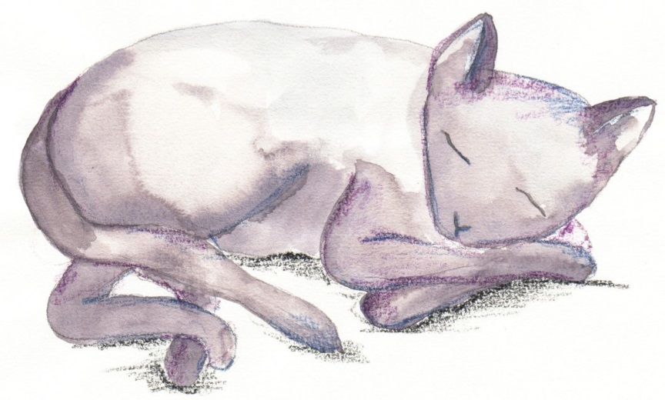

**Third Verse Questions**

1. Where does Old Deuteronomy sleep this time?
2. What does the landlady do when he falls asleep in her pub?
3. What do you think ‘digestive repose’ might mean?
4. How does this verse fit the pattern of the other two verses?

**Notes**

|  |
| --- |
| **T.S. Eliot reading** |
| **Cats the Musical** |

**Writing Brief**

*Think of a fourth scene for Old Deuteronomy. Think about:*

* Where he falls asleep
* Why this is comfortable for him
* Why this is inconvenient to others
* What people do to prevent him from being disturbed
* What ailment the Oldest Inhabitant feels this time

*Write sentences to describe your scenario. Include:*

* Relative pronouns, introducing relative clauses.
* Embedded relative clauses

*Remember to use commas to keep the meaning clear.*

**Relative Pronouns List**

**who**

**which**

**where**

**when**

**whose**

**that**

**Where Old Deuteronomy slept next**

*Think of another place for Old Deuteronomy to sleep. What problems will he cause? What will the villagers do? What will the oldest inhabitant say?*

**

**Third Verse - ANSWERS**

1. Where does Old Deuteronomy sleep this time?

In a pub called ‘The Fox and French Horn’

1. What does the landlady do when he falls asleep in her pub?

She makes sure he is undisturbed. She sends customers away.

1. What do you think ‘digestive repose’ might mean?

It means a rest after a meal to help the body to digest the meal.

1. How does this verse fit the pattern of the other two verses?

The rhyme pattern is the same. The cat sleeps in a place which he finds comfortable but which is inconvenient to others. The villagers don’t disturb him. The oldest villager says almost the same thing again.