What to do today
IMPORTANT Parent or Carer – Read this page with your child and check that you are happy with what they have to do and any weblinks or use of internet.

1. Read a poem
- Read Hold Fast to Dreams. What is the message of this poem?
- Re-read it, really thinking about each line.
- What do you like about this poem? Is there anything that you dislike? What patterns can you spot?

2. Revise metaphors
- Use the Revision Card to remind yourself about metaphors and similes.
- Write a sentence to remind yourself what a metaphor is and a sentence to remind yourself what a simile is.

3. Plan and write a Poem.
- Plan a poem called, ‘Life Without Dreams’.
- On the Planning Frame write metaphors for a life without dreams and verbs that could show dreams ending. Use the Ideas Sheets or think of your own ideas.
- Now try turning your ideas into a poem. Choose your favourite ideas and see how they could fit and flow together.

Well done. Share your poems with a grown-up. Show them the verbs that you have chosen and the metaphors that you have used.

Try the Fun-Time Extras
- Share your poem with somebody else. Send it to them or make a recording so they can hear you or watch you.
- Make an illustration for your poem.
- Read Langston Hughes’s Poem – A Dream Deferred. What do you think deferred must mean?

Hold Fast to Dreams

Hold fast to dreams
For if dreams die
Life is a broken-winged bird
That cannot fly.

Hold fast to dreams
For when dreams go
Life is a barren field
Frozen with snow.

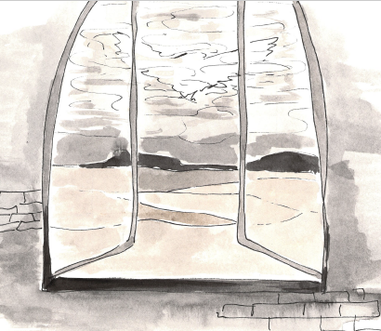

Langston Hughes,
The Collected Poems of Langston Hughes,
Vintage, 1995

REVISION CARD: Metaphors

A metaphor is a comparison in which a place, person or thing is described as if it was another entirely different but similar thing.
Ben is a greedy pig.

Ben is not actually a pig - he’s a boy - but the comparison to a greedy pig is very effective in telling us that Ben obviously tucks into his food like a farm animal at meal times!

Metaphors very often contain the verbs is or are, was or were.

The stars were jewels in the night sky.
Life is a journey.
The children in my class are a dream.
He was a big baby, moaning about the weather like that.

Metaphors are different to similes

Similes describe people, places, situations or things by comparing them to something that they are like.
Similes either contain the word like or the phrase as…as…

Ben ate like a snuffling pig.
Ben was as greedy as a pig.

In Hold Fast to Dreams, Langston Hughes uses two metaphors to describe a life without dreams as if it is something else.

a broken-winged bird
a barren field, frozen with snow

Planning Frame

Verbs for dreams ending | Metaphors for a life without dreams

Ideas Sheet

Possible verbs

wither decay bleed break shatter rupture implode collapse break apart shrivel fracture crack fade empty dry up blanch ossify calcify darken close shut down evaporate disperse scatter are extinguished

Possible metaphors

Something…
deserted poisoned abandoned shuttered broken cracked homeless leafless sunless empty splintered unloved cheerless unfinished lost smashed snuffed out frozen buried

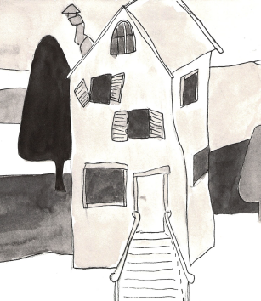

Life Without Dreams

A Dream Deferred (Harlem)

What happens to a dream deferred?

Does it dry up
Like a raisin in the sun?
Or fester like a sore–
And then run?
Does it stink like rotten meat?
Or crust and sugar over
Like a syrupy sweet?

Maybe it just sags like a heavy load.

Or does it explode?

Langston Hughes,
The Collected Poems of Langston Hughes,
Vintage, 1995

