What to do today
IMPORTANT Parent or Carer – Read this page with your child and check that you are happy with what they have to do and any weblinks or use of internet.

1. Read a poem and think about the story.
- Read How Tortoise Got His Shell.
- What did you like about the poem? What patterns did you notice?
- Why was Zeus so angry with Tortoise? How did Zeus punish Tortoise? Do you think this was fair?

Find a grown-up and read them the poem. Can you help them to understand the story by the way that you read the poem?

2. Imagine a conversation
- Try writing a conversation between Zeus and the Tortoise in the Speech Bubbles.
- Now use the Revision Card to remind yourself about direct speech. Can you turn some of your Speech Bubble writing into sentences with direct speech? (add speech marks and reporting clauses)

3. Now for some writing
- Make a Story Plan for the story of how tortoise got his shell.
- Read your plan through and then try writing your story. Include some of your direct speech if you can.

Try the Fun-Time Extras
- Can you make an illustration of the story? You could even make a comic strip version.
- Can you perform the poem and film it to share with someone else?
- Can you perform your speech bubbles with someone else. Who will be Zeus and who will be the Tortoise? How will you show their different characters?

How the Tortoise Got His Shell

Come to my feast!
cried the great god Zeus.
Today I shall be wed!
And from each corner of the earth
all Zeus’s creatures sped…
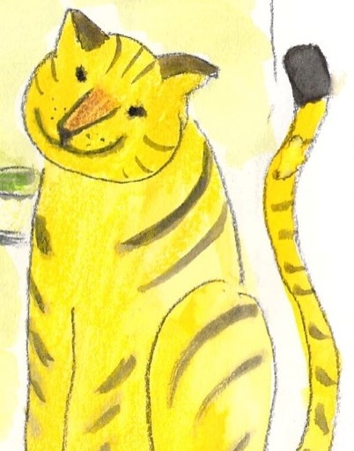

The fliers and the creepers,
The long, the short, the tall;
The crawlers and the leapers,
The feathered, furred and bald;
Hunters, biters, finders, fighters,
Hooters, whistlers, roarers;
Squeakers, screamers, squawkers, dreamers,
Nibblers, gulpers, borers.
Paws and claws from hills and shores
From south, from north, from west and east,
From mountain tops and forest floors
all Zeus’s creatures joined the feast
except
the tortoise

They raved, they pranced, they feasted, danced;
six days and nights each creature stayed
to chatter, flatter, clap and cheer
at the great god Zeus’s grand parade
except
the tortoise
Next day…
Why weren’t you there, my friend, asked Zeus,
the day that I was wed?

The tortoise smiled her small, slow smile
and raised her small, slow head.
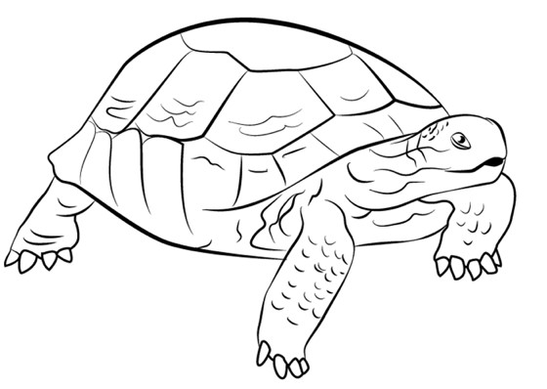
A wedding feast is fun, I guess,
But I’m a simple one.
I’m happy by myself, she said.
There’s no place quite like home!

How dare you stay away! roared Zeus.
I’ll show you just what for!
From this day on you’ll carry your home
On your back, for evermore!

Judith Nicholls (The Works p57)
Unit 1 Day 3

Revision Card – Direct Speech
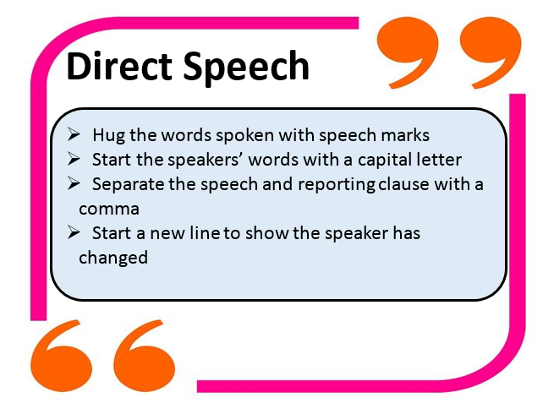

Speech Bubbles
Zeus Tortoise

Story Plan

How will you introduce your story?
What will be the first event?
What will happen next?
What will be your final event?
How will you round off your story?

Zeus and the Tortoise

Write your story here.

