What to do today
IMPORTANT Parent or Carer – Read this page with your child and check that you are happy with what they have to do and any weblinks or use of internet.

1. Listen to a story
- Listen to the reading of The Great Kapok Tree by Lynne Cherry.
https://www.youtube.com/watch?v=J1Teb-_jTyI
- What do you like about this story? Is there anything that you dislike? What patterns can you spot?
- Read the First Page. What type of words are in bold on this page?

2. Revise verbs
- Use the Revision Card to remind yourself about verbs.
- Read the Second Page. Highlight the verbs that you can find on this page.

3. Now for some writing
- Complete Changing Verbs. Write the verbs in the present tense and think of synonyms (other words that mean something similar).
- Now write some sentences that use these verbs and synonyms. Try a mix of sentences in the present and past tense.

Well done. Share your sentences with a grown-up, who can check that they make sense. You can check your Second Page highlighting at the end of this pack.

Try the Fun-Time Extras
- Find out more about Kapok trees. You could start by watching this video:
https://www.youtube.com/watch?v=nCftbqisA3A
- Start a list of unusual verbs. Look in your reading books or ask somebody in your house.

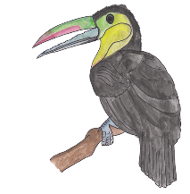
First Page

Two men walked into the rain forest.
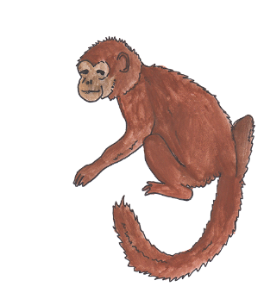
Moments before the forest had been alive with the sounds of squawking birds and howling monkeys. Now all was quiet as the creatures watched the two men and wondered why they had come.
The larger man stopped and pointed to a great Kapok Tree. Then he left.
Revision Card - Verbs
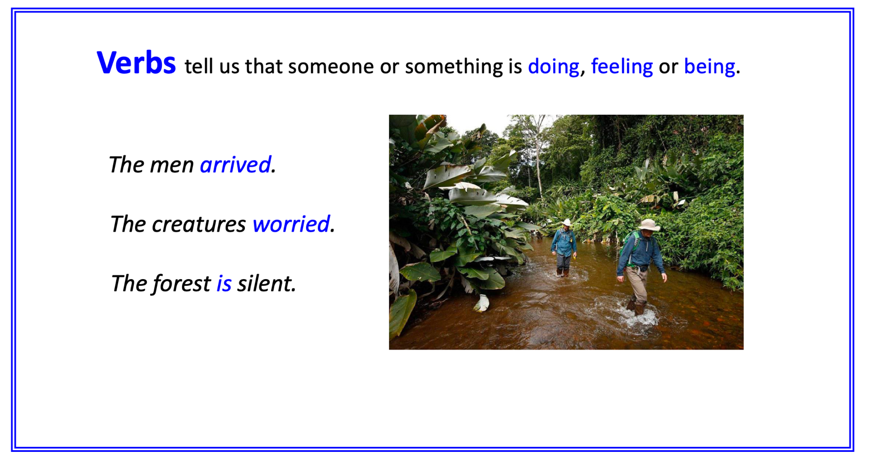
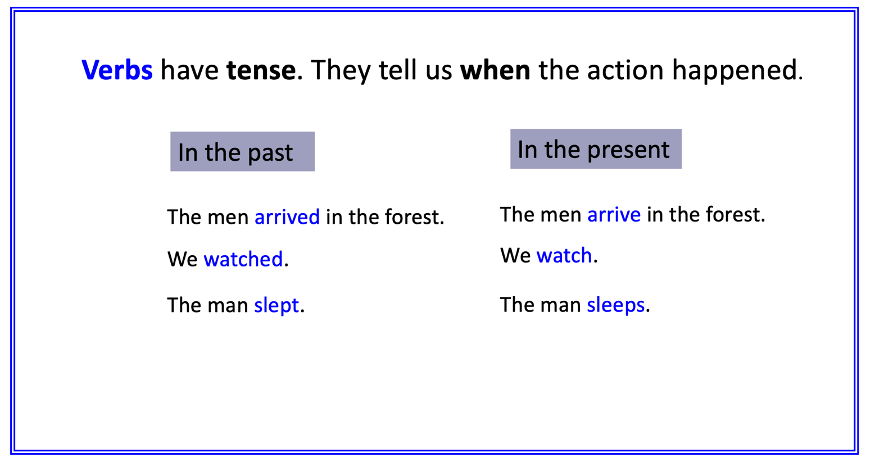
Second Page

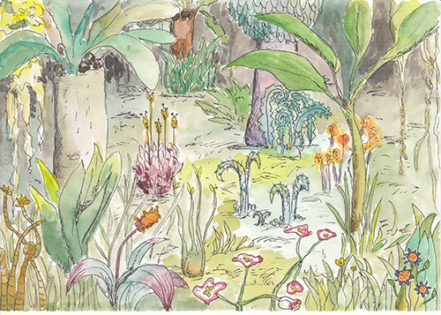
The smaller man took the axe he carried and struck the trunk of the tree. Whack! Whack! Whack! The sounds of the blows rang through the forest. The wood of the tree was very hard. Chop! Chop! Chop! The man wiped off the sweat that ran down his face and neck. Whack! Chop! Whack! Chop!
Soon the man grew tired. He sat down to rest at the foot of the great Kapok tree. Before he knew it, the heat and hum of the forest lulled him to sleep.

Changing verbs

Past tense | Present tense | Synonyms
he took | takes | grabs, picks-up, grasps
he carried | carries
he struck
sounds rang
it was
he wiped
that ran
he grew
he sat
he knew
heat lulled him

Sentences

Second Page – Verbs Highlighted

The smaller man took the axe he carried and struck the trunk of the tree. Whack! Whack! Whack! The sounds of the blows rang through the forest. The wood of the tree was very hard. Chop! Chop! Chop! The man wiped off the sweat that ran down his face and neck. Whack! Chop! Whack! Chop!
Soon the man grew tired. He sat down to rest at the foot of the great Kapok tree. Before he knew it, the heat and hum of the forest lulled him to sleep.

