What to do today
IMPORTANT Parent or Carer – Read this page with your child and check that you are happy with what they have to do and any weblinks or use of internet.

1. Read a poem
- Read the poem: Claws. Read it twice: once in your head and once out loud.
- Read the Poetry Questions. Think about your answers and then write some of them as sentences.

2. Remind yourself about metaphors and similes
- Use the Revision Card to remind yourself about metaphors and similes.
- Complete Metaphors and Similes Practice. Try writing a metaphor or simile for each of the pets. Challenge yourself to write more than one for some of them. Which is your favourite metaphor or simile? Why?

3. Plan and write a poem
- Think about a pet that you know or have seen or imagine one from the pictures.
- Write ideas in Poem Ideas.
- Try organising your ideas so that they look and sound like a poem. What patterns can you use? Write your poem out carefully.

Well done! Now show a grown-up your poem. Show them any metaphors or similes that you have used.

Try these Fun-Time Extras
- Can you perform your poem, record your performance and share it with somebody else?
- Can you make an illustration for your poem?

Claws

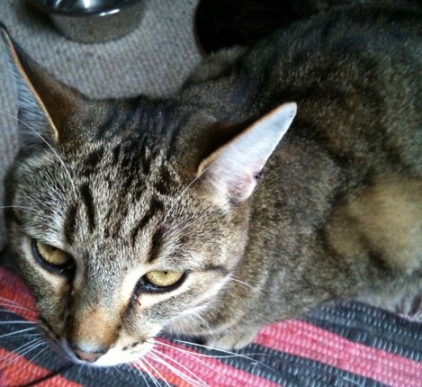  If my cat  were a fish, he’d be a shark.  A big shark.  A big, mean shark.  A Great White Shark.  But he’s not a fish.  He’s a cat.  A big cat.  A big, mean cat.  A Great White Cat  who cruises the neighbourhood  terrorising any creature  he happens to meet.  Birds wing away  when he prowls the gardens.  Other cats scat  when he struts his stuff  and even dogs make sure  they’re somewhere else  when he’s around. | He’s rough. He’s tough.  He’s terrible to behold.  More terrible  than any tiger.  Sometimes he disappears  for days and days  and days  but just when  I start to think  I’ll never see him again  in he strolls  pushing through the cat-flap  as if he’s never been away  and he jumps up  into my lap  and curls himself  around himself  and falls asleep  purring like a Porsche  while I stroke him  and stroke him  and tell him  over and over again  that he’s  the Best Cat  in the Whole Universe.  By Tony Langham

Poetry Questions

What do you like about the poem? Is there anything that you dislike about it? | Does the poem remind you of anything that you have ever read? Does it remind you of any person you know? Does it remind you of anything that has happened to you?
What patterns can you find in the poem? Are any of the words or phrases linked with other words or phrases? How? | What puzzles does the poem leave? What questions does it make you want to ask?

Revision Card – Metaphors and Similes

To describe something, we often compare it to something else.  Sometimes we write a simile  The cat was as regal as the Queen of Sheba  The cat was as still as a statue.  A simile is a comparison where we say one thing is like something else. | 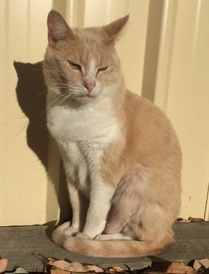

Sometimes we say that something IS something else in order to make a strong comparison. This is a metaphor.

My cat is a flash of lightning.
This means that the cat is like a flash of lightning – it runs really fast!

My dog is a pig.
This means that the dog is like a pig – it is very greedy about food.

To write a simile or a metaphor….

Think of a characteristic of your pet | E.g. My rabbit is really soft
Think of something which is known for having that characteristic. | E.g. A baby’s blanket
Compare your pet to that thing | My rabbit is like my favourite blanket (simile)  My rabbit is my favourite blanket. (metaphor)

Metaphors and Similes Practice
Write a simile or metaphor for each of these pets. Think of something about them, think of something else that has that characteristic, then compare the pet to that thing.

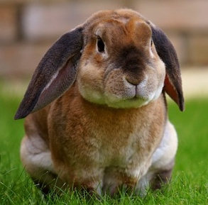
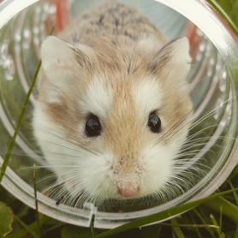
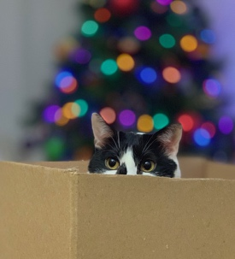
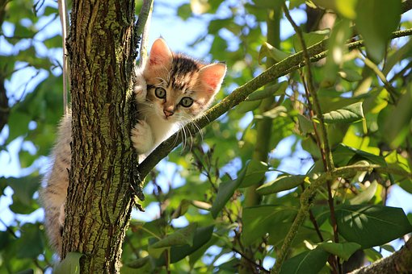

Poem Ideas

What is special about the pet?

What do you notice most about its appearance?

What’s the funniest thing it has done?

How would you describe its character?

What metaphors or similes describe this pet?
Pet Poem

Write your poem out carefully.

