What to do today
IMPORTANT Parent or Carer – Read this page with your child and check that you are happy with what they have to do and any weblinks or use of internet.

1. Think about a picture
- Look at the picture: My Pet. What do you think has happened just before this picture was taken? What might happen next? What names would you give these dogs? Who might own them?
- Can you think of three reasons why people like to keep pets?
- Make notes about your answers or tell someone about them.

2. Read a poem
- Read the poem: My Dog. Read it two times, once in your head once out loud.
- Read and think about the Poetry Questions. Write some of your answers as clear sentences.

3. Read a poetry collection
- Read the poems in Animal Poetry Collection.
- Read at least three of the poems. Challenge yourself to read them all.
- Complete Poetry Notes and write about your favourite poem.

Well done. Share the poems with a grown-up. Do they have the same favourite as you?

Try these Fun-Time Extras
- Can you practise reading your favourite animal poem, then record it and share your recording with someone else?
- Can you make an illustration for your favourite animal poem?

My Pet

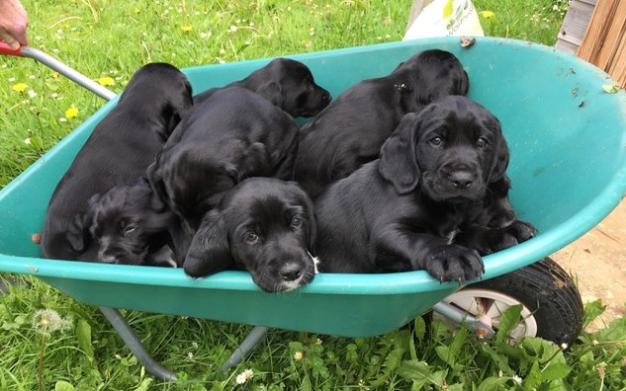

My Dog by Vernon Scannell

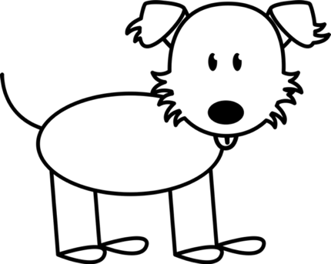

My dog belongs to no known breed,
A bit of this and that,
His head looks like a small haystack,
He’s lazy, smelly, fat.

If I say, ‘Sit!’ he walks away,
When I throw stick or ball
He flops down in the grass as if
He had no legs at all.

Then looks at me with eyes that say,
‘You threw the thing, not me,
You want it back? Then get it back,
Fair’s fair, you must agree.’

He is a thief. Last week but one
He stole the Sunday roast
And showed no guilt at all as we
Sat down to beans on toast.

The only time I saw him run –
And he went like a flash –
Was when a mugger in the park
Tried to steal my cash.

My loyal brave companion flew
Like a missile to the gate
And didn’t stop till safely home,
He left me to my fate.

And would I swap him for a dog
Obedient, clean and good,
An honest, faithful, lively chap?
Oh boy, I would, I would!

(Read Me Out Loud p310)

Poetry Questions

What do you like about the poem? Is there anything that you dislike about it? | Does the poem remind you of anything that you have ever read? Does it remind you of any person you know? Does it remind you of anything that has happened to you?
What patterns can you find in the poem? Are any of the words or phrases linked with other words or phrases? How? | What puzzles does the poem leave? What questions does it make you want to ask?

Animal Poetry Collection
Page 1
Mother doesn’t want a dog  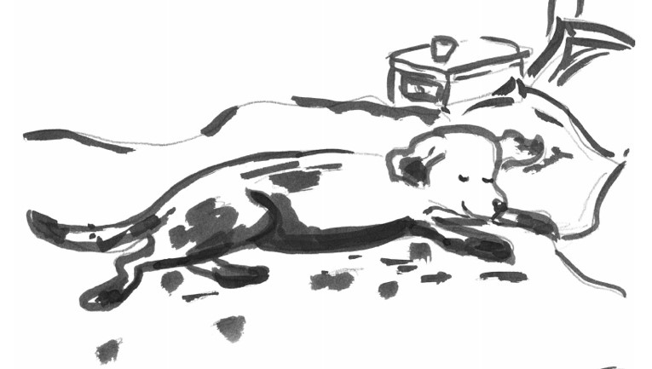  Mother doesn't want a dog.  Mother says they smell,  And never sit when you say sit,  Or even when you yell.  And when you come home late at night  And there is ice and snow,  You have to go back out because  The dumb dog has to go.  Mother doesn't want a dog.  Mother says they shed,  And always let the strangers in  And bark at friends instead,  And do disgraceful things on rugs,  And track mud on the floor,  And flop upon your bed at night  And snore their doggy snore.  Mother doesn't want a dog.  She's making a mistake.  Because, more than a dog, I think  She will not want this snake. by Judith Viorst | The Dog Lovers  So they bought you  And kept you in a  Very good home  Central heating  TV  A deep freeze  A very good home-  No one to take you  For that lovely long run-  But otherwise  'A very good home'  They fed you Pal and Chun  But not that lovely long run,  Until, mad with energy and boredom  You escaped- and ran and ran and ran  Under a car.  Today they will cry for you-  Tomorrow they will buy another dog.  by Spike Milligan

Page 2
Black Cat  Sleepy-purred cat peers out  from the nest of my duvet  eyes glinting green gold black  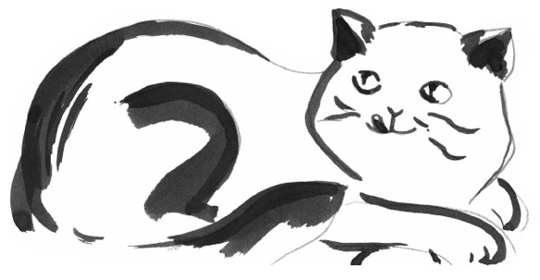  He yawns  mouth prawn-pink.  Settles.  Sleek black paw  over coal black nose  and sleeps.  by Suzanne Elvidge  The Dog  The truth I do not stretch or shove  When I state that the dog is full of love.  I've also found, by actual test,  A wet dog is the lovingest.  By Ogden Nash | Barry’s Budgie… Beware!  Dave’s got a dog the size of a lion  Half-wolf, half-mad, frothing with venom  It chews up policemen and then spits them out  But it’s nothing to the bird I’m talking about.  Claire’s got a cat as wild as a cheetah  Scratching and hissing, draws blood by the litre  Jumps high walls and hedges, fights wolves on its own  But there’s one tough budgie it leaves well alone.  Murray my eel has teeth like a shark  Don’t mess with Murray, he’ll zap out a spark  But when Barry’s budgie flies over the houses  Murray dims down his lights, blows his own fuses.  This budgie’s fierce, a scar down its cheek  Tattoos on its wings, a knife in its beak  Squawks wicked words, does things scarcely legal  Someone should tell Barry it’s really an eagle.  by David Harmer

Page 3
My Praying Mantis  I once had a mantis as a pet  A praying mantis, you must not forget,  is the tiger of the insect world,  hungry, fierce and extremely bold,  and if you are an insect, keep away  should a mantis be lurking where you play.  Anyway my mantis was my very best friend.  He sat on my shoulder and I did defend his  insect’s right to stay with me,  protect him from people’s curiosity;  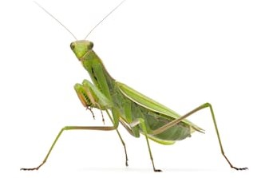 | for they thought it very strange  the way his body was arranged.  For a start his neck was very long,  and his heart-shaped head did not belong  to that thin neck and bulbous abdomen  or toothed arms as strong as ten,  wings which gave him speed in flight  when he attacked and with delight  grabbed a cockroach for his supper,  tore and ate it with his choppers.  However, one day, Phoebe, the neighbour’s cat,  gobbled up my mantis and that was that.  Phoebe licked her lips, seemed satisfied  with a chewed up mantis in her inside.  I suppose, for a mantis, the moral to this story  Is, look out for cats or you’ll be sorry.  by John Lyons

Page 4
The Gerbil  “Can we have a gerbil, Mum?”  “We can’t,” is what Mum said.  “I’m sorry, love,” she added.  “I’m having a baby, instead.”  “I’d rather have a gerbil, Mum  I’d like a pet,” I said,  But what I’ll get is a baby,  With a face all screaming and red.  “I’ll tell you what,” said Mother,  “I’ll tell you what we’ll do.  If you help me with the baby,  You can have a gerbil, too.”  I got the gerbil I wanted,  And I help Mum every day.  The baby isn’t too bad –  But the gerbil’s quieter, I’d say.  by Tony Bradman | Rabbit Poem  To keep  a rabbit  is a good  habit.  A rabbit is truly curious:  his eyes are soft  but his whiskers wiggle  and his nose twitches  and his ears jiggle  and his tail  is a bump  on  his rump.  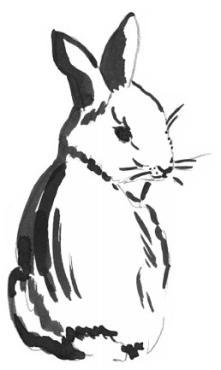 | A rabbit  Is cheerful  but not especially  careful  about multiplying:  the answers  he gets  to the simple  sum  of one and one  are mystifying…  A rabbit Is easy  to care for:  to munch on grass  is what he’s hare for.  So if you get  the chance  to have a rabbit  grab it!  by Pamela Mordecai

Feedback on poems

Poem | Like or not?  (Give a score) | Patterns I noticed. | Questions I have.
Mother doesn’t want a dog
The Dog Lovers
Black Cat
The Dog
Barry’s Budgie… Beware!
My Praying Mantis
The Gerbil
Rabbit Poem
My favourite poem is… ________________________________________
My reasons are….

