What to do today
IMPORTANT Parent or Carer – Read this page with your child and check that you are happy with what they have to do and any weblinks or use of internet.

1. Look closely at an illustration
- Look at New Characters. These are six possible new characters that could join Mario in a game.
- Label each character, writing about 3-5 things that you notice about them.

2. Remind yourself about word classes
- Use the Revision Card to remind yourself about word classes.
- Complete Character Sentences. Invent a name for each of the six new characters, fill in the grid for them and then write a sentence about them.

3. Now for some writing
- Make up a story about some of the new characters.
- Try to include adjectives and adverbs in your story.

Well done! Now read your story to a grown-up. Can you tell them the adjectives and adverbs that you have used? Can you ask them to spot any nouns or verbs that you have used?

Try these Fun-Time Extra
- Can you make a scene from your story? You could act it out with others or could use toys.
- Can you read your story to someone who isn’t in your house?
- Can you look in books to collect some really good nouns, adjectives, adverbs and verbs?

New Characters

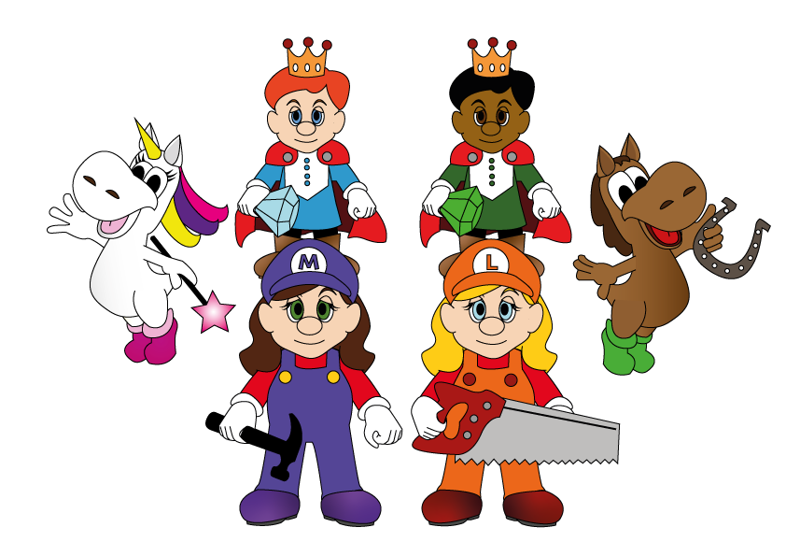

Revision Card – Word Classes

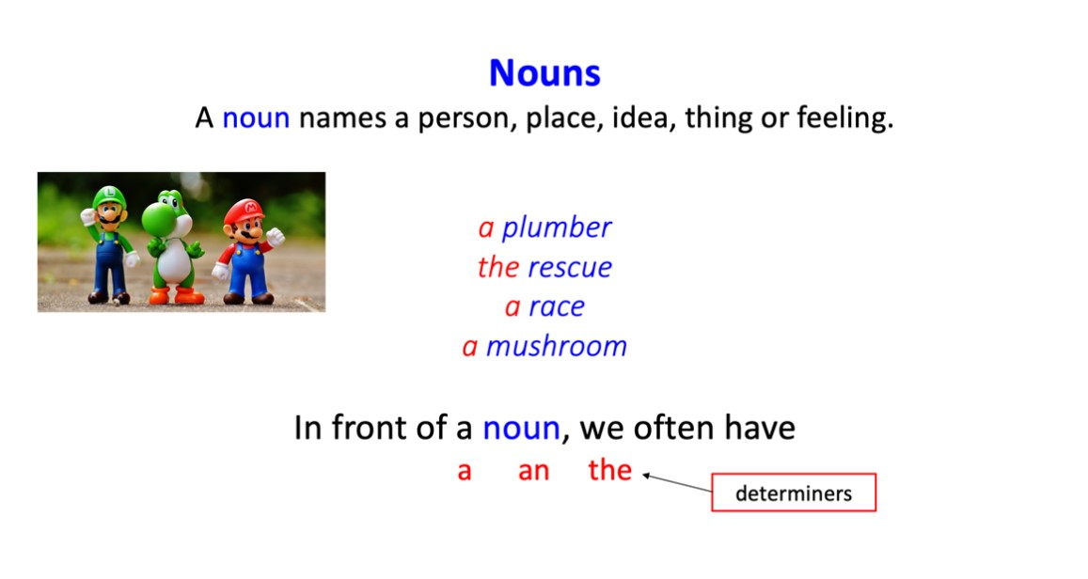 | 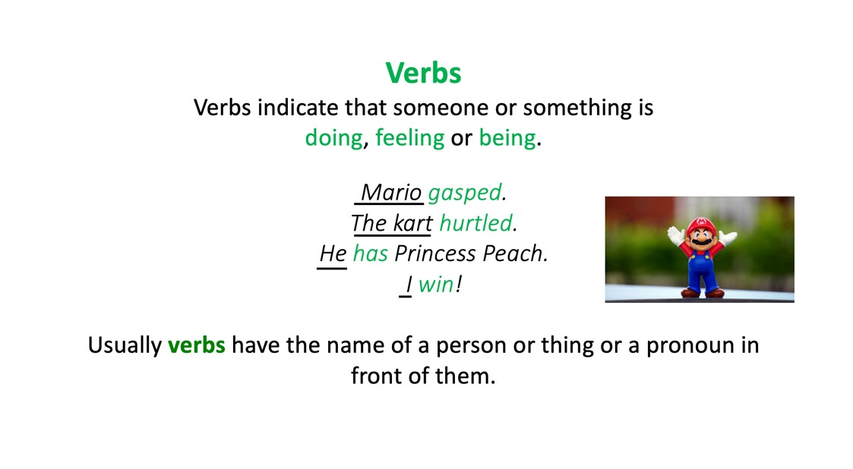
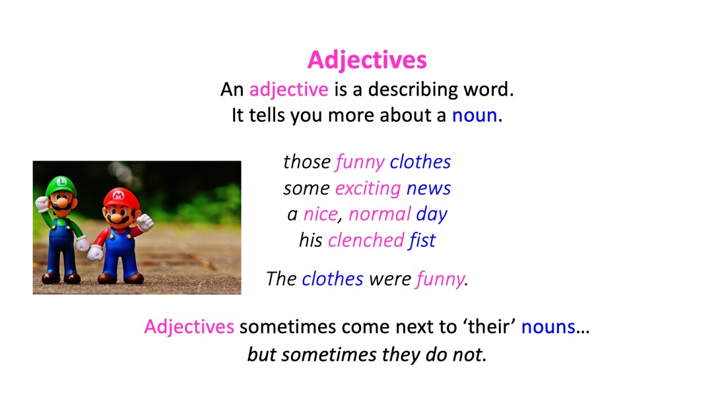 | 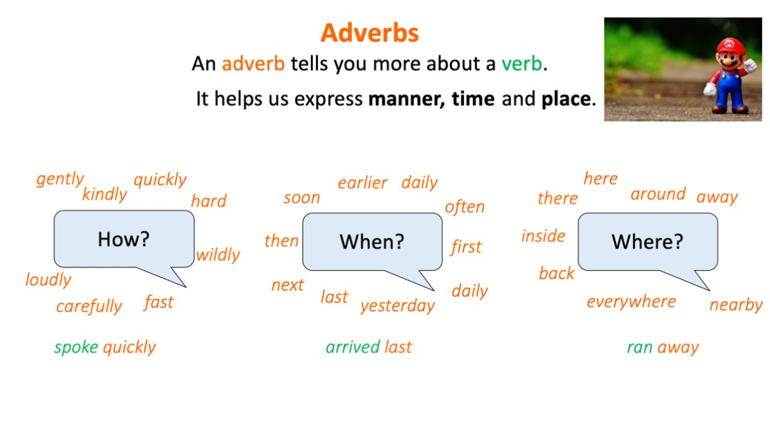

Character sentences

Invent a name for each character. Complete the grid and then use those words to make a sentence for them.
Proper noun | adjective | noun | verb | adverb
Mario | enthusiastic | plumber | jumps | high

Mario is an enthusiastic plumber who jumps high.

Mario Character Story

Take up to three of the characters. Make up a story that involves them. Try to use adverbs and adjectives in your writing.

