What to do today
IMPORTANT Parent or Carer – Read this page with your child and check that you are happy with what they have to do and any weblinks or use of internet.

1. Read a profile
- Read Mario Profile. What questions does this profile answer? What other questions could be answered? Do you know any other information about this video-game character?
- Look at Colourful Writing. Can you work out what each of these colours means? Write a key to the colours on the table provided.

2. Remind yourself about word classes
- Use the PowerPoint teaching word classes. If this not possible, remind yourself using the Revision Card on the same subject.
- Read Profiles 1-3. Collect examples of different word classes from these profiles. Write them on the Word Class Grid.
- Challenge yourself to read Profiles 4-6 and to collect different words from here too.

Well done! Now show a grown-up the words that you have collected. You can check your answers at the end of the pack.

3. Write some sentences
- Write some sentences about a video-game that you know.
- When you have written them, highlight the different classes of words that you have used. Can you add any adjectives or adverbs to your writing?

Try this Fun-Time Extra
- Use the descriptions in the profiles to draw each of the characters.
- Add labels to your drawings to show the different things that you have included.

Mario Profile
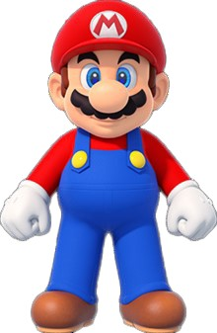

Mario is a short, Italian plumber with a round portly tummy. He lives within the Mushroom Kingdom with his younger brother, Luigi. Mario usually wears a long-sleeved red shirt, a pair of blue overalls with yellow buttons and a red cap. Mario has countless adventures that usually result in him bravely rescuing Princess Peach from the villain, Bowser.
Mario jumps high and is widely known for his jump-stomp move which can entirely crush smaller enemies. This attack often enables Mario to quickly knock the turtle-like Koopa Troopas into or out of their shells. He can also perform an impressive back-flip and the Wall Kick, which rapidly propels him upwards by kicking off walls.

Mario - Colourful Writing
Mario is a short, Italian plumber with a round portly tummy. He lives within the Mushroom Kingdom with his younger brother, Luigi. Mario usually wears a long-sleeved red shirt, a pair of blue overalls with yellow buttons and a red cap. Mario has countless adventures that usually result in him bravely rescuing Princess Peach from the villain, Bowser.
Mario jumps high and is widely known for his jump-stomp move which can entirely crush smaller enemies. This attack often enables Mario to quickly knock the turtle-like Koopa Troopas into or out of their shells. He can also perform an impressive back-flip and the Wall Kick, which rapidly propels him upwards by kicking off walls.

Write the word classes here

blue | pink | orange | green

Revision Card – Word Classes
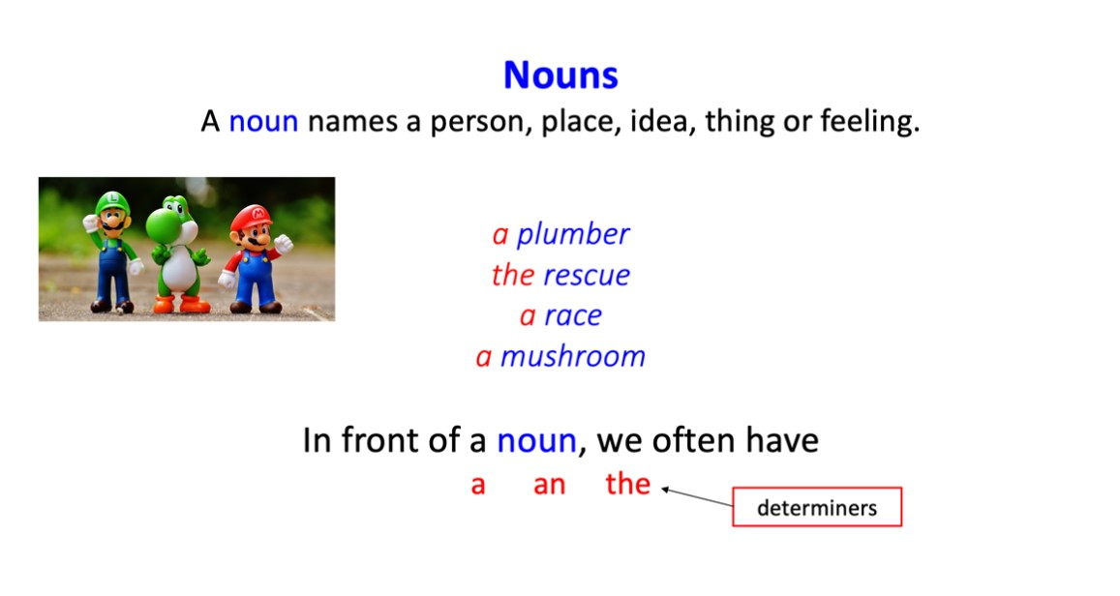 | 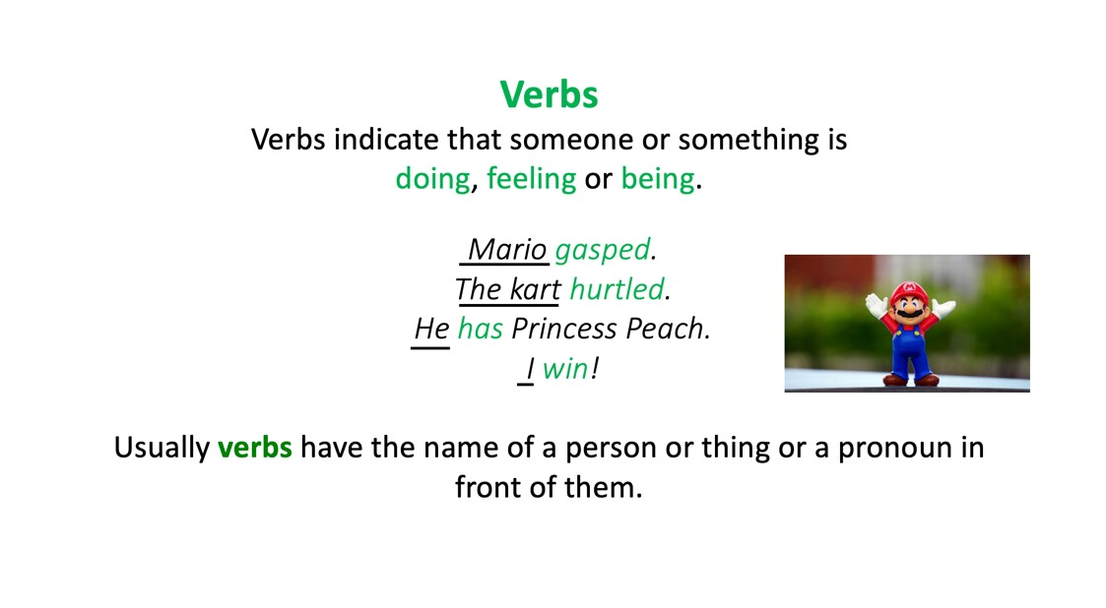
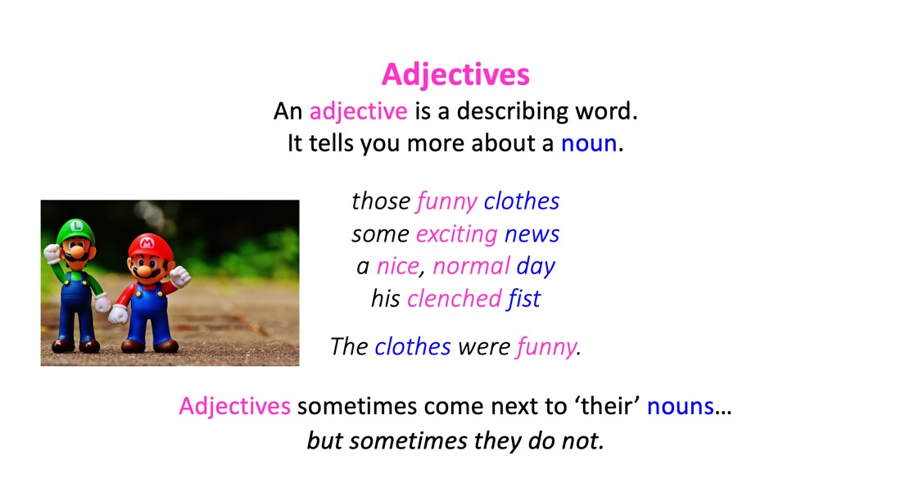 | 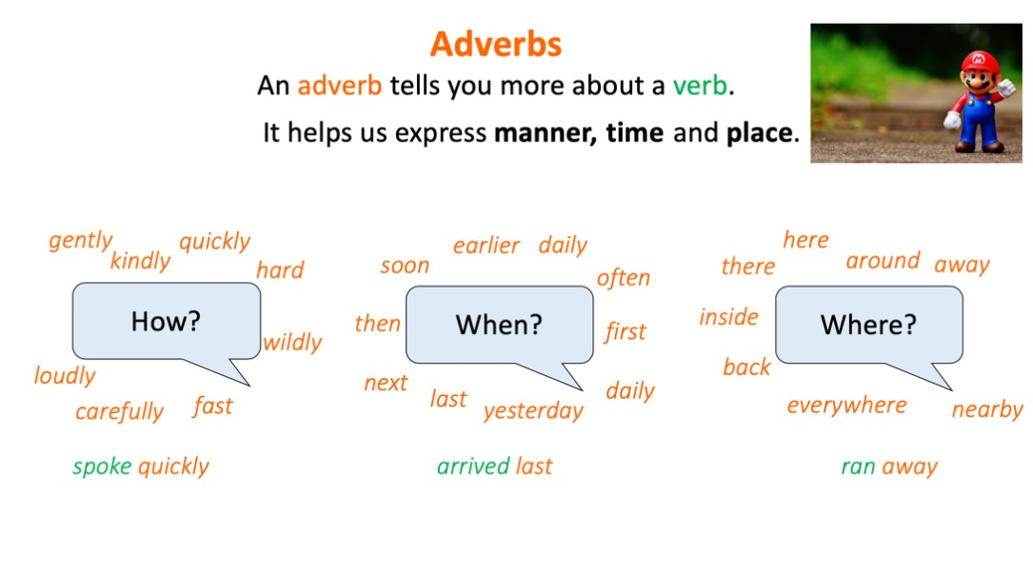

Profiles 1 to 3

Princess Peach
Princess Peach has long, blonde hair and blue eyes. She is tall and usually wears a pink evening gown with frilly trimmings. Her hair is sometimes pulled back into a high ponytail.
Peach is mostly kind and does not show an aggressive nature, even when she is fearlessly fighting or confronting her enemies.
Although often kidnapped by huge Bowser, Peach is
always happy to have Bowser on the team when a bigger evil threatens the Mushroom Kingdom. She puts previous disagreements aside.

Bowser
Bowser is the King of the Koopas. Koopas are active turtles that live in the Mushroom Kingdom. Bowser has a large, spiked turtle shell, horns, razor-sharp fangs, clawed fingers and toes, and bright red hair. He is hugely strong and regularly breathes fire. Bowser can also jump high. He often kidnaps Princess Peach to lure poor Mario into a trap. Bowser occasionally works with Mario and Luigi to defeat a greater evil. Then they work together.

Luigi
Luigi is taller than his older brother, Mario, and is usually dressed in a green shirt with dark blue overalls. Luigi is an Italian plumber, just like his brother. He always seems nervous and timid but is good-natured. He is calmer than his famous brother. If there is conflict, Luigi will smile and walk away. It is often thought that Luigi may secretly love Princess Daisy.

Profiles 4 to 6

Yoshi
Yoshi is a human-like dinosaur who faithfully acts as Mario and Luigi's faithful sidekick. Wherever the brothers are, Yoshi is often found nearby. The Yoshi species, to which Yoshi belongs, appear in various colours. His grasping tongue can extend a huge distance to successfully grab distant objects or out-of-reach areas. Yoshi sometimes makes high-pitched babyish squeals as well as recognisable words.

Wario
Wario is Mario‘s wicked arch enemy. He has a large head and chin, huge muscular arms, a wide and short, tubby body, and a zig-zag moustache. He always wears a yellow and purple outfit. Wario was a childhood rival to Mario and Luigi who gradually became jealous of their success. He cackles aggressively and often uses exploding bombs. He throws them everywhere.

Toad
Toad is one of Princess Peach's loyal attendants; constantly working on her behalf. He is very small in size but has a large head that hugely resembles a mushroom in shape and colour. Sometimes, Toad appears with a red vest, though he is usually seen with his blue vest. Toad is generally a cheerful character, and quite shy, but he can suddenly become extremely distressed when a major event happens nearby.

Word Classes Grid
adjective | noun | verb | adverb

Video Game Sentences

Write some sentences about a game that you know about. Highlight your words to show the different word classes.

Profiles (answers)
You are not expected to identify every example!

Nouns Verbs Adjectives Adverbs

Princess Peach
Princess Peach has long, blonde hair and blue eyes. She is tall and usually wears a pink evening gown with frilly trimmings. Her hair is sometimes pulled back into a high ponytail. Peach is mostly kind and does not show an aggressive nature, even when she is fearlessly fighting or confronting her enemies. Although often kidnapped by huge Bowser, Peach is always happy to have Bowser on the team when a bigger evil threatens the Mushroom Kingdom. She puts previous disagreements aside.

Bowser
Bowser is the King of the Koopas. Koopas are active turtles that live in the Mushroom Kingdom. Bowser has a large, spiked turtle shell, horns, razor-sharp fangs, clawed fingers and toes, and bright red hair. He is hugely strong and regularly breathes fire. Bowser can also jump high. He often kidnaps Princess Peach to lure poor Mario into a trap. Bowser occasionally works with Mario and Luigi to defeat a greater evil. Then they work together.

Luigi
Luigi is taller than his older brother, Mario, and is usually dressed in a green shirt with dark blue overalls. Luigi is an Italian plumber, just like his brother. He always seems nervous and timid but is good-natured. He is calmer than his famous brother. If there is conflict, Luigi will smile and walk away. It is often thought that Luigi may secretly love Princess Daisy.
Yoshi
Yoshi is a human-like dinosaur who faithfully acts is Mario and Luigi's faithful sidekick. Wherever the brothers are, Yoshi is often found nearby. The Yoshi species, to which Yoshi belongs, appear in various colours. His grasping tongue can extend a huge distance to successfully grab distant objects or out-of-reach areas. Yoshi sometimes makes high-pitched babyish squeals as well as recognisable words.

Wario
Wario is Mario‘s wicked archenemy. He has a large head and chin, huge muscular arms, a wide and short, tubby body, and a zig-zag moustache. He always wears a yellow and purple outfit. Wario was a childhood rival to Mario and Luigi who gradually became jealous of their success. He cackles aggressively and often uses exploding bombs. He throws them everywhere.

Toad
Toad is one of Princess Peach's loyal attendants; constantly working on her behalf. He is very small in size but has a large head that hugely resembles a mushroom in shape and colour. Sometimes, Toad appears with a red vest, though he is usually seen with his blue vest. Toad is generally a cheerful character, and quite shy, but he can suddenly become extremely distressed when a major event happens nearby.

