What to do today
IMPORTANT Parent or Carer – Read this page with your child and check that you are happy with what they have to do and any weblinks or use of internet.

1. Read an extract from Harry Potter
- Read Quidditch. What did Harry learn about Quidditch? Which of these imagined facts is the best would you say?
- Watch the film version of Harry learning the rules of Quidditch. What do you learn from the film that you don’t learn from the book?
https://www.youtube.com/watch?v=thL8QAsPhK0

2. Remind yourself about adverbs
- Use the PowerPoint to hear the teaching about adverbs. If this is not possible, use the Revision Card to remind yourself.
- Complete Adverb Practice.

3. Now for some writing
- Watch the film scene of Harry’s first Quidditch match.
https://www.youtube.com/watch?v=YOVS9yn2R7c
- Write some sentences that use adverbs to describe the match. Use Adverbs List to help you.

Try these Fun-Time Extras
- Can you write some sentences with adverbs about a sport that you enjoy?
- Can you find out more about the rules of Quidditch? You could make a plan to play it when you go back to school.

Quidditch

﻿
The Quidditch season had begun. On Saturday, Harry would be playing in his first match after weeks of training: Gryffindor versus Slytherin. If Gryffindor won, they would move up into second place in the House Championship. | 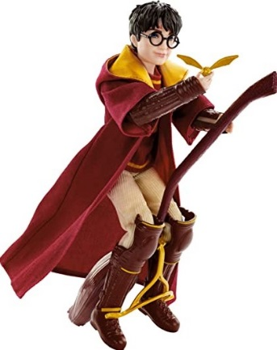
Hardly anyone had seen Harry play because Wood had decided that, as their secret weapon, Harry should be kept, well, secret. But the news that he was playing Seeker had leaked out somehow, and Harry didn’t know which was worse – people telling him he’d be brilliant or people telling him they’d be running around underneath him, holding a mattress.

It was really lucky that Harry now had Hermione as a friend. He didn’t know how he’d have got through all his homework without her, what with all the last-minute Quidditch practice Wood was making them do. She had also lent him Quidditch Through the Ages, which turned out to be a very interesting read.

Harry learnt that there were seven hundred ways of committing a Quidditch foul and that all of them had happened during a World Cup match in 1473; that Seekers were usually the smallest and fastest players and that most serious Quidditch accidents seemed to happen to them; that although people rarely died playing Quidditch, referees had been known to vanish and turn up months later in the Sahara Desert.
JK Rowling - Harry Potter and the Philosopher's Stone

Revision Card – Adverbs

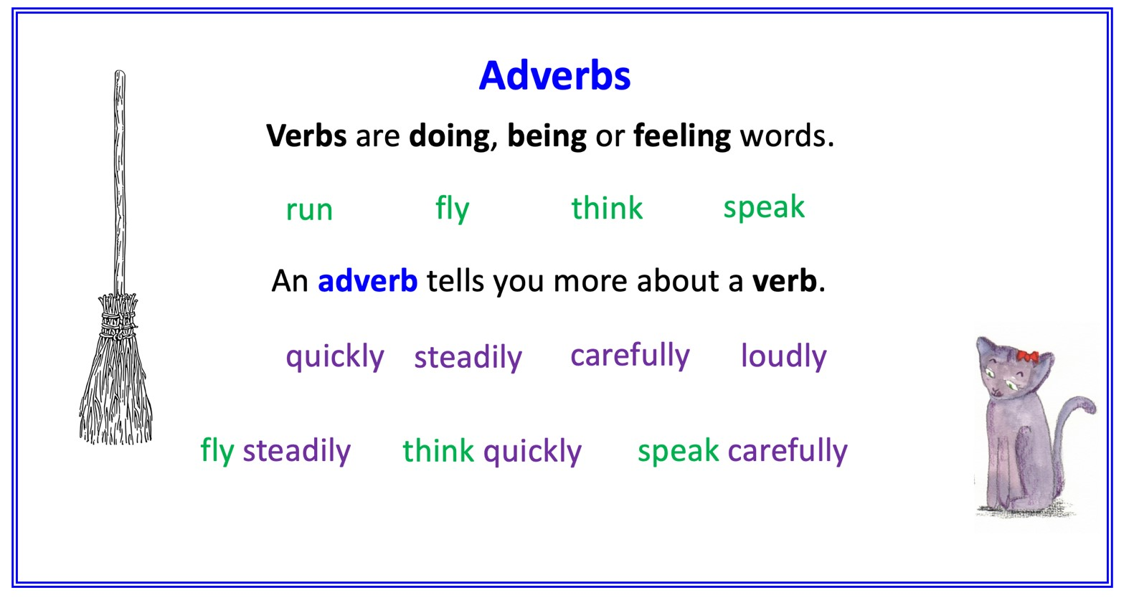
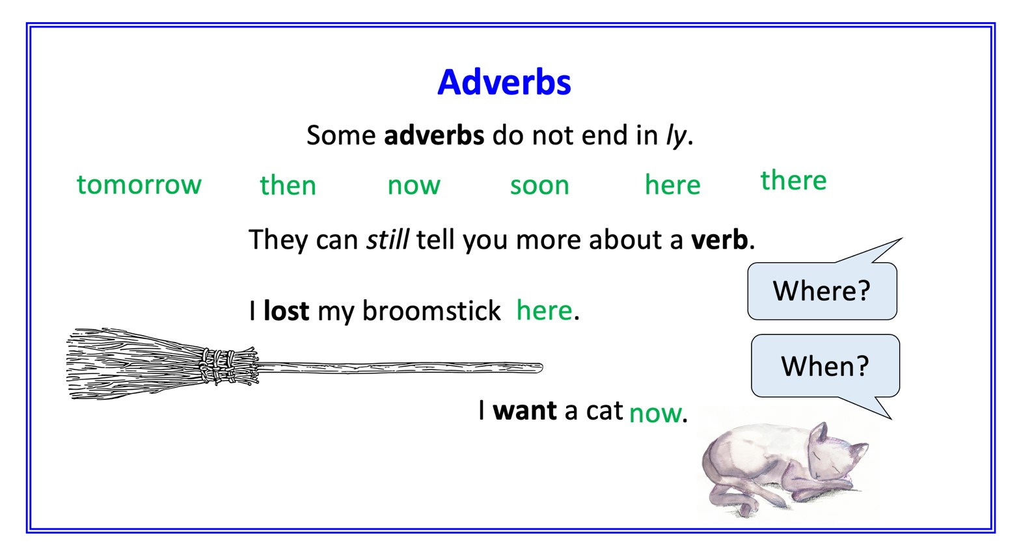

Adverb Practice

Identify the adverbs in each sentence
The 422nd World cup started spectacularly, with amazing fireworks.
Viktor Krum then flew skilfully around the arena.
The Bulgarian fans cheered loudly for their popular seeker.
The game began fast with both teams flying around the stadium.
Ireland scored promptly while Bulgaria played well.
Bulgaria grabbed the quaffle quickly and the teams were finally level.
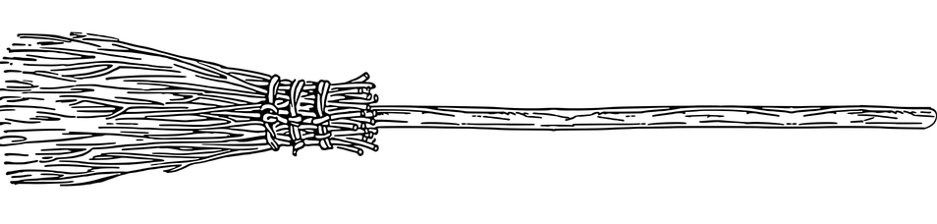

Modify these sentences by adding two new adverbs to each one

e.g. Viktor grabbed the Snitch. could become Victor grabbed the Snitch greedily /quickly /skilfully /tightly etc.

Victor grabbed the snitch.

The quaffle soared.

The Irish players celebrated.

Adverb List

almost | awkwardly | calmly
immediately | easily | rapidly
nearly | defiantly | perfectly
victoriously | well | excitedly
afterwards | fortunately | fast
cheerfully | unfortunately | reluctantly
beforehand | triumphantly | wildly
madly | skilfully | really
quietly | yesterday | honestly

Quidditch Match Sentences

Watch the film version of Harry’s first Quidditch match. Write sentences with adverbs about the match.

Quidditch Report – Answers

Identify the adverbs in each sentence - easier
The 422nd World cup started spectacularly, with amazing fireworks.
Viktor Krum then flew skilfully around the arena.
The Bulgarian fans cheered loudly for their popular seeker.
The game began fast with both teams flying around the stadium.
Ireland scored promptly while Bulgaria played well.
Bulgaria grabbed the quaffle quickly and the teams were finally level.

