What to do today
IMPORTANT Parent or Carer – Read this page with your child and check that you are happy with what they have to do and any weblinks or use of internet.

1. Read an extract from Harry Potter
- Read Broomstick Lesson. How do you think Harry was feeling? How is Madam Hooch described? How would you feel to be taught by her?
- Watch the film version of this scene. Do you notice anything that is different to the book? What is the same?
https://www.youtube.com/watch?v=yTS1VlvlGRg

2. Order the events of the story
- Think about how you would feel at different parts of the Broomstick lesson.
- Complete How would you feel? Use some of the Emotion Vocabulary in your answers.

3. Now for some writing
- Write about taking part in a Broomstick Lesson. Describe what you do and how you feel, what happens to you and what happens to other people.
- Use Conjunctions List and include some sentences with conjunctions joining clauses together.

Try these Fun-Time Extras
- Can you design a broomstick? Make a labelled diagram to show its magical features.
- Can you make your own broomstick charm? Follow the instructions on this video:
https://www.wizardingworld.com/features/learn-how-to-make-broomstick-charm

Broomstick Lesson

﻿ At three-thirty that afternoon, Harry, Ron and the other Gryffindors hurried down the front steps into the grounds for their first flying lesson. It was a clear, breezy day and the grass rippled under their feet as they marched down the sloping lawns towards a smooth lawn on the opposite side of the grounds to the Forbidden Forest, whose trees were swaying darkly in the distance.

The Slytherins were already there, and so were twenty broomsticks lying in neat lines on the ground. Harry had heard Fred and George Weasley complain about the school brooms, saying that some of them started to vibrate if you flew too high, or always flew slightly to the left.
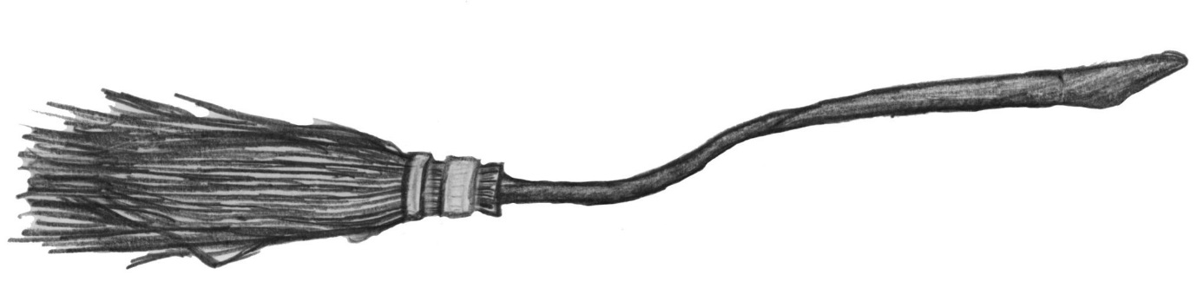
Their teacher, Madam Hooch, arrived. She had short, grey hair and yellow eyes like a hawk.
‘Well, what are you all waiting for?’ she barked. ‘Everyone stand by a broomstick. Come on, hurry up.’
Harry glanced down at his broom. It was old and some of the twigs stuck out at odd angles.
‘Stick out your right hand over your broom,’ called Madam Hooch at the front, ‘and say, “Up!”’
‘UP!’ everyone shouted.

Harry’s broom jumped into his hand at once, but it was one of the few that did. Hermione Granger’s had simply rolled over on the ground and Neville’s hadn’t moved at all. Perhaps brooms, like horses, could tell when you were afraid, thought Harry; there was a quaver in Neville’s voice that said only too clearly that he wanted to keep his feet on the ground.

JK Rowling - Harry Potter and the Philosopher's Stone

How would you feel?

How would you feel as the lesson was starting?
How would you feel as you gave the ‘Up’ command?
How would you feel as you got on your broomstick?
How would you feel as it started to fly?
How would you feel when it came back to land?

Emotion Vocabulary

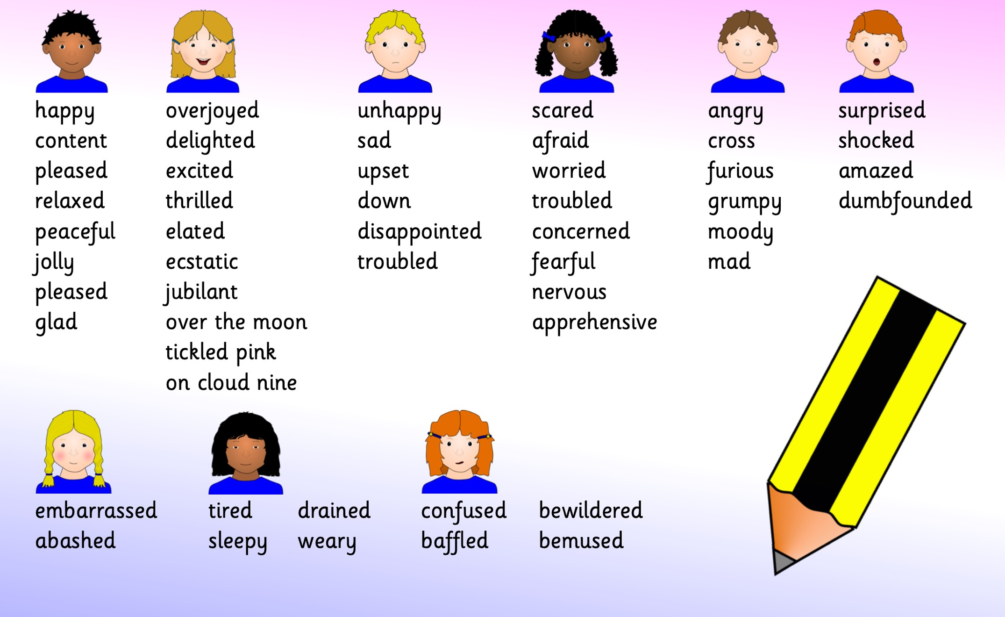

List of Conjunctions

When?
before
after
when
while
as
until

Why?
because
as
so

Where?
where
wherever

Broomstick Lesson
Write about a broomstick lesson. Describe what you do and how you feel, what happens to you and what happens to other people.
Use conjunctions in your writing.

