What to do today
IMPORTANT Parent or Carer – Read this page with your child and check that you are happy with what they have to do and any weblinks or use of internet.

1. Read an extract from Harry Potter
- Read We Got Potter. Now watch the Sorting Hat scene again https://www.youtube.com/watch?v=A0cla_h_f8M
- Which is better at helping you know how Harry is feeling? Why? Why might someone say the opposite?

2. Use Clauses and Conjunctions
- Use the Revision Card to remind yourself about clauses and conjunctions.
- Complete Harry Potter Clauses. Challenge yourself to come up with two or even three versions of each sentence. You can use List of Conjunctions to help you.

Share your sentences with a grown-up. Show them the conjunctions that you have used and the clauses that you have added.

3. Illustrate your sentences
- Choose your three favourite sentences.
- Write them in your best handwriting and illustrate them carefully to make a set of Scenes from Harry Potter.

Try this Fun-Time Extra
- Can you find out more about the main characters in Harry Potter? Could you make a guide about them? You could start with this website: https://www.wizardingworld.com/features/web-harry-potter-whos-who-harry-ron-hermione-hp-at-home

We got Potter!

The last thing Harry saw before the hat dropped over his eyes was the Hall full of people craning to get a good look at him. Next second he was looking at the black inside of the hat. He waited. | 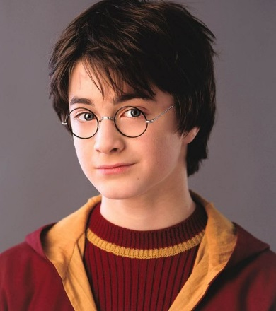
‘Hmm,’ said a small voice in his ear. ‘Difficult. Very difficult. Plenty of courage, I see. Not a bad mind, either. There’s talent, oh my goodness, yes – and a nice thirst to prove yourself, now that’s interesting … So where shall I put you?’ Harry gripped the edges of the stool and thought, ‘Not Slytherin, not Slytherin.’

‘Not Slytherin, eh?’ said the small voice. ‘Are you sure? You could be great, you know, it’s all here in your head, and Slytherin will help you on the way to greatness, no doubt about that – no? Well, if you’re sure – better be GRYFFINDOR!’

Harry heard the hat shout the last word to the whole Hall. He took off the hat and walked shakily towards the Gryffindor table. He was so relieved to have been chosen and not put in Slytherin, he hardly noticed that he was getting the loudest cheer yet. Percy the Prefect got up and shook his hand vigorously, while the Weasley twins yelled, ‘We got Potter! We got Potter!’ Harry sat down opposite the ghost in the ruff he’d seen earlier. The ghost patted his arm, giving Harry the sudden, horrible feeling he’d just plunged it into a bucket of ice-cold water.

JK Rowling - Harry Potter and the Philosopher's Stone
Revision Card – Conjunctions

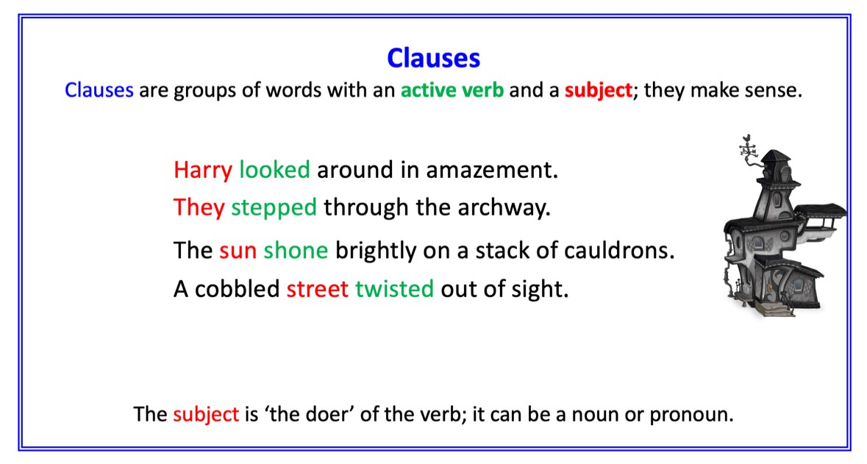 | 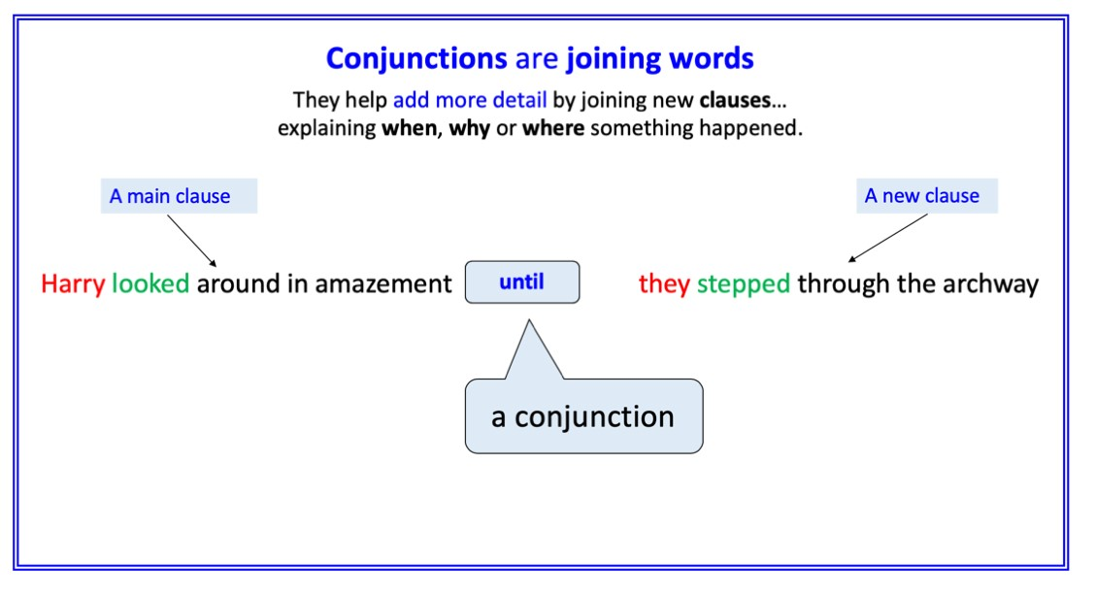
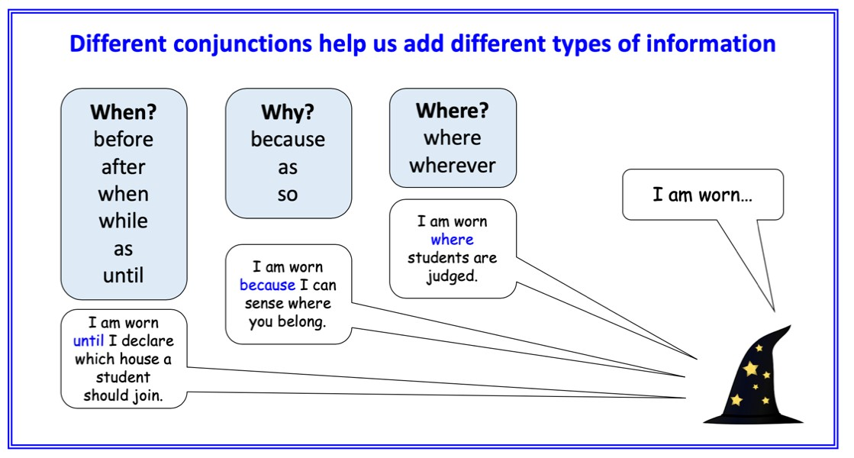 | 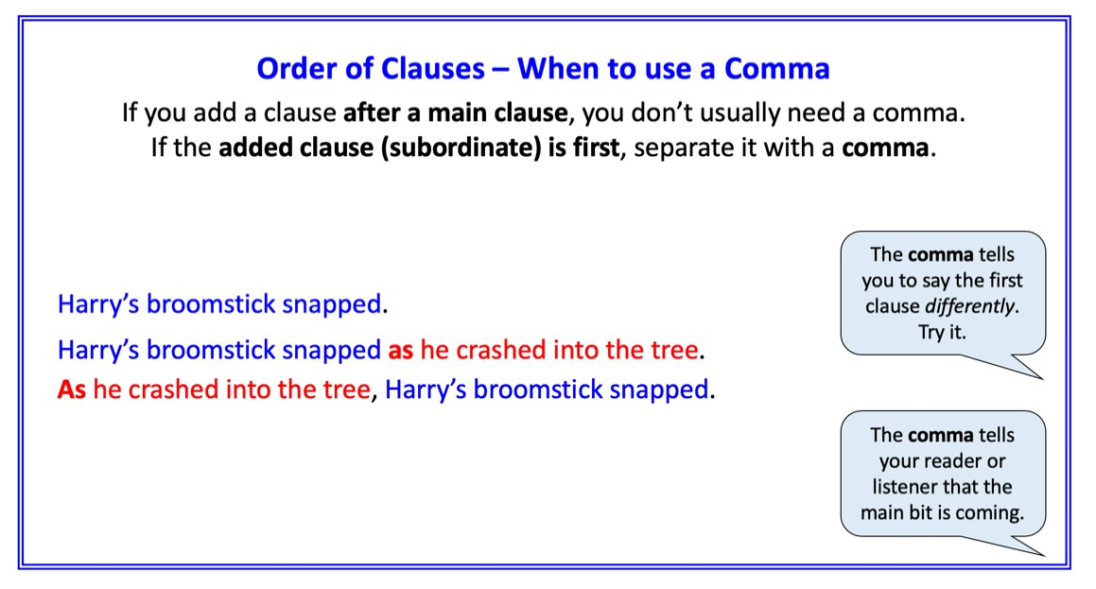

Harry Potter Clauses

Read the sentences and add an extra clause to add more detail.
Choose a conjunction to join the two clauses together.
E.g. Draco sniggered in Crabbe’s ear…. before he kicked Harry’s chair over.

Harry slammed the door shut

They were looking straight in the eyes of a monstrous dog

Neville had never been on a broomstick in his life

Harry picked the soft, shining cloth off the floor

Potions lessons were turning into a sort of weekly torture

List of Conjunctions

When?
before
after
when
while
as
until

Why?
because
as
so

Where?
where
wherever
Scenes from Harry Potter

___________________________  ___________________________  ___________________________  ___________________________ | ___________________________  ___________________________  ___________________________  ___________________________ | ___________________________  ___________________________  ___________________________  ___________________________

