What to do today
IMPORTANT! Parent or Carer – Read this page with your child and check that you are happy with what they have to do and with any weblinks or use of the Internet required.

1. It’s reading time!
Read all about How to Escape a Giant.
- Are all the sentences commands? See if you can spot the sentence that is not a command.
It’s coming to get you!

2. Laying out a set of instructions
Look carefully at the layout of How to Escape a Giant.
- Find and highlight the following features – (i) the heading; (ii) bullet points. Do the bullet points go in order, or are they all jumbled?
- Read Some Instructions. Have these instructions been laid out properly, like they have in How to Escape a Giant?
- Copy out the instructions, reformatting the sentences so that you have a clear heading and numbered or bulleted points in order.

3. Now for some writing
Write a set of instructions for someone coming into your space, whether it’s a part of, or the whole of, a bedroom.
- State some things that person must do if they come into your room.
- Say some things they must not do.
- Use the language and layout features of instructions.

Now try these Fun-Time Extras
- Decorate and/or illustrate your instructions and put them up on your bedroom door!
- Write some other instructions to put in different rooms. E.g. next to taps: Wash your hands carefully; By the back door: Take your shoes off before you come in!

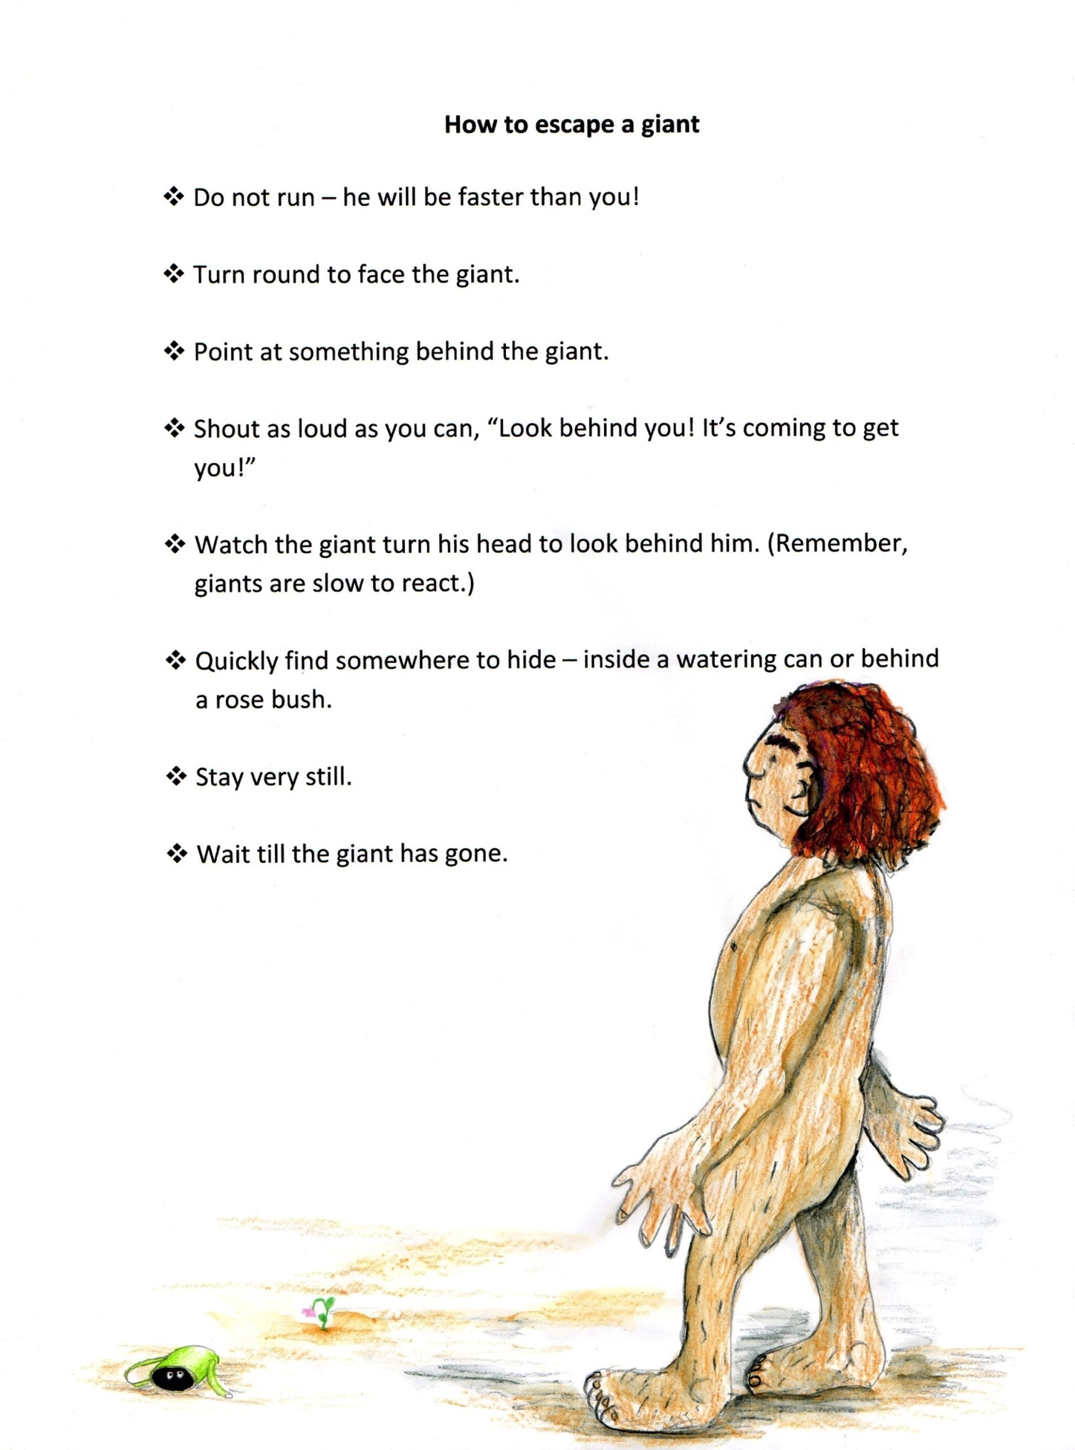
Some Instructions

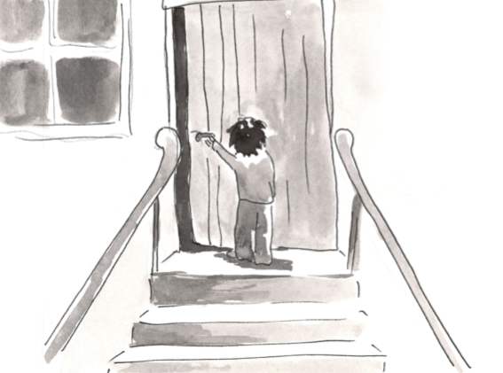

2. Push the door open. 1. Walk up to the door. 3 Walk confidently in (unless it’s a giant’s house in which case – RUN AWAY!) How to open a door.

Instructions – for my space!

