What to do today
IMPORTANT! Parent or Carer – Read this page with your child and check that you are happy with what they have to do and with any weblinks or use of the Internet required.

1. Story time
Re-read the Hamilton Group Reader, Dream On.

2. Finding out about different sorts of sentence
Open the Hamilton PowerPoint, Sentence Types.
- Read the information on identifying and writing questions, statements, exclamations and commands.
- Complete the 2 exercises on the slides. Don’t look at the answers until you have had a go yourself!

3. Identifying different sentences linked to Dream On.
Read each of the Dream On Sentences in turn.
- Say what type of sentence each is – a question, a statement, an exclamation or a command. Write it with correct punctuation.
- Carefully check your work against the Answers page.
Did you get all of them right?

4. Let’s get ready to write
On My Dream, write an account of a dream of your own, made up or real.
- Start like Dream On: I dreamed that I....
- As well as statement sentences, challenge yourself to use a question, an exclamation and a command in your writing.

Now try this Fun-Time Extra
- Do a drawing of your dream to go with your writing.
- Keep a diary of any dreams you have.

Dream on Sentences

- Say what type of sentence each one below is – a question, a statement, an exclamation or a command.  - Write the sentence out, adding all the correct punctuation. | 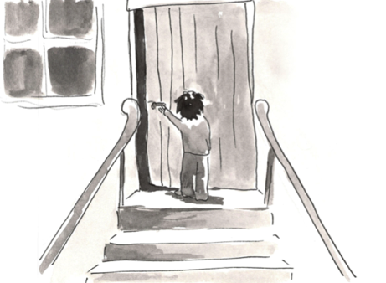

why wasn’t the girl scared ( _______________________ )

___________________________________________________________

the house had a calm, quiet feeling ( _____________________ )

___________________________________________________________

walk upstairs as softly as possible ( _______________________ )

___________________________________________________________

did the thing in the upstairs room want to be seen ( _______________ )

___________________________________________________________

how amazing ( _______________________ )

___________________________________________________________

in dreams, we can realise something important ( ___________________ )

___________________________________________________________

how could she find the house ( _______________________ )

___________________________________________________________

perhaps it only exists in a dream ( _______________________ )

___________________________________________________________

keep on searching ( _______________________ )

___________________________________________________________

what a task ( _______________________ )

___________________________________________________________

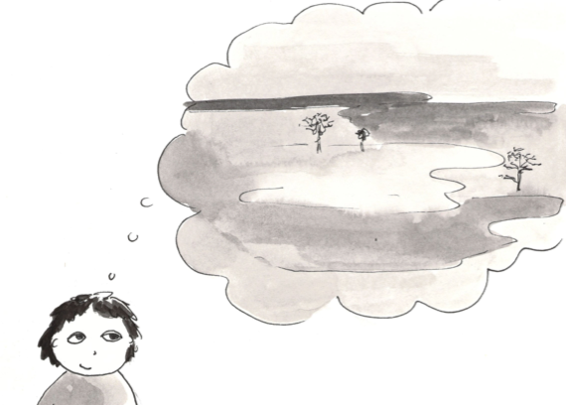

Dream On Sentences

Answers

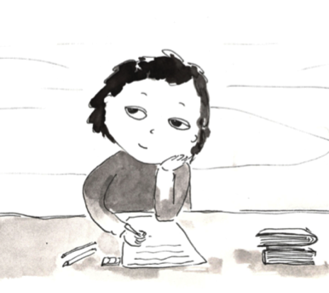

Why wasn’t the girl scared? question

The house had a calm, quiet feeling. statement

Walk upstairs as softly as possible. or ! command

Did the thing in the upstairs room want to be seen? question

How amazing! or . exclamation

In dreams, we can realise something important. statement

How could she find the house? question

Perhaps it only exists in a dream? question

Keep on searching. or ! command

What a task! or . exclamation

My Dream

