What to do today
IMPORTANT! Parent or Carer – Read this page with your child and check that you are happy with what they have to do and with any weblinks or use of the Internet required.

1. It’s reading time!
Read and enjoy the Hamilton Group Reader, Dream On.

2. Comprehension
Read each of the Questions about Dream On.
- Write your answers in the spaces provided.
- Go back and check with the story if you are not sure of an answer.
- Re-read your answers to check that what you have written makes sense.

3. Let’s get ready to write
What do you think the thing in the room was?
- Read the suggestions at the top of The Thing in the Room.
- Decide what you think the creature was and do a drawing of it.
- Write a good paragraph about what you think was in the room. Use full sentences, remembering to use a capital letter and full stop for each one.

Now try this Fun-Time Extra
- What are the best things to do if you have a slightly scary dream? On What to do if you have a scary dream, write some instructions for things to help you to feel better and go back to sleep.

Questions about Dream On

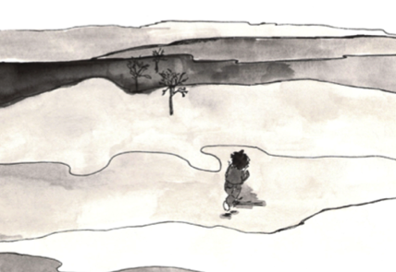

What is the girl doing at the very start of the story?

______________________________________________________________

Which of these lines best describes the trees that the girl runs through in her dream?

Short and wide with lots of leaves __________________________________
Spaced far apart with high branches ________________________________
Bare and skinny with long scratchy branches _________________________
Peaceful and calm with birds singing in them _________________________

The girl says the house in her dreams was a crazy house. Why do you think she called it a ‘crazy’ house?
____________________________________________________________________________________________________________________________
Would you have gone through the door into the crazy house like the girl does? Why/ why not?
____________________________________________________________________________________________________________________________
______________________________________________________________

She says the room inside the house was massive. Can you think of some other words that mean the same thing as massive? How many can you come up with?

______________________________________________________________

In your own words, describe what the inside of the house is like.

____________________________________________________________________________________________________________________________
______________________________________________________________

The girl says her heart was in her mouth. What does my heart was in my mouth mean?

______________________________________________________________

Would you have been more frightened or excited to go into the room where the thing was breathing and moving around? Why is that?

____________________________________________________________________________________________________________________________
______________________________________________________________
______________________________________________________________

Does the little girl seem to be happy or sad at the end of the story? Why do you think that?

____________________________________________________________________________________________________________________________
______________________________________________________________

The Thing in the Room
What do you think was in the room?
Could it have been an angel? What things in the story might make us think that?
Could it have been a fairy or a bird? Maybe it was a giant butterfly, or a ghost – or a dragon?

Decide what you think the thing was. Think really hard about what it looked like. Consider its personality too – was it a kind or a fierce creature? Do you think it was scared of the girl or did it want to be her friend?

What to do if you have a scary dream

