What to do today
IMPORTANT! Parent or Carer – Read this page with your child and check that you are happy with what they have to do and with any weblinks or use of the Internet required.

1. It’s reading time!
Go back to https://www.youtube.com/watch?v=Ra4pZ3OTUKA&t=32s and re-listen to Instructions by Neil Gaiman.

2. Thinking about verbs
Say what a verb is – the ‘doing’ or ‘action’ word in a sentence. Remind yourselves by reading Verbs.
- There are 9 verbs in the box of words on Dragon Trapping. How many can you find?
- Check the Answers to see if you got all of them. Well done!
- Now re-read Features of Instructions and highlight the verbs. The first two have been done for you.
- Are the verbs all bossy? Are they all at or near the beginning of the sentence? Confirm that in each case, they are. Check the Answers.

3. Finding bossy verbs, writing bossy sentences
Read The Magic Cottage.
- Highlight all the bossy, instructional verbs.
- Follow the rest of the instructions.

Now try this Fun-Time Extra
- Look at the picture of the Months of the Year sitting round the fire. Learn the order of the months of the year by heart. Try learning the spellings – Look, cover write, check. Which months are special to you? Why is that?

Verbs

A verb names an action.
It is a doing or being word.
A verb often has one of these words in front of it.
It
He
She
You

I
We
They

OR
The name of a person or thing

I run quickly. He chases me. It rains heavily.
We laugh. The dog feels sad. The cat was mean.

What a bad day the dragon was having.

Dragon Trapping

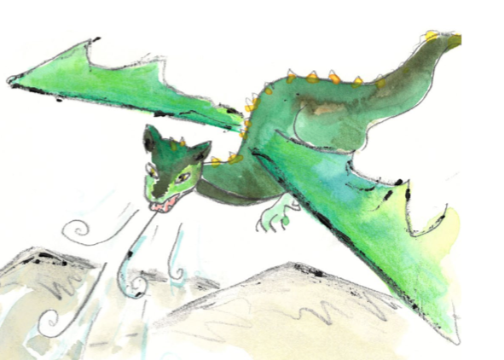

Which of these words are verbs?

dragon wriggle food follow hide cave teeth
catch flames tree brave jump run wings
fly nets potion sword wait charge huge

Dragon Trapping

Answers

dragon wriggle food follow hide cave teeth
catch flames tree brave jump run wings
fly nets potion sword wait charge huge

The Features of Instructions

Instructions are sentences that give a commands or orders. They are bossy and tell the reader what to do. They:

- are usually short, sharp sentences that do not contain much description or story language.

Open the gate. Go down the garden path.

- always contain bossy verbs that tell someone what to do or not do.
These verbs are always in the present tense. They come at or near the beginning of the sentence.

Listen for the doorbell. Do not use the doorknocker.

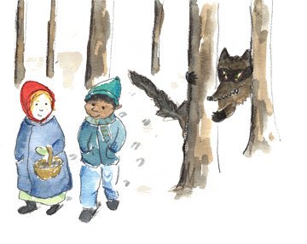
- are addressed to the reader, as if the reader is being spoken to directly by someone.

Go into the wood.
Watch out for the wolves.

- often ‘list’ things to do or avoid doing.

Walk through the wood, jump over the wall and then climb into the tree.

- can be numbered or have bullet points.

- Jump on board the ferry
- Pay the ferryman
- Stay sat down till you reach the far side of the river

The Features of Instructions - ANSWERS

Instructions are sentences that give a commands or orders. They are bossy and tell the reader what to do. They:

- are usually short, sharp sentences that do not contain much description or story language.

Open the gate. Go down the garden path.

- always contain bossy verbs that tell someone what to do or not do.
These verbs are always in the present tense. They come at or near the beginning of the sentence.

Listen for the doorbell. Do not use the doorknocker.

- are addressed to the reader, as if the reader is being spoken to directly by someone.

Go into the wood.
Watch out for the wolves.

- often ‘list’ things to do or avoid doing.

Walk through the wood, jump over the wall and then climb into the tree.

- can be numbered or have bullet points.

- Jump on board the ferry
- Pay the ferryman
- Stay sat down till you reach the far side of the river
The Magic Cottage

Highlight all the bossy, instructional verbs.  Identify the 2 sentences that are not instructions.  Underneath, re-write these 2 sentences as instructions. | 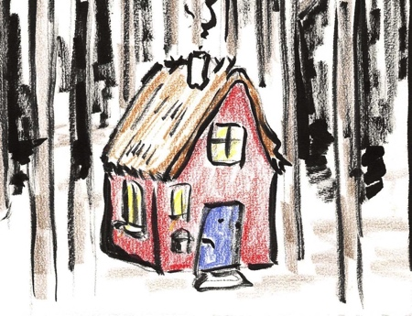
You will not need to use all the words; just have fun creating an instruction that links to what is going on in the sentence

Ask the elf for the map that shows the magic cottage.
Pay him with a pocketful of pebbles, shining and bright.
Read the map carefully.
If you breathe gently upon the map, the path you need to follow will magically appear.
Begin your great journey.
Listen to the birds; their song will be clear.
Pay attention to the wind; it will tell you your future.
What ever you do, do not pick any mushrooms – they will lull you into a deep and dreamless sleep.
On arriving at the cottage, knock three times upon the oak door.
Take off your cap, bow and curtsey to the old woman within.
She is 109 years old but still dances through the trees in search of healing herbs.
Relax - your quest is at an end.

____________________________________________________________________________________________________________________________________________________________________________________________________________________________________________________________________________________________________________________________________________________________________________________________

The Magic Cottage

Answers
Each instructional verb is highlighted. The two sentences that are not instructions are in orange.

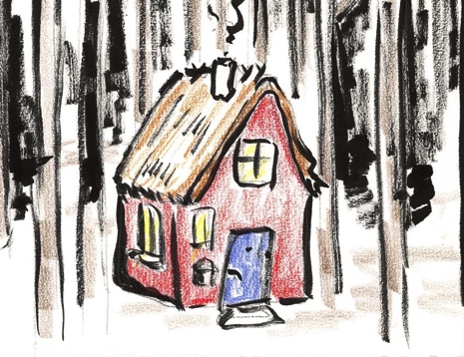

Ask the elf for the map that shows the magic cottage.
Pay him with a pocketful of pebbles, shining and bright.
Read the map carefully.
If you breathe gently upon the map, the path you need to follow will magically appear.
Begin your great journey.
Listen to the birds; their song will be clear.
Pay attention to the wind; it will tell you your future.
What ever you do, do not pick any mushrooms – they will lull you into a deep and dreamless sleep.
On arriving at the cottage, knock three times upon the oak door.
Take off your cap, bow and curtsey to the old woman within.
She is 109 years old but still dances through the trees in search of healing herbs.
Relax - your quest is at an end!
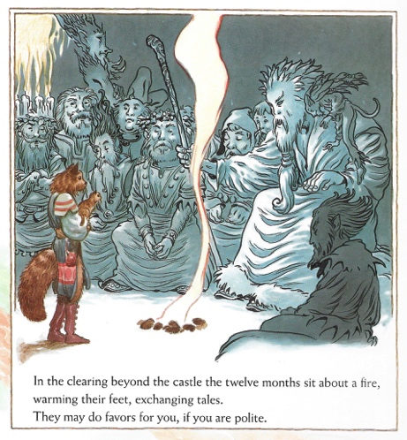

January ______________________________________________________
February _____________________________________________________
March _______________________________________________________
April ________________________________________________________
May ________________________________________________________
June ________________________________________________________
July _________________________________________________________
August ______________________________________________________
September __________________________________________________
October _____________________________________________________
November ___________________________________________________
December ___________________________________________________

