What to do today
IMPORTANT! Parent or Carer – Read this page with your child and check that you are happy with what they have to do and with any weblinks or use of the Internet required.

1. Story time
Go to https://www.youtube.com/watch?v=Ra4pZ3OTUKA&t=32s and listen to Neil Gaiman read his book, Instructions.
- Which fairy tale characters and settings did you recognise in the story?
- Why is the story called Instructions? Did you hear any instructions being given in the story?

2. All about instructions
Carefully read through The Features of Instructions.
- Now read the three instructions on Catching a Dragon.
- Write the next three instructions.
- Read How to Catch a Dragon and compare these instructions with your own.
- Whose might be more successful in helping you to catch a dragon?! Why do you think that?

3. Instruction Hunting
Read the first Extract from Instructions.
- Find and highlight each instruction in it.
- How many did you find? Give yourself a point for each one you find. (There are 16 – see Answers).

Now try this Fun-Time Extra
- Decide which your favourite bit in Instructions was. Draw this part of the story and write about what happened in it.

The Features of Instructions

Instructions are sentences that give commands or orders. They are bossy and tell the reader what to do. They:

- are usually short, sharp sentences that do not contain much description or story language.

Open the gate. Go down the garden path.

- always contain bossy verbs that tell someone what to do or not do.
These verbs are always in the present tense.

Listen for the doorbell. Do not use the door knocker.

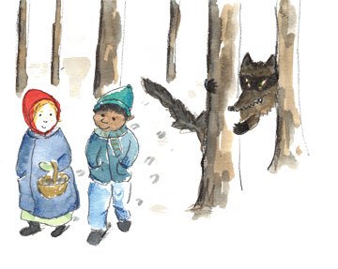
- are addressed to the reader, as if the reader is being spoken to directly by someone.

Go into the wood.
Watch out for the wolves.

- often ‘list’ things to do or avoid doing.

Walk through the wood, jump over the wall and then climb into the tree.

- can be numbered or have bullet points.

- Jump on board the ferry
- Pay the ferryman
- Stay sat down till you reach the far side of the river

Catching a Dragon

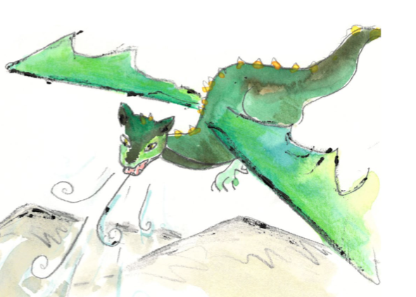

- Find some bait.

- Wait until a new moon rises.

- Take a very large net – it needs to be as big as a tree and as light as a feather.

- __________________________________________________________________________________________________________________

- __________________________________________________________________________________________________________________

- __________________________________________________________________________________________________________________

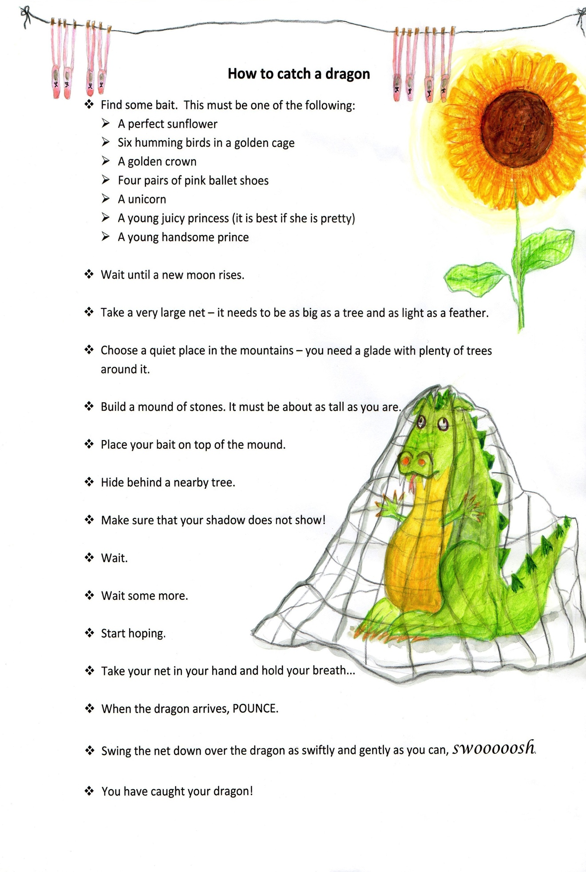

Extract from Instructions
by Neil Gaiman

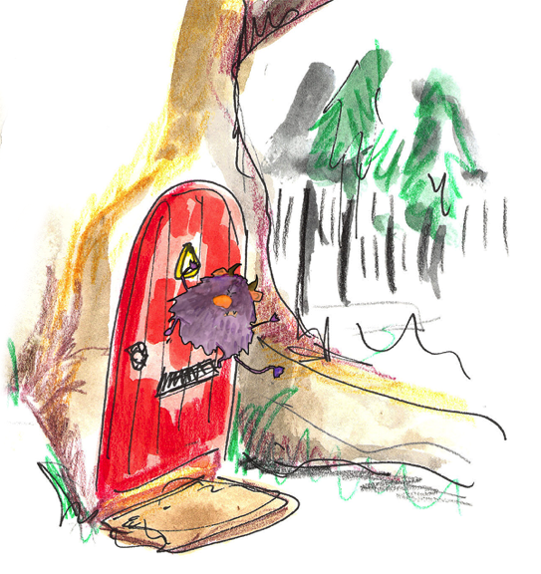
Touch the wooden gate in the wall you never saw before, say “Please” before you open the latch, go through, walk down the path.
A red metal imp hangs from the front door, as a knocker. Do not touch it – it will bite your fingers.
Walk through the house. Take nothing. Eat nothing. However, if any creature tells you that it hungers, feed it. If it tells you that it is dirty, clean it. If it cries to you that it is hurt, if you can, ease its pain.
From the back garden you will be able to see the wild wood. The deep well you walk past leads to Winter’s realm; there is another land at the bottom of it. If you turn around here, you can walk back, safely; you will lose no face. I will think no less of you.
Once through the garden you will be in the wood. The trees are old. Eyes peer from the undergrowth. Beneath a twisted oak sits an old woman. She may ask for something; give it to her. She will point the way to the castle.
Inside it are three princesses. Do not trust the youngest. Walk on.
In the clearing beyond the castle the twelve months sit, warming their feet, exchanging tales. They may do favours for you, if you are polite. You may pick strawberries in December’s frost.
Trust the wolves, but do not tell them where you are going.
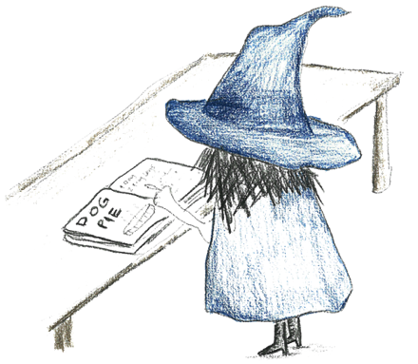 | How many instructions did you find?

Extract from Instructions
by Neil Gaiman

Answers

Touch the wooden gate in the wall you never saw before, say “Please” before you open the latch, go through, walk down the path.
A red metal imp hangs from the front door, as a knocker. Do not touch it – it will bite your fingers.
Walk through the house. Take nothing. Eat nothing. However, if any creature tells you that it hungers, feed it. If it tells you that it is dirty, clean it. If it cries to you that it is hurt, if you can, ease its pain.
From the back garden you will be able to see the wild wood. The deep well you walk past leads to Winter’s realm; there is another land at the bottom of it. If you turn around here, you can walk back, safely; you will lose no face. I will think no less of you.
Once through the garden you will be in the wood. The trees are old. Eyes peer from the undergrowth. Beneath a twisted oak sits an old woman. She may ask for something; give it to her. She will point the way to the castle.
Inside it are three princesses. Do not trust the youngest. Walk on.
In the clearing beyond the castle the twelve months sit, warming their feet, exchanging tales. They may do favours for you, if you are polite. You may pick strawberries in December’s frost. Trust the wolves, but do not tell them where you are going.

My Favourite Bit in Instructions

