What to do today
IMPORTANT! Parent or Carer – Read this page with your child and check that you are happy with what they have to do and with any weblinks or use of the Internet required.

1. Story time
Read the suggestions on Reading Strategies to remind yourself of the things to try when reading new or tricky words.
- Now read and enjoy The Mouse, The Frog and The Little Red Hen.
- Which words were tricky to read? Re-read these words and write them out on paper.

2. Describing characters
Look at the set of Story Character Describing Words.
- Carefully read each word or phrase. Copy each word under the name of the animal(s) that the description goes with – Hen, or Mouse/Frog?
- Add any other good words you can think of to describe the animals.

3. Writing time
Think carefully about all the hard-working things that Hen does in the story.
- On Busy..., draw Hen doing one of these hard-working things.
- In the box beneath, write several full, punctuated sentences.
- Use the word and to join together two things in one sentence.
- On ...Lazy! do the same thing for Mouse and Frog and what they do when Hen is working so hard.

Now try this Fun-Time Extra
- On I’m Here to Help!, make a list of all the things you think you could do to be kind and helpful.
- Ask Mum and Dad and see if you can do some of those things today!

Reading Strategies
When you come across a word you don’t know, use these strategies to help you read it.

Slowly sound out and blend the letters

c a t e r p i l l a r

Break longer words up into syllables

ca – ter – pill – ar

Look for smaller words you know that are hidden inside the bigger word

caterpillar

Think if the word makes sense

A caterpillar is a kind of animal. Yes! It makes sense in a story about animals.

Look at the pictures to see if they can help you

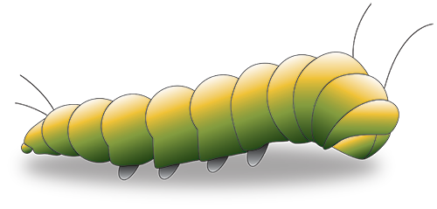

Story Character Describing Words

lazy greedy busy kind naughty

helpful selfish mean thoughtful

rude hard-working

Hen  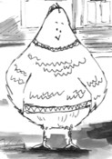 | Frog and Mouse  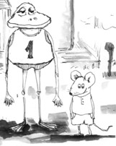

Busy

Draw hen doing one of those hard-working things …

- Write several full, punctuated sentences explaining some of the things Hen does in the story
- Use the word and to join together two things in one sentence. Hen bakes a lovely loaf of bread and does all the cleaning in the house. She...

... and Lazy!

Draw Mouse or Frog doing something in the story

- Write several full, punctuated sentences explaining some of the things Mouse and Frog do in the story
- Use the word and to join together two things in one sentence.
I’m Here to Help!

