What to do today
IMPORTANT! Parent or Carer – Read this page with your child and check that you are happy with what they have to do and with any weblinks or use of the Internet required.

You will use the Story Planner you produce today in the lesson tomorrow

1. Story time
Re-open https://www.youtube.com/watch?v=-9FZqX1CBqE and listen again to the story of Handa’s Hen. In which continent does Handa live? Africa.

2. Describing words
Look at the Animal Pictures and at the list of Akeyo’s Animal Descriptions.
- Read each descriptive phrase aloud.
- Suggest other good describing words you could use for each of the animals. What words could you use for the spoonbills and the chicks?

3. Plan a new version of Handa’s Hen
You are going to plan and write a new version of Handa’s Hen. Today you will plan your story.
- Use the Story Planner and look at the pictures of Handa and Akeyo’s African Animals.
- Keep filling in the Story Planner with your ideas, giving really good describing words for each animal.
- Decide where Handa’s missing animal was finally found.

Now try this Fun-Time Extra
- Play a game of Describing I Spy with the picture from the book.
- List some animals you know. Find out what their offspring are called – cats/kittens, dogs/puppies etc.
Animal Pictures

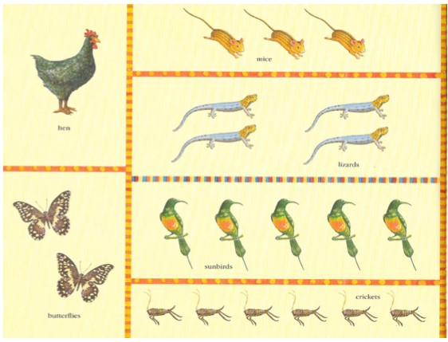
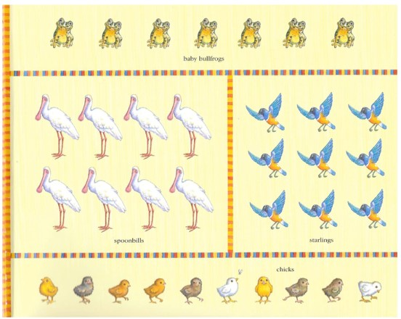

Akeyo’s Animal Descriptions

Akeyo’s descriptive phrases | Other words you could use to describe the animals

fluttery butterflies | butterflies
stripy mice | mice
little lizards | lizards
beautiful sunbirds | sunbirds
jumpy crickets | crickets
baby bullfrogs | bullfrogs
shiny starlings | starlings
spoonbills
chicks

How to use the story planner

- Carefully read the Story Planner and begin by deciding what missing pet Handa will search for. A mouse, a hamster, a cat, etc. Fill in the box, using describing words for the pet: a stripy grey cat.

- Now look at the pictures of Handa and Akeyo’s African Animals. Read each animal’s name and choose four different creatures that Handa will accidentally find as she searches for her lost pet.

- Keep filling in the Story Planner with your ideas, giving really good describing words for each animal you choose: tall spotty giraffes, huge fierce lions, etc.
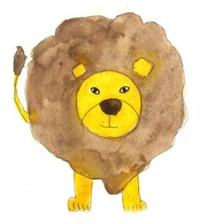

- Decide where Handa’s missing animal was finally found (under a tall tree)... and what little things she found with it!

Story Planner

Handa’s _________________

What pet did Handa lose?
Which animals did Handa see as she went looking for her pet? | one
 | two
 | three
 | four
Where did Handa find her lost pet?
What did Handa find with her lost pet!? | five

Handa and Akeyo’s African Animals

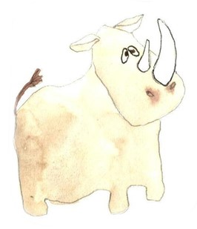  rhinocerus | 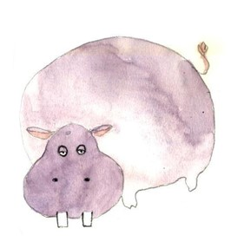  hippopotamus | 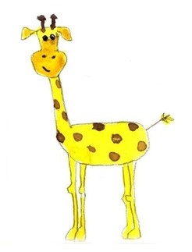  giraffe
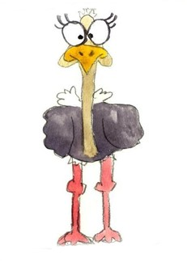  ostrich | 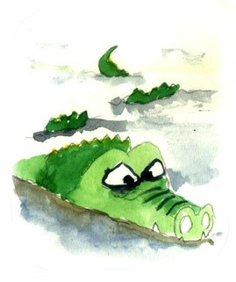  crocodile | 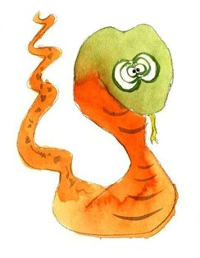  snake
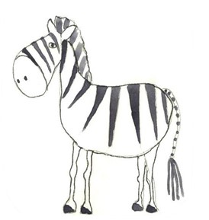  zebra | lion | If you prefer, choose some different animals of your own.

Describing I Spy

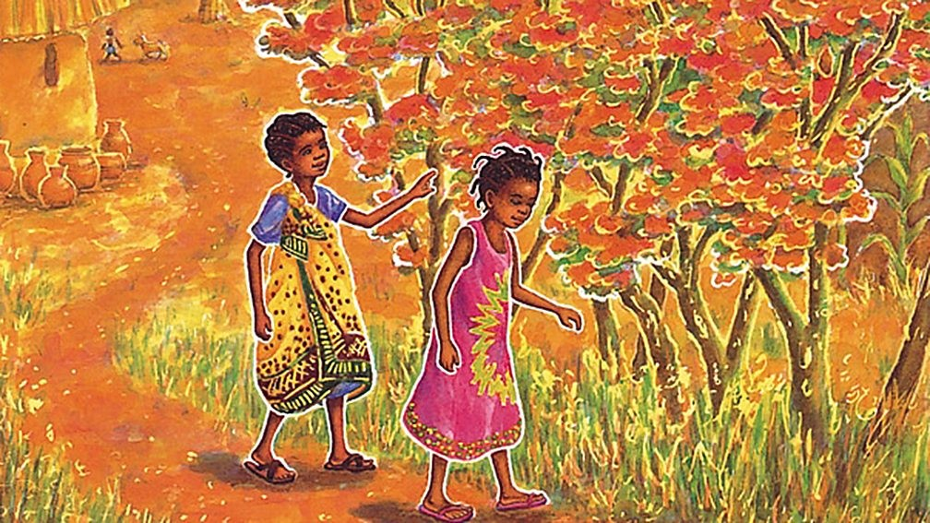

What can you see in the picture?

Animals and their Young

Animal | What their young ones are called

cat | kitten

