What to do today
IMPORTANT! Parent or Carer – Read this page with your child and check that you are happy with what they have to do and with any weblinks or use of the Internet required.

1. Story time
Go to https://www.youtube.com/watch?v=-9FZqX1CBqE and enjoy the reading of Handa’s Hen by Eileen Browne.

2. Reading numbers
Look at the random set of Number Words.
- Read each number word aloud.
- Cut out the cards and sequence the set vertically so that the numbers are in the right order, one to ten.
- Add the correct digit to each card (one/1; two/2, etc.).

3. Writing numbers
Look at the set of Handa’s Number Sentences.
- Carefully read each sentence.
- Write in the missing number word on each one: I saw two butterflies.
- Write in any missing animal names too. Check with the Animal Pictures if you get stuck.

Now try this Fun-Time Extra
- What is the best animal in the story? Draw it on My Favourite Animal and say why you like it. Which is your least favourite animal? Draw it too and explain why you are not so keen on it.
- Akeyo is Handa’s best friend. Who is your best friend? On My Best Friend, draw and describe your best friend.

Number Words

ten
two
four
eight
nine
five
seven
three
six
one

Handa’s Number Sentences

I can see hen.
I can see butterflies.
I can see .
I can see lizards.
I can see sunbirds.
I can see .
I can see bullfrogs.
I can see .
I can see starlings.
And I can see !

Animal Pictures

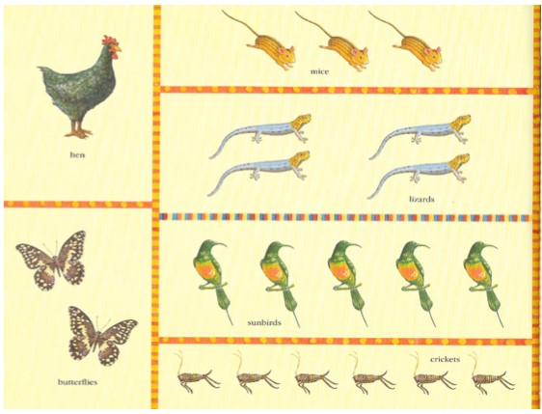

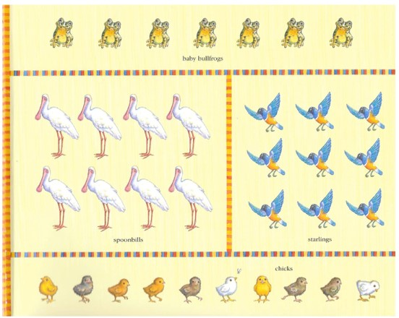

My Favourite Animal

____________________________________________
____________________________________________
____________________________________________
____________________________________________
____________________________________________
____________________________________________
____________________________________________
____________________________________________
____________________________________________
____________________________________________
____________________________________________

My Best Friend

My Least Favourite Animal

____________________________________________
____________________________________________
____________________________________________
____________________________________________
____________________________________________
____________________________________________
____________________________________________
____________________________________________
____________________________________________
____________________________________________
____________________________________________

