What to do today
IMPORTANT! Parent or Carer – Read this page with your child and check that you are happy with what they have to do and with any weblinks or use of the Internet required.

1. It’s reading time!
Read and enjoy Custard the Dragon by Ogden Nash. Read it slowly talking about it as you go. Make sure that you understand how brave Custard is!
- Discuss what was your favourite part of the poem.

2. Describing characters
Read the names of each of the characters on Custard’s Family.
- Write a sentence or two describing each one. Use the word and to join ideas in your sentence. Blink is a small mouse and she has grey fur. She is brave and chases lions down the stairs.
- If you need to, go back to the poem to check what the characters are like and what they do.

3. Let’s get ready to write
Imagine that Custard and his friends climbed into their little red wagon and went on holiday. Write the story of where everyone went, following the instructions on Write about Custard’s Holiday.

Now try these Fun-Time Extras
- Draw a picture to go with your story.
- Read your story out loud to your family.
Custard the Dragon
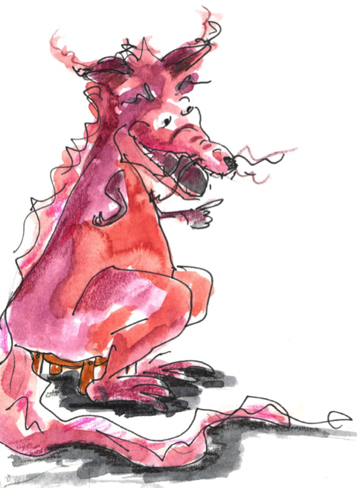

Belinda lived in a little white house,
With a little black kitten and a little grey mouse,
And a little yellow dog and a little red wagon,
And a realio, trulio, little pet dragon.
Now the name of the little black kitten was Ink,
And the little grey mouse, she called her Blink,
And the little yellow dog was sharp as Mustard,
But the dragon was a coward, and she called him Custard.
Custard the dragon had big sharp teeth,
And spikes on top of him and scales underneath,
Mouth like a fireplace, chimney for a nose,
And realio, trulio, daggers on his toes.
Belinda was as brave as a barrel full of bears,
And Ink and Blink chased lions down the stairs,
Mustard was as brave as a tiger in a rage,
But Custard cried for a nice safe cage.
Belinda tickled him, she tickled him unmerciful,
Ink, Blink and Mustard, they rudely called him Percival,
They all sat laughing in the little red wagon
At the realio, trulio, cowardly dragon.
Belinda giggled till she shook the house,
And Blink said Week!, which is giggling for a mouse,
Ink and Mustard rudely asked his age,
When Custard cried for a nice safe cage.
Suddenly, suddenly they heard a nasty sound,
And Mustard growled, and they all looked around.
Meowch! cried Ink, and Ooh! cried Belinda,
For there was a pirate, climbing in the winda.
Pistol in his left hand, pistol in his right,
And he held in his teeth a cutlass bright,
His beard was black, one leg was wood;
It was clear that the pirate meant no good.

Belinda paled, and she cried, Help! Help!
But Mustard fled with a terrified yelp,
Ink trickled down to the bottom of the household,
And little mouse Blink strategically mouseholed.
But up jumped Custard, snorting like an engine,
Clashed his tail like irons in a dungeon,
With a clatter and a clank and a jangling squirm
He went at the pirate like a robin at a worm.
The pirate gaped at Belinda's dragon,
And gulped some grog from his pocket flagon,
He fired two bullets but they didn't hit,
And Custard gobbled him, every bit.
Belinda embraced him, Mustard licked him,
No one mourned for his pirate victim
Ink and Blink in glee did gyrate
Around the dragon that ate the pyrate.
Belinda still lives in her little white house,
With her little black kitten and her little gray mouse,
And her little yellow dog and her little red wagon,
And her realio, trulio, little pet dragon.
Belinda is as brave as a barrel full of bears,
And Ink and Blink chase lions down the stairs,
Mustard is as brave as a tiger in a rage,
But Custard keeps crying for a nice safe cage.
Ogden Nash,
The Tale of Custard the Dragon
1935

Custard’s Family

Belinda | ____________________________________________________________________________________________________________________________________________________________________
Blink | ____________________________________________________________________________________________________________________________________________________________________
Ink | ____________________________________________________________________________________________________________________________________________________________________
Mustard | ____________________________________________________________________________________________________________________________________________________________________
Custard | ____________________________________________________________________________________________________________________________________________________________________

Write about Custard’s Holiday

Imagine that Custard and his friends climbed into their little red wagon and went on holiday.

- Where did Custard and the others go? Maybe the seaside or London, a camp site – or America!

- What did they do when they got there? Swam, went bicycling, played games, visited friends, etc.

- On Custard’s Holiday, write the story of where everyone went on their holiday in your best handwriting. One day, Custard and his friends went on holiday to...

- Say one thing that Custard did on the holiday. Do the same for each of the other characters – Belinda, Ink, Blink and Mustard.

Custard’s Holiday
A picture of Custard and his friends on holiday

