What to do today
IMPORTANT! Parent or Carer – Read this page with your child and check that you are happy with what they have to do and with any weblinks or use of the Internet required.

1. It’s reading time!
Can you remember who came fifth in the Jade Emperor’s race across the river? The dragon! Poems and stories about dragons are very popular all around the world, not just in China.
- Read and enjoy I Wish I Had a Dragon by Shel Silverstein.
- What sounds like the best thing about the dragon Shel Silverstein says he wants? Why is that so cool?

2. Rhymes and rhyming
Highlight the pairs of words in I Wish I Had a Dragon that rhyme.
- Use the Answers page to check. Did you get all the pairs of words? Well done!
- Look at Rhyme Time. Copy the words from the big box into the correct column, making sure that the words rhyme.
- Now add some rhyming words of your own to each column.

3. Let’s get ready to write
What would your perfect pet dragon be like?
- Use My Perfect Dragon to draw your ideal pet.
- Now write sentences about your dragon, following the instructions on the page.

Now try this Fun-Time Extra
- Look at the dragon body part anagrams on Here be Dragons! Can you work out what each world is? Check with the Answers.

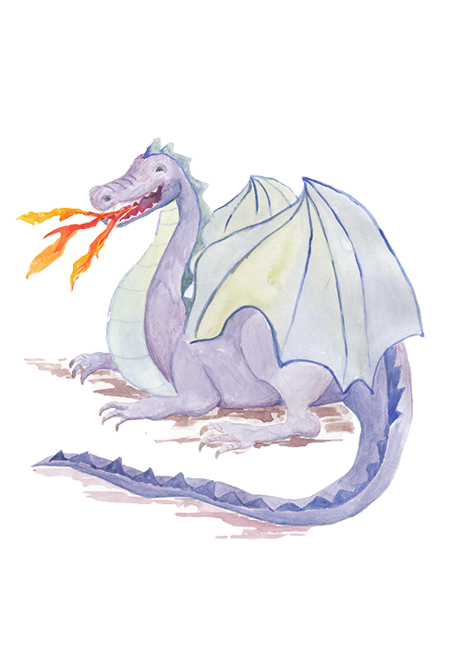
I Wish I Had A Dragon

I wish I had a dragon
With diamond-studded scales,
With claws like silver sabres,
And fangs like silver nails,
A dragon fierce and faithful,
Always ready by my side,
A dragon to defend me
Or take me for a ride

I wish I had a dragon
With eyes of shining gold,
Who breathed a plume of fire
Whenever it was told,
A dragon so ferocious
It might frighten Frankenstein,
But not a lazy dragon
Who sleeps all day…like mine.

Shel Silverstein,
http://www.tooter4kids.com/MedievalTimes/dragon_poetry.htm

Answers – Rhymes in I Wish I Had A Dragon

I wish I had a dragon
With diamond-studded scales,
With claws like silver sabres,
And fangs like silver nails,
A dragon fierce and faithful,
Always ready by my side,
A dragon to defend me
Or take me for a ride

I wish I had a dragon
With eyes of shining gold,
Who breathed a plume of fire
Whenever it was told,
A dragon so ferocious
It might frighten Frankenstein,
But not a lazy dragon
Who sleeps all day…like mine.

Shel Silverstein,
http://www.tooter4kids.com/MedievalTimes/dragon_poetry.htm

Rhyme Time

scales  nails | side  ride | gold  told | stein  mine

sold rails sign mould died gaols lied tales fold gales guide sighed tails

My Perfect Dragon - Picture

My Perfect Dragon

- Write sentences with the word and in them to describe you're your dragon looks like. My dragon is green with a long tail and a huge horn on its head, etc.
- Think about all the things your pet dragon would be really useful for. Write sentences about your dragon with the word because in them to say why or how it would be useful. My dragon would be useful for cooking because it could make toast with its flames, etc.

Here be Dragons!

liat | lawc
nwig | rhon
gel | cnek
yee | psiek
slaces | touhm
ttehe | lamfe

Here be Dragons!

Answers

tail | claw
wing | horn
leg | neck
eye | spike
scales | mouth
teeth | flame

