What to do today
IMPORTANT! Parent or Carer – Read this page with your child and check that you are happy with what they have to do and with any weblinks or use of the Internet required.

1. It’s story time!
Go to https://www.youtube.com/watch?v=idUlDEOrJec&t=450s and listen to storyteller Adele Moss tell the tale of The River Race (14 mins).

2. Using because to help express an opinion.
Think carefully about the two versions of the Jade Emperor’s story that you have read and heard.
- On My Opinions, write a full, punctuated sentence in your best handwriting giving a reason you liked The Race Across the River.
- In your sentence, use the word because to give reasons.
- Now do the same for River Race.
- Now say which you think was the best story, and why you feel that.

3. Being a storyteller
Now you are going to tell a simple version of the story of the animals’ race across the river!
- Begin with the Jade Emperor’s birthday. Once upon a time...
- When you get to the race, read from the Race Result Chart you completed yesterday to help get the animals in the right order.
- Keep retelling the story till you feel confident. Speak in a big, strong storyteller voice. Try adding in some funny voices for the animals.

Now try this Fun-Time Extra
- When you are ready, perform your story for Mum or Dad. Ask them to record or film you telling the story so that other relatives can see and hear it too.
My Opinions
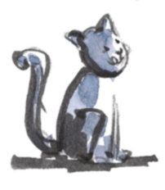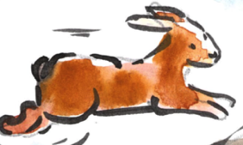

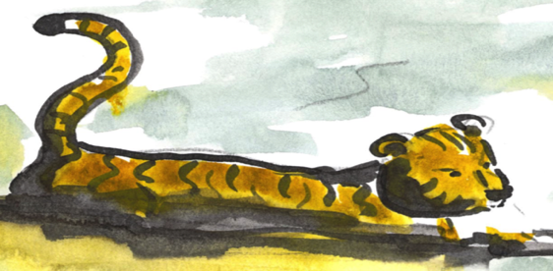
because

big elephants can always understand small elephants

The word because joins together two independent clauses in a sentence.

I like The Race Across the River and It has funny drawings

I like the Race Across the River because it has funny drawings.

Using because lets you explain or give a reason for something.

I think River Race is the best because you hear the animals speaking.

Helping Children Tell Their Story Out Loud

1. Getting the story started
- Suggest children use a traditional story opening such as Once upon a time..., One day many years ago..., etc.

2. Setting the scene
- Help chn to begin by explaining what is happening at the start of the story.
- It was the Jade Emperor’s birthday
- The Jade Emperor decided to have a race between all the animals
- The Emperor wanted to name the years after different animals etc.

3. Recounting the race
- Encourage less confident storytellers to begin by reading from their Race Results from Day 2. First was the cheeky rat, second was the kind ox, etc.
- As their confidence grows, children can try simply recalling the order of the animals and adding in more detail.

4. Developing storytelling skills
- Encourage children to use big, strong voices and to speak slowly & clearly.
- Once they have got the outline of the story clear, help them to add in some lines spoken in character voices – deep and booming for the Jade Emperor, miaows and oinks, hisses and moos for the cat, pig, snake and ox, etc!
- They may also wish to add movements to indicate each animal or what they do (swimming or jumping motions, for example. Fingers twitching by their noses for the rat, using a slithering arm to show the snake.)

5. Ending the story
- Remind children of how both versions they have seen end – with the cat chasing the rat.
- Teach children to use a traditional story ending – And that is why cat’s chase rats; And they all lived happily ever after, etc.

