What to do today
IMPORTANT! Parent or Carer – Read this page with your child and check that you are happy with what they have to do and with any weblinks or use of the Internet required.

1. It’s reading time!
Re-read The Race Across the River by Ruth Merttens & Anne Holm Petersen.
- Say which animals feature in the story.

2. Reading animals’ names
- Look at the animal names listed in The Jade Emperor’s Zoo.
- Use My Best Reading Strategies to help read new and tricky words.
- Highlight only the names of the animals that are in the story.
- Check by re-reading the story if you are not sure you have got them all.

3. Sequencing events from The Race Across the River
Which animal won the race? Who was second? And third?
- Use the Race Result Chart to record the order the animals came in in the race. The first one has been done for you.
- Use a descriptive word for each animal (the tiny rat, the huge ox, etc.).
- Look at The Emperor’s Twelve Animals if you need to make sure you got the order right.

Now try these Fun-Time Extras
- Think up an alternative set of animals that you would put in the story: the Year of the Hamster, the Year of the Blackbird, etc.
- Go to https://www.chinahighlights.com/travelguide/chinese-zodiac/ and discover which animal is linked to the year you were born.
The Jade Emperor’s Zoo

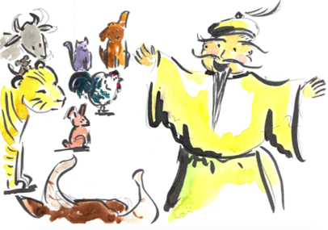

giraffe elephant ox cat crocodile horse

rat dragon unicorn horse eagle blackbird tiger

monkey caterpillar cat ostrich hippo rooster squirrel

pig rabbit hamster snake mouse goat dog

My Best Reading Strategies

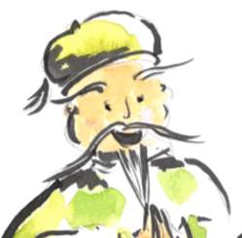

Slowly sound out and blend the letters

c a t e r p i l l a r

Break longer words up into syllables

ca – ter – pill – ar

Look for smaller words you know that are hidden inside the bigger word

caterpillar

Think if the word makes sense

A caterpillar is a kind of animal. Yes! It makes sense in a list of animals.

Race Result Chart

- Use your best handwriting to write the animals’ names and the numbers 1 to 12.  - At the bottom of the page, write a sentence about the animal which is your favourite. | 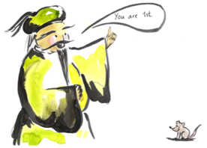

Number | Picture | Name

1 |  | the crafty rat

____________________________________________________________________________________________________________________________

The Emperor’s Twelve Animals

Number | Animal

1 | rat
2 | ox
3 | tiger
4 | rabbit
5 | dragon
6 | snake
7 | horse
8 | goat
9 | monkey
10 | rooster
11 | dog
12 | pig

Alternative Animals Zodiac

Number | Animal

1
2
3
4
5
6
7
8
9
10
11
12

